1.1 Background of the Study 7
1.1.1 Evolution of Packaging Automation 7
1.1.2 Role of VFFS Systems in Global Supply Chains 7
1.1.3 Precision Dosing: The Critical Role of Auger Fillers 8
1.2 Problem Statement 9
1.2.1 Inaccuracy and Inconsistency in Powder Filling 9
1.2.2 Structural and Thermal Challenges in Continuous Operation 9
1.2.3 Limitations of Conventional Empirical Design Methods 10
1.3 Aim and Objectives 10
1.4 Research Questions 11
1.5 Scope and Limitations 12
1.5.1 Scope of Work 12
1.5.2 Limitations 12
1.6 Significance of the Study 12
1.6.1 Academic Contribution 12
1.6.2 Industrial Relevance 13
1.6.3 Technological Innovation 13
1.7 Methodology Overview 13
1.7.1 Research Design Framework 13
1.7.2 Analytical Modeling Phase 13
1.7.3 Numerical Simulation Phase 13
1.7.4 Validation and Correlation 14
1.8 Organization of the Report 14
References 15
3.1 Research Design Framework 54
3.2 Design Requirements and Constraints 55
3.2.1 Target Output (PPM: Packs Per Minute) and Accuracy (±σ) 55
3.2.2 Sanitary and Material Standards (e.g., AISI 304 Stainless Steel) 56
3.3 Conceptual Development 57
3.3.1 Functional Decomposition (Dosing System, Packaging & Sealing System.) 57
3.3.2 Selection of Actuation (Servo-driven vs. Induction) 63
3.4 Final Mechanical Architecture (CAD) 65
The final mechanical design integrates all functional subsystems into a single, optimized unit that is easier to manufacture and maintain. This section presents the machine's mechanical design in the SolidWorks software. 65
3.4.1 Dosing System CAD: 65
3.4.2 Packaging and Sealing System CAD: 73
3.4.2 Drive Train and Power Transmission 77
3.4.3 Supporting Frame and Vibration Isolation 78
3.4.4 Hopper and Agitator Design 79
3.5 Control System Logic 80
3.5.1 Motion Control Profiles (Trapezoidal vs. S-Curve) 80
3.5.2 Sensor Integration (Feedback Loops) 81
3.5.3 Safety and Interlock Systems 82
3.6 Integration with VFFS System 83
3.6.1 Mechanical Interface 83
3.6.2 Control Interface 84
3.7 Summary of Design Specifications 85
References 86
4.1 Mathematical Foundations and Assumptions 89
4.1.1 Fundamental Assumptions 89
4.1.2 Material Properties 90
4.2 Kinematic and Kinetic Modeling 90
4.2.1 Theoretical Volumetric Flow Rate 90
4.2.2 Mass Flow Rate as a Function of Bulk Density and Rotational Speed 91
4.3 Dynamic Torque and Power Estimation 91
4.3.1 Torque Components: Powder Resistance and Friction 92
4.3.2 Motor Sizing and Gear Ratio Optimization 92
4.4 Structural Mechanics Equations 93
4.4.1 Torsional Stress on the Auger Shaft 93
4.4.2 Deflection and Critical Speed Analysis 94
4.5 Film Motion and Sealing Equations 95
4.5.1 Film Transport Kinematics 95
4.5.2 Tension and Sealing Force Calculations 95
4.5.3 Heat Transfer Equations for Thermal Sealing 96
4.5.4 Speed and Productivity Calculations 97
4.5.5 Auger Filler Engineering Calculations 97
4.5.6 Stepper Motor Calculations for Film Feed System 98
4.7 Summary of Analytical Results 107
References 110
CHAPTER 5 112
MULTIPHYSICS SIMULATION AND VALIDATION 112
5.1 Computational Setup 113
5.1.1 Pre-processing: Meshing Strategy and Convergence Study 113
5.1.2 Material Properties and Boundary Conditions 114
5.2 Static Structural Analysis 115
5.2.1 Stress Distribution and Factor of Safety (FoS) 116
5.2.2 Displacement and Deformation Profiles 116
5.3 Thermal-Structural Coupling 117
5.3.1 Steady-State Thermal Analysis 117
Funnel Assembly 118
5.3.2 Thermal Expansion Effects on Clearances and Dosing Accuracy 118
5.4 Modal Analysis (Vibration Characteristics) 118
5.4.1 Natural Frequencies and Mode Shapes 119
5.4.2 Resonance Avoidance in VFFS Integration 119
5.5 Control System Validation 120
5.5.1 Thermal Control System Simulation 120
5.5.2 System Timing Diagram and Cycle Rate Validation 121
5.6 Safety Validation and Failure Mode Analysis 122
5.6.1 Software Interlocks and Edge Case Handling 122
5.6.2 Failure Mode and Effects Analysis (FMEA) 123
5.6.3 Alignment with International Industrial Standards 124
5.7 Validation Summary and Correlation Analysis 125
References 125

CHAPTER ONE
INTRODUCTION
────────────────────
Design and Development of a Vertical Form-Fill-Seal (VFFS)
Packaging Machine with Auger Filler for Powder Materials

1.1 Background of the Study
The global packaging industry represents one of the most dynamic and technologically advanced sectors of modern manufacturing, with an estimated market value exceeding $1 trillion annually. Within this expansive domain, automated packaging machinery has emerged as a critical enabler of industrial efficiency, product safety, and supply chain optimization. The Vertical Form-Fill-Seal (VFFS) machine, first conceptualized in the mid-20th century, has evolved from simple mechanical devices into sophisticated mechatronic systems capable of achieving production rates exceeding 200 packages per minute while maintaining precise weight tolerances of less than one percent [1].
This graduation project addresses the design, analysis, and development of a VFFS packaging system specifically engineered for the precision dosing of granular and powdered materials, with particular emphasis on sodium chloride (table salt) packaging. The project integrates mechanical engineering principles, bulk solids mechanics, control systems theory, and modern simulation techniques to deliver a comprehensive engineering solution that meets contemporary industrial standards for accuracy, reliability, and hygienic compliance.

1.1.1 Evolution of Packaging Automation
The historical trajectory of packaging automation reflects broader patterns of industrial development, from the mechanization of the 19th century through the digital revolution of the late 20th and early 21st centuries. Early packaging operations were entirely manual, relying on human labor for filling, sealing, and labeling operations. The introduction of semi-automatic filling machines in the 1930s marked the first significant departure from manual methods, though these early devices offered limited throughput and minimal process control [2].
The post-World War II era witnessed accelerated development in packaging machinery, driven by rising consumer demand and the expansion of mass retail distribution. The invention of the form-fill-seal concept by Walter Zwoyer in the 1930s, later refined and commercialized by companies such as Hayssen and Bosch, established the fundamental operating principles that continue to govern modern VFFS systems. These early machines employed mechanical cams, gears, and linkages to coordinate the sequential operations of film transport, forming, filling, and sealing [3].
The digital revolution of the 1980s and 1990s transformed VFFS technology through the integration of programmable logic controllers (PLCs), servo motor drives, and electronic sensors. This transition from purely mechanical to electromechanical systems enabled unprecedented levels of precision, flexibility, and diagnostic capability. Contemporary VFFS machines incorporate advanced motion control algorithms, real-time process monitoring, and network connectivity, establishing the foundation for Industry 4.0 integration [4].

1.1.2 Role of VFFS Systems in Global Supply Chains
Vertical Form-Fill-Seal machines occupy a strategically significant position within global food and consumer goods supply chains. Their compact footprint, high operational speed, and adaptability to diverse product specifications make them the preferred packaging solution for granular and powdered commodities including food products, pharmaceuticals, chemicals, and agricultural materials. Industry estimates indicate that VFFS systems account for approximately 35% of all flexible packaging operations worldwide [5].
The economic significance of VFFS technology extends beyond direct equipment sales to encompass substantial operational savings through reduced labor requirements, minimized material waste, and enhanced product protection. Modern VFFS systems achieve material utilization rates exceeding 95% through precise film tracking and optimized bag forming geometry, contributing to both economic efficiency and environmental sustainability objectives [6].
Furthermore, the hygienic design principles incorporated into contemporary VFFS machinery address increasingly stringent food safety regulations, including FDA requirements in the United States and EU hygiene standards in Europe. Stainless steel construction, smooth surface finishes, and clean-in-place (CIP) capabilities ensure compliance with Good Manufacturing Practice (GMP) guidelines essential for food-grade packaging operations [7].

1.1.3 Precision Dosing: The Critical Role of Auger Fillers
Among the various dosing mechanisms employed in VFFS applications, auger filling systems represent the most widely adopted technology for granular and powdered materials. The auger filler operates on the principle of positive displacement, wherein a rotating helical screw (auger) within a cylindrical housing transports material from a supply hopper to a discharge point. The volumetric displacement per revolution is determined by the auger geometry, enabling precise control of dispensed quantity through accurate angular positioning [8].
The fundamental relationship governing auger filling performance derives from the geometric displacement of the helical screw:
V_th = (π/4) × (D² - D_s²) × P
Where V_th represents the theoretical volumetric displacement per revolution, D is the outer diameter of the auger flight, D_s is the shaft diameter, and P is the pitch of the helical flight. This geometric relationship, first systematically analyzed by Roberts and Rademacher in the context of screw conveyor theory, provides the theoretical foundation for auger design and performance prediction [9].
However, the practical implementation of auger filling involves significant deviations from ideal theoretical behavior due to the complex mechanical properties of bulk solids. Factors including particle size distribution, bulk density variation, interparticle friction, cohesive forces, and wall friction effects all contribute to the difference between theoretical and actual volumetric efficiency. Empirical studies indicate that typical volumetric efficiency factors range from 0.4 to 0.9, depending on material properties and operating conditions [10].
[Insert Figure Here]
Figure 1.1: Schematic illustration of VFFS machine with integrated auger filling system, showing key functional components including film transport, forming collar, filling zone, and sealing jaws.

1.2 Problem Statement
Despite the widespread adoption of VFFS technology in industrial packaging applications, several persistent challenges limit the achievement of optimal performance in powder and granular material handling. These challenges span mechanical design, process control, and operational reliability domains, creating opportunities for significant engineering improvement through systematic research and development.

1.2.1 Inaccuracy and Inconsistency in Powder Filling
The primary performance metric for any filling system is dosing accuracy, typically expressed as the percentage deviation between target and actual dispensed mass. For commercial packaging operations, regulatory standards such as OIML R87 specify maximum permissible errors based on package weight, with stricter tolerances applied to smaller packages. For a 500g package of salt, the maximum permissible error is typically ±1.5%, corresponding to ±7.5g [11].
Achieving consistent accuracy in auger filling is complicated by several factors inherent to bulk solid behavior. Bulk density variation, resulting from changes in material consolidation, moisture content, or particle packing arrangement, directly affects the mass-to-volume conversion that underlies volumetric dosing principles. Studies have demonstrated that bulk density of granular salt can vary by ±5-10% under normal operating conditions, creating corresponding variations in dispensed mass unless compensated through control system intervention [12].
Additional sources of dosing error include:
• Slip between material and auger flight surfaces, reducing effective displacement;
• Backflow through radial clearance between flight tip and housing wall;
• Incomplete filling of auger flights due to hopper flow irregularities;
• In-flight material continuing to fall after motor stop command;
• Kinematic inertia causing continued rotation during deceleration phases.
The cumulative effect of these error sources can result in total dosing errors exceeding acceptable limits unless addressed through integrated mechanical and control system design.

1.2.2 Structural and Thermal Challenges in Continuous Operation
Industrial VFFS machines are typically required to operate continuously for extended periods, often exceeding eight hours per shift under demanding production schedules. This operational intensity imposes significant mechanical and thermal loads on critical components, particularly the auger drive system and sealing mechanisms.
The auger shaft experiences substantial torsional loading during operation, particularly during startup when breakaway torque is required to initiate motion of compacted material. Analytical calculations for the proposed design indicate maximum torque requirements of approximately 20 N·m under worst-case conditions. The shaft must withstand these loads without excessive deflection that would compromise the critical radial clearance between rotating and stationary components [13].
Thermal considerations arise from multiple sources including motor heating, friction at bearing surfaces, and heat transfer from the sealing jaws. The sealing operation for plastic films typically requires temperatures of 150-200°C, creating thermal gradients that can affect component dimensions and material properties. Thermal expansion of the auger shaft, if not properly accommodated, can result in binding or increased friction within the dosing chamber [14].

1.2.3 Limitations of Conventional Empirical Design Methods
Traditional approaches to auger filler design have relied heavily on empirical correlations and industry rules of thumb developed through decades of practical experience. While these methods have proven effective for conventional applications, they exhibit significant limitations when applied to novel materials, non-standard operating conditions, or precision requirements exceeding typical industrial norms.
The Conveyor Equipment Manufacturers Association (CEMA) provides standardized design equations for screw conveyors, but these formulations were developed for bulk material transport rather than precision dosing applications. The translation from continuous conveying to discrete volumetric metering introduces additional complexity not fully addressed by conventional design methodologies [15].
Furthermore, empirical design approaches provide limited insight into the underlying physical phenomena governing system behavior. Without fundamental understanding of powder flow mechanics, stress distribution, and dynamic response, optimization of design parameters becomes a trial-and-error process rather than a systematic engineering exercise. This project addresses this gap through the integration of analytical modeling, numerical simulation, and experimental validation methodologies.

1.3 Aim and Objectives
The overarching aim of this graduation project is to design, analyze, and validate a complete VFFS packaging system with integrated auger filler specifically optimized for the precision packaging of granular sodium chloride. The project encompasses mechanical design, control system development, and comprehensive performance validation through analytical and numerical methods.
The specific objectives of the project are:
1.To develop a comprehensive understanding of bulk solids mechanics and powder flow behavior as applied to auger filling systems, including the characterization of material properties affecting dosing accuracy.
2.To design the mechanical architecture of a VFFS auger filling system, including auger geometry, drive train specification, hopper configuration, and flow control mechanisms, meeting industrial standards for hygiene and reliability.
3.To establish analytical models for volumetric displacement, torque requirements, and structural loading, enabling quantitative prediction of system performance.
4.To perform multiphysics numerical simulations including static structural analysis, thermal analysis, and modal analysis to validate mechanical design decisions and identify potential failure modes.
5.To develop control system architecture incorporating servo motor positioning, sensor integration, and feedback algorithms to achieve target dosing accuracy of ±1.5% for 500g packages.
6.To correlate analytical predictions with numerical simulation results, establishing confidence in the design methodology and identifying areas requiring refinement.

1.4 Research Questions
This project addresses the following research questions that guide the investigation and provide focus for the engineering analysis:
RQ1.What auger geometry (outer diameter, shaft diameter, pitch, and flight profile) optimizes the trade-off between volumetric displacement capacity and mechanical stress distribution for the target 500g dose requirement?
RQ2.How do bulk density variations and powder flow properties affect dosing accuracy, and what control strategies can compensate for these variations in real-time operation?
RQ3.What are the critical structural loading conditions for the auger shaft and drive train, and what safety factors ensure reliable operation under worst-case scenarios including material caking and startup conditions?
RQ4.How does thermal expansion from sealing jaw heating affect component clearances and dosing accuracy, and what design measures mitigate thermal effects?
RQ5.What is the correlation between analytical predictions and numerical simulation results, and how do deviations inform design refinement decisions?

1.5 Scope and Limitations
The scope of this graduation project encompasses the complete engineering design and analysis of a VFFS auger filling system, with specific boundaries defining the extent of investigation and areas explicitly excluded from consideration.

1.5.1 Scope of Work
The project scope includes:
• Mechanical design of auger screw, central shaft, spinner plate, and associated tooling;
• Specification and selection of servo motor, gearbox, and drive train components;
• Design of hopper and agitator system for consistent material feeding;
• Development of control system architecture and motion control algorithms;
• Analytical modeling of volumetric displacement, torque, and power requirements;
• Finite Element Analysis (FEA) of structural, thermal, and modal behavior;
• Validation of design through correlation between analytical and numerical results.

1.5.2 Limitations
The following aspects are explicitly outside the scope of this project:
• Physical prototype fabrication and experimental testing (the project is limited to design and simulation phases);
• Complete VFFS machine including film transport, forming, and sealing subsystems (focus is specifically on the auger filling mechanism);
• Economic analysis, cost estimation, and market feasibility studies;
• Investigation of alternative dosing technologies (cup fillers, weigh fillers, etc.);
• Long-term reliability testing and wear analysis under extended operation.
The target material is limited to granular sodium chloride (table salt) with specified particle size distribution and moisture content. While the design principles may be applicable to other granular materials, validation is specifically performed for salt packaging applications.

1.6 Significance of the Study
This graduation project contributes to engineering knowledge and industrial practice through multiple pathways of significance:

1.6.1 Academic Contribution
The project demonstrates the integration of multiple engineering disciplines—mechanical design, bulk solids mechanics, control systems, and numerical simulation—within a unified design framework. The systematic correlation between analytical models and finite element analysis provides a methodology applicable to similar mechatronic system development. Furthermore, the detailed treatment of powder flow phenomena augments the existing literature on auger filling technology, which has historically received less scholarly attention than other bulk material handling systems [16].

1.6.2 Industrial Relevance
The design outcomes directly address industrial requirements for high-speed, accurate, and reliable powder packaging. The target specifications—500g packages at 15 bags per minute with ±1.5% accuracy—represent typical production requirements for medium-scale food packaging operations. The methodology employed, combining theoretical analysis with simulation validation, offers a template for systematic design optimization that can reduce development time and prototyping costs [17].

1.6.3 Technological Innovation
The integration of advanced servo control with mechanical flow control mechanisms (spinner plate) represents an innovative approach to addressing the persistent challenge of dribble elimination in free-flowing granular materials. The dual-core ESP32 control architecture with distributed processing of motion control and thermal management tasks demonstrates the application of modern embedded systems technology to packaging machinery [18].

1.7 Methodology Overview
The project follows a systematic engineering design methodology progressing from requirements definition through conceptual design, detailed analysis, and validation. The overall approach integrates analytical modeling, computational simulation, and design verification in an iterative framework.

1.7.1 Research Design Framework
The methodology adopts a mixed-methods approach combining theoretical analysis, numerical simulation, and design validation. The research design follows the classical engineering method: problem definition, background research, conceptual design, detailed analysis, and verification. This structured approach ensures comprehensive coverage of all technical aspects while maintaining traceability from requirements to final design [19].

1.7.2 Analytical Modeling Phase
The analytical phase establishes mathematical models governing system behavior:
• Volumetric displacement theory based on auger geometry and powder properties;
• Torque and power requirements derived from material resistance and inertial loading;
• Structural mechanics equations for stress, deflection, and critical speed analysis;
• Control system models for motion profiling and feedback compensation.

1.7.3 Numerical Simulation Phase
Finite Element Analysis (FEA) using SOLIDWORKS Simulation and ANSYS Mechanical provides detailed insight into:
• Static structural response under maximum torque loading;
• Thermal distribution and expansion effects;
• Modal characteristics and resonance avoidance;
• Motion dynamics and interference validation.

1.7.4 Validation and Correlation
The final phase correlates analytical predictions with simulation results, quantifying deviations and establishing confidence bounds for design decisions. Statistical comparison of key performance parameters—stress, deflection, torque, and dosing accuracy—validates the analytical framework and confirms design adequacy.
[Insert Figure Here]
Figure 1.2: Project methodology flowchart showing the sequential phases from requirements definition through analytical modeling, numerical simulation, and final validation.

1.8 Organization of the Report
This graduation project report is organized into seven chapters, each addressing specific aspects of the design and analysis process:
Chapter One: Introduction presents the background, problem statement, objectives, research questions, scope, and significance of the study. This chapter establishes the context and motivation for the project.
Chapter Two: Literature Review provides a comprehensive survey of existing knowledge in VFFS technology, powder rheology, auger engineering, and multiphysics simulation. This chapter identifies the theoretical foundations and research gaps addressed by the project.
Chapter Three: System Design and Specifications details the design requirements, conceptual development, and final mechanical architecture. CAD representations and control system logic are presented in this chapter.
Chapter Four: Analytical Modeling and Calculations presents the mathematical foundations, kinematic and kinetic models, torque and power estimation, and structural mechanics equations governing system behavior.
Chapter Five: Multiphysics Simulation and Validation describes the computational setup, static structural analysis, thermal-structural coupling, modal analysis, and correlation between analytical and simulation results.
Chapter Six: Results Discussion and Evaluation synthesizes the findings, evaluates machine performance, discusses mechatronic synergy, and assesses the contribution to engineering knowledge.
Chapter Seven: Conclusion and Future Work summarizes the key findings, evaluates objective fulfillment, provides recommendations for prototype fabrication, and suggests directions for future research including AI/ML integration.
The report also includes comprehensive appendices containing engineering drawings, control documentation, simulation reports, and detailed calculation spreadsheets.

References
[1] Grand View Research. (2023). Packaging Machinery Market Size, Share & Trends Analysis Report. Grand View Research, Inc.
[2] Yam, K. L. (2009). The Wiley Encyclopedia of Packaging Technology (3rd ed.). John Wiley & Sons.
[3] Hanlon, J. F., Kelsey, R. J., & Forcinio, H. E. (1998). Handbook of Package Engineering (3rd ed.). CRC Press.
[4] Bosch Packaging Technology. (2018). The Future of Packaging: Industry 4.0 and Smart Machines. Bosch GmbH.
[5] PMMI Media Group. (2022). The State of the Industry: U.S. Packaging Machinery. PMMI Media Group.
[6] Smithers Pira. (2019). The Future of Flexible Packaging to 2024. Smithers Pira Ltd.
[7] FDA. (2020). Current Good Manufacturing Practice in Manufacturing, Packing, or Holding Human Food. 21 CFR Part 110.
[8] Conveyor Equipment Manufacturers Association (CEMA). Screw Conveyor Engineering Guide. CEMA, Naples, FL.
[9] Roberts, A. W. (1999). The influence of granular vortex motion on the volumetric performance of enclosed screw conveyors. Powder Technology, 104(1), 56-67.
[10] Schulze, D. (2008). Powders and Bulk Solids: Behavior, Characterization, Storage and Flow. Springer Science & Business Media.
[11] OIML. (2016). OIML R 87: Quantity of Product in Prepackages. International Organization of Legal Metrology.
[12] Hohmann, H. J. (1988). Filling characteristics and dosing accuracy of volumetric dosing devices in vertical form fill seal machines. Packaging Technology and Science, 1(3), 123-135.
[13] Shigley, J. E., & Mischke, C. R. (2001). Mechanical Engineering Design (6th ed.). McGraw-Hill.
[14] Incropera, F. P., & DeWitt, D. P. (2002). Fundamentals of Heat and Mass Transfer (5th ed.). John Wiley & Sons.
[15] CEMA. (2015). Screw Conveyors for Bulk Materials. ANSI/CEMA Standard 350-2015.
[16] Nedderman, R. M. (1992). Statics and Kinematics of Granular Materials. Cambridge University Press.
[17] Ulrich, K. T., & Eppinger, S. D. (2015). Product Design and Development (6th ed.). McGraw-Hill Education.
[18] Espressif Systems. (2023). ESP32 Technical Reference Manual. Espressif Systems.
[19] Arora, J. S. (2017). Introduction to Optimum Design (4th ed.). Academic Press.

CHAPTER TWO
LITERATURE REVIEW
────────────────────
A Comprehensive Survey of VFFS Technology,
Powder Rheology, and Auger Filling Systems

CHAPTER TWO: LITERATURE REVIEW
The development of automated packaging systems for powdered materials represents a sophisticated convergence of mechanical design, granular mechanics, and mechatronic control engineering. This chapter presents a critical review of the fundamental engineering principles and state-of-the-art advancements in Vertical Form-Fill-Seal (VFFS) technology and auger-driven dosing mechanisms, establishing the theoretical foundation for the mechatronic system developed in this project.

2.1 VFFS and Dosing Technologies
Vertical Form-Fill-Seal (VFFS) technology represents a cornerstone in modern automated packaging, particularly for granular, powdered, and liquid products. Its efficiency stems from the integrated process of forming a bag from a roll of film, filling it with the product, and then sealing it, all within a continuous vertical motion. The efficacy of a VFFS system is intrinsically linked to the precision and reliability of its dosing mechanism, which dictates product consistency and economic viability. This section delineates the operational principles of VFFS machines and provides a comparative analysis of volumetric versus gravimetric dosing technologies, highlighting their respective advantages, limitations, and suitability for various industrial applications.

2.1.1 Operating Principles of Vertical Form-Fill-Seal Machines
The Vertical Form-Fill-Seal (VFFS) machine constitutes a cornerstone technology in modern automated packaging, integrating three distinct yet kinematically synchronized operations—forming, filling, and sealing into a single continuous production cycle [1]. Since its commercial introduction in the mid-20th century, VFFS technology has evolved from simple mechanical cam-driven systems to sophisticated mechatronic architectures incorporating advanced servo control, real-time process monitoring, and adaptive adjustment capabilities [2].

Kinematic Sequence and Film Handling
The operational sequence of a VFFS system initiates with the tension-controlled unwinding of flexible packaging film from a supply reel. The film web is drawn through the machine via motor-driven friction belts or vacuum pull mechanisms, with precise tension regulation maintained through dancer roller assemblies and electronic feedback systems to prevent wrinkles, stretching, or misalignment that would compromise package integrity [3]. The film subsequently passes over a forming collar (forming shoulder), a geometrically optimized component that transforms the two-dimensional web into a cylindrical configuration around the central forming tube. The design of the forming collar particularly its bending angles and surface curvature requires precise reverse engineering to minimize film stress and ensure consistent bag geometry [4].

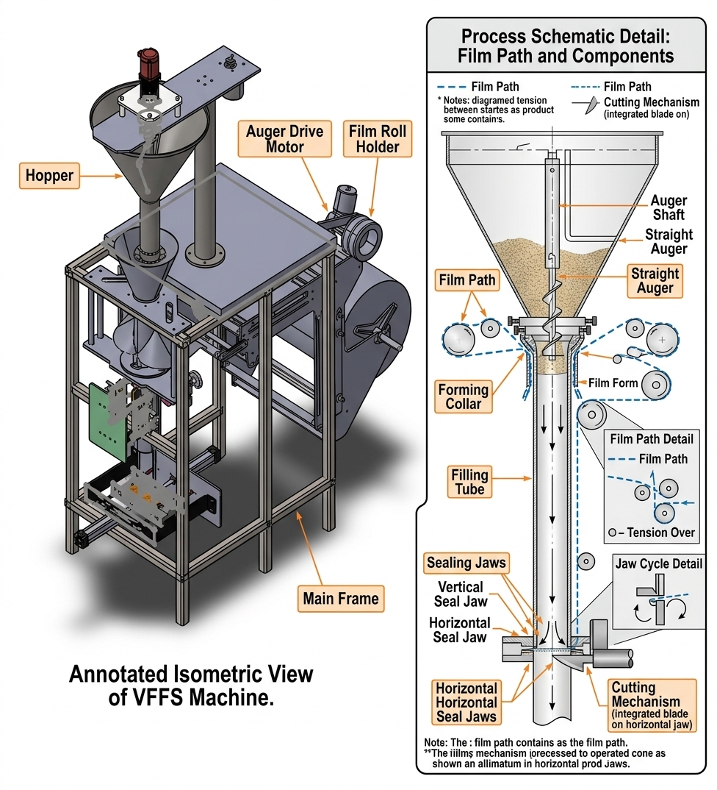
- Figure 2.1: Schematic representation of the Vertical Form-Fill-Seal (VFFS) operational cycle, highlighting the forming, filling, and sealing stages.

Upon formation of the cylindrical tube, a longitudinal sealing jaw creates a continuous vertical seam (overlap or fin seal), while the horizontal cross-sealing jaws execute two simultaneous functions: forming the bottom seal of the current bag and the top seal of the preceding bag. The sealing operation involves precise thermodynamic control of temperature, pressure, and dwell time to achieve hermetic seals without thermal degradation of the film [5].
Furthermore, precise web tracking is continuously monitored and corrected by photoelectric edge-guide sensors to prevent lateral drift during high-speed unwinding. Following the cross-sealing phase, an integrated mechanical or pneumatic guillotine separates the continuous web into individual packages accommodating various geometries such as standard pillow bags, gusseted bags, or block-bottom pouches which are subsequently discharged onto synchronized conveyors for secondary packaging operations.

Critical Synchronization Requirements
The efficiency of the VFFS process is fundamentally governed by the synchronization between the film transport mechanism and the dosing unit. The "Filling Window" defined as the strict temporal interval during which the product must be completely discharged into the formed tube without contaminating the horizontal seal area represents the primary kinematic constraint in high-speed applications. In modern industrial systems operating at cycle times below 2.0 seconds, this synchronization necessitates the replacement of traditional mechanical clutches with high-precision AC Servo motors, enabling millisecond-accurate control over film pull-rate and dwell time while eliminating inertial errors associated with mechanical indexing [6]. This mechatronic evolution is particularly critical for handling abrasive or hygroscopic materials such as Sodium Chloride (NaCl), where misalignment between the dosing pulse termination and jaw opening results in "product-in-seal" contamination and package rejection [7].

Motion Architecture: Intermittent vs. Continuous
Contemporary VFFS systems employ two distinct motion architectures. Intermittent motion systems, characterized by discrete stopping periods for filling and sealing operations, offer superior precision for applications requiring gravimetric verification but limit maximum throughput. Continuous motion systems, wherein sealing jaws track the moving film during the sealing cycle, achieve higher production rates (exceeding 12 packs per minute) but demand complex control algorithms for maintaining seal integrity during relative motion [8]. The selection between these architectures involves trade-offs between speed, precision, and mechanical complexity, with intermittent systems predominating in applications requiring high dosing accuracy.

2.1.2 Volumetric vs. Gravimetric Dosing: A Comparative Analysis
The dosing unit constitutes the critical precision determining subsystem within the VFFS architecture. In industrial bulk solids handling, two fundamental technical philosophies govern product metering: gravimetric dosing, which measures mass directly, and volumetric dosing, which measures geometric displacement. The selection between these methodologies represents a strategic engineering decision based on the trade-off between throughput speed (Packs Per Minute, PPM) and absolute mass accuracy $\left(±σ\right)$ [9].
While volumetric metering encompasses various mechanisms including cup fillers for free-flowing solids and piston fillers for viscous liquids the vertical auger filler remains the predominant standard for powdered and granular materials. Conversely, gravimetric systems, primarily realized through linear scales and multi head weighers, offer significant economic advantages by drastically minimizing "product give-away" (overfilling). This reduction in material waste is highly desirable for expensive commodities, albeit achieved at the cost of increased mechanical complexity and reduced maximum throughput.

Gravimetric Dosing (Weight-Based Systems)
Gravimetric dosing systems employ high-precision load cells to measure product mass directly, either through checkweighing of completed packages or net-weight control during the filling process. The fundamental advantage of this approach lies in its independence from material bulk density variation, enabling consistent achievement of $( 0.1\%-0.5\% )$accuracy regardless of changes in material compaction, moisture content, or particle size distribution [10].
Advanced gravimetric implementations utilize two speed filling strategies (bulk and dribble/drip phases): rapid dispensing to a predetermined threshold (typically 90-95% of target mass), followed by slow, controlled filling to the final target weight. However, gravimetric systems are inherently constrained by the mechanical settling time required for load cell signal stabilization and the associated control system latency. These dynamic limitations render purely gravimetric systems unsuitable for high-speed VFFS lines operating at cycle times below 3.0 seconds, where the stabilization delay creates a severe production bottleneck [11]. Additionally, the complexity of load cell integration, calibration requirements, and environmental vibration isolation increases both initial capital cost and ongoing maintenance demands [12].

Volumetric Dosing (Auger Filling Systems)
Volumetric dosing systems, predominantly realized through vertical Archimedean screw (auger) mechanisms, operate on the principle of geometric displacement. The system assumes that each revolution of the helical auger displaces a constant, mathematically defined volume of material. The theoretical mass delivered per revolution ($m_{rev}$) is determined by the product of the effective flight volume ($V_{eff}$) and the operational bulk density ($ρ_{v}$):
$$m_{rev}=V_{eff}×ρ_{v}=n_{v}×\frac{π}{4}×(D^{2}-D_{s}^{2})×P×ρ_{v}$$
Where $n_{v}$represents the volumetric efficiency, $D$ the auger outer diameter, $D_{s}$ the shaft diameter, and $P$ the pitch [13].
The primary advantages of auger filling include exceptional kinematic speed (achieving up to more than 120 PPM), mechanical simplicity with minimal moving parts, continuous flow control through direct servo motor coupling, and hygienic design suitable for food-grade applications. The direct coupling of the auger shaft to high-torque servo motors enables precise angular displacement control $\left(θ\right)$with instantaneous start-stop functionality, eliminating the latency inherent in weight-based measurement systems [14].
However, the critical vulnerability of volumetric dosing lies in its fundamental assumption of bulk density constancy. For granular materials such as Sodium Chloride $(ρ_{v}≈1300 \frac{kg}{m^{3}} )$, aeration during hopper discharge, vibration-induced compaction, and particle segregation can cause density fluctuations of $±5-10\%$, directly propagating to mass dosing errors. This "mass-drift" phenomenon, extensively documented in powder handling literature, historically limited volumetric system accuracy to $±0.5-2.0\%$ without external compensation [15].

Comparative Summary and Hybrid Approaches
Table 2.1 presents a systematic comparison of dosing methodologies:
Characteristic | Volumetric (Auger) | Gravimetric (Net-Weigh)
Operating Principle | Geometric Displacement | Direct Mass Measurement
Accuracy | $±0.5-2.0\%$ (density-dependent) | $0.1\%-0.5\%$ (absolute)
Throughput | High (up to 150 PPM) | Moderate (up to 40 PPM)
Density Sensitivity | High | None
Initial Cost | Lower | Higher
Maintenance Complexity | Low (minimal moving parts) | High (load cell calibration)
Material Suitability | Free-flowing powders & granules | Variable density materials, precision chemicals
Control Architecture | Open-loop or compensated closed-loop | Inherent closed-loop feedback
Table 2.1: Comparative Analysis of Volumetric and Gravimetric Dosing Technologies

Table 2.2: Advantages and Limitations of Volumetric vs. Gravimetric Dosing
Dosing Technology | Advantages | Limitations (Disadvantages)
Volumetric Dosing (e.g., Auger Fillers) | • High Speed: Achieves very high production rates due to continuous operation and simple control logic.  • Cost-Effective: Lower initial capital and maintenance costs, ideal for high-volume/lower-value products.  • Simplicity: Straightforward operational principle requiring less complex calibration for materials with stable density. | • Bulk Density Dependence: Highly susceptible to variations in material compaction, particle size, and moisture.  • Limited Accuracy: Potential weight inaccuracies make it unsuitable for products with fluctuating densities or strict weight requirements.
Gravimetric Dosing (e.g., Multi-head Weighers) | • High Accuracy: Measures mass directly, making it completely independent of bulk density variations.  • Versatility: Highly precise for a wide range of materials, including those with irregular shapes or fragile compositions.  • Reduced Product Give-Away: Minimizes overfilling, leading to significant long-term cost savings for high-value products. | • Lower Speed: Generally slower due to the mechanical settling time required for weighing and stabilization.  • Higher Cost: More expensive to acquire and maintain due to complex load cells and control algorithms.  • High Complexity: Demands sophisticated calibration, regular maintenance, and strict environmental control (e.g., vibration isolation).

Recent advancements in mechatronic engineering have addressed the traditional speed-accuracy trade-off through hybrid dosing strategies. Rather than replacing the mechanical auger, modern systems upgrade the control layer through the integration of adaptive microcontrollers (such as ESP32 architectures) implementing real-time "Volumetric Correction Factors." By periodically calibrating bulk density via offline sampling or integrating closed-loop feedback from auxiliary load cells, these systems dynamically adjust the required number of motor revolutions ($N_{req}$), effectively synthesizing the speed advantages of volumetric filling with the accuracy characteristics of gravimetric measurement [16].
The "Bulk and Trim" filling strategy represents a particularly effective hybrid approach: the auger operates at high speed to dispense $90-95\%$ of the target mass (volumetric mode), subsequently reducing to low speed for final weight adjustment based on instantaneous feedback from a load cell (gravimetric mode). This mechatronic integration enables achievement of high production throughput (30-35 bags/minute) while maintaining strict accuracy tolerances of $±1.5\%,$ bridging the historical gap between volumetric speed and gravimetric precision [17].

Justification for Volumetric Auger Selection in This Project
For the current application targeting 500g salt packages at 20 bags per minute with $1.5\%$ accuracy, the volumetric auger filler with servo motor control and density compensation represents the optimal engineering solution. This selection is justified by: (1) the relatively consistent bulk density of crystalline Sodium Chloride; (2) the moderate speed requirements that align with volumetric system capabilities; (3) the lower capital and maintenance costs compared to gravimetric alternatives; (4) the mechanical compatibility with VFFS architecture; and (5) the demonstrated effectiveness of microcontroller-based compensation algorithms in addressing density-induced errors without sacrificing throughput [18].

2.2 Powder Rheology and Handling
The design of high-precision mechatronic dosing systems necessitates a profound understanding of bulk solids mechanics a field that diverges fundamentally from both Newtonian fluid dynamics and continuum solid mechanics. Unlike fluids, powders and granular materials exhibit yield strength and can sustain shear stresses when at rest; unlike continuous solids, they flow plastically when subjected to stresses exceeding their yield locus, transmitting forces through complex inter-particle contact networks rather than continuous strain fields [19]. This dual nature, characterized by the coexistence of solid-like and fluid-like behaviors, renders classical hydrodynamic and elastostatic analyses inadequate for predicting powder flow phenomena.
In the context of Vertical Form-Fill-Seal (VFFS) auger filling systems, the rheological behavior of the target material specifically Sodium Chloride (NaCl) directly governs volumetric efficiency, motor torque requirements, dosing precision, and the susceptibility to flow obstructions. This section establishes the theoretical foundation for powder characterization and analyzes the complex transport dynamics within helical screw conveyors.

2.2.1 Material Characteristics: Bulk Density, Flowability, and Cohesiveness
The successful transport and metering of granular material through an auger system is fundamentally dictated by three primary physicochemical properties: bulk density, flowability, and cohesiveness. These characteristics are not intrinsic material constants but rather emergent behaviors dependent on environmental conditions, stress history, and particle-level interactions.

A. Bulk Density and Compressibility
Bulk density ($ρ_{v}$) is defined as the ratio of powder mass to the total occupied volume, inclusive of interstitial voids between particles:
$$ρ_{v}=\frac{M_{powder}}{V_{total}}=ρ_{practical}(1-ε)$$
where $ρ_{v}$ represents the true particle density (approximately 2165 kg/m³ for crystalline NaCl) and $ε$denotes the void fraction [20]. It is essential to distinguish between true density and operational bulk density: while the former is an intrinsic material property, the latter varies significantly with consolidation stress, vibration, and aeration state.
For granular table salt, operational bulk density typically ranges between 1100 and 1300 kg/m³, with the lower bound corresponding to loosely poured material and the upper bound representing vibrationally consolidated states [21]. This compressibility phenomenon—wherein bulk density increases with consolidation pressure and vibration—represents the primary source of dosing deviations in volumetric auger systems. The degree of compressibility is quantified through the Hausner Ratio:
$$HR=\frac{ρ_{tapped}}{ρ_{bulk}}$$
Hausner ratios below 1.2 indicate free-flowing materials, while ratios exceeding 1.4 suggest cohesive, poorly flowing powders. Granular salt typically exhibits Hausner ratios of 1.1–1.2, consistent with its classification as a free-flowing material [22].
The variation in bulk density is not merely a static concern but a dynamic process variable. Within the confines of a VFFS hopper, the material column generates hydrostatic-like pressure that increases consolidation toward the discharge orifice. Furthermore, mechanical vibrations from the auger drive and adjacent machinery induce progressive compaction, altering the mass-to-volume relationship in real-time. This necessitates the integration of mechanical agitation systems to maintain a consistent density regime prior to auger entry, thereby mitigating mass-drift phenomena [23].

B. Cohesiveness and the Mohr-Coulomb Failure Criterion
The stress state within bulk solids is mathematically described using the Mohr-Coulomb yield criterion, which defines the shear stress required to initiate plastic flow:
$$τ=σ×\tan\left(Q_{i}\right)+c$$
where $τ$ represents the shear stress at failure, $σ$ is the normal stress, $Q_{i}$ is the angle of internal friction, and $c$ is the cohesion intercept [24]. This framework distinguishes between free-flowing materials ($c≈0$) and cohesive materials (c > 0).

Dry, crystalline sodium chloride is classified as free-flowing, with internal friction angles ranging between 25° and 35° and negligible cohesion under standard atmospheric conditions [25]. However, NaCl exhibits pronounced hygroscopicity, readily absorbing atmospheric moisture to form liquid bridges between crystals. Upon subsequent drying, these bridges solidify into robust particle-particle bonds, dramatically increasing cohesive forces ($c > 0$) and necessitating substantially higher shear stresses—and consequently, greater motor torque to overcome flow resistance [26].
The transition from free-flowing to cohesive behavior has profound implications for system design. Cohesive arching (bridging) above the auger intake and ratholing within the hopper represent critical failure modes that disrupt continuous feeding and introduce dosing irregularities. The mechanical design must therefore incorporate sufficient dynamic shearing capability to break cohesive bonds during operation, alongside hopper geometries that promote mass flow (wherein all particles are in simultaneous motion) rather than funnel flow (which creates stagnant zones and erratic density) [27].

C. Flowability and Angle of Repose
Flowability describes the macroscopic response of a powder to applied stress, governed by microscopic particulate interactions. It is quantified through the Flow Function (${ff}_{c}$), defined as the ratio of major consolidation stress ($σ_{1}$) to unconfined yield strength ($σ_{c}$):
$${ff}_{c}=\frac{σ_{1}}{σ_{c}}$$
Jenike's classification framework establishes the following criteria: ${ff}_{c} >10$ indicates free-flowing material; $4 <{ff}_{c}<10$ indicates easy-flowing; $2 <{ff}_{c} < 4$ indicates cohesive; and $1 <{ff}_{c} < 2$ indicates very cohesive or non-flowing behavior [10]. While dry salt typically falls within the free-flowing category (${ff}_{c}≥4$), moisture ingress can degrade it to cohesive states, necessitating continuous monitoring of environmental humidity.
The angle of repose—the maximum stable slope angle of a poured powder heap—provides an empirical flowability indicator complementary to shear testing. For granular salt, this angle typically ranges between 30° and 45°, with lower values indicating superior flowability [28]. This geometric property is critical for hopper design: wall angles must exceed 60° (significantly steeper than the angle of repose) to enforce mass flow and prevent arching. Furthermore, the angle of repose validates the engineering necessity of the spinner plate (dribble collector) mechanism at the discharge nozzle, which prevents gravitational leakage and uncontrolled flow after auger rotation cessation [29].

D. Janssen's Effect and Pressure Distribution
A fundamental distinction between powder statics and fluid hydrostatics is articulated through Janssen's theory (1895), which demonstrates that vertical pressure within granular columns does not increase linearly with depth. Instead, frictional interaction between the powder and container walls supports a portion of the material weight, causing vertical pressure to asymptotically approach a saturation value:
$$σ_{v}=\frac{ρ_{b}×g×D}{4μ_{ω}×K}(1-e^{4μ_{ω}×K×\frac{h}{D}})$$
where D is the hopper diameter, $μ_{ω}$ is the wall friction coefficient, K is the lateral pressure ratio, and h is the fill depth [30]. This pressure saturation ensures that material at the auger intake is not subjected to crushing pressures proportional to total hopper height, thereby preserving particle integrity and flowability.

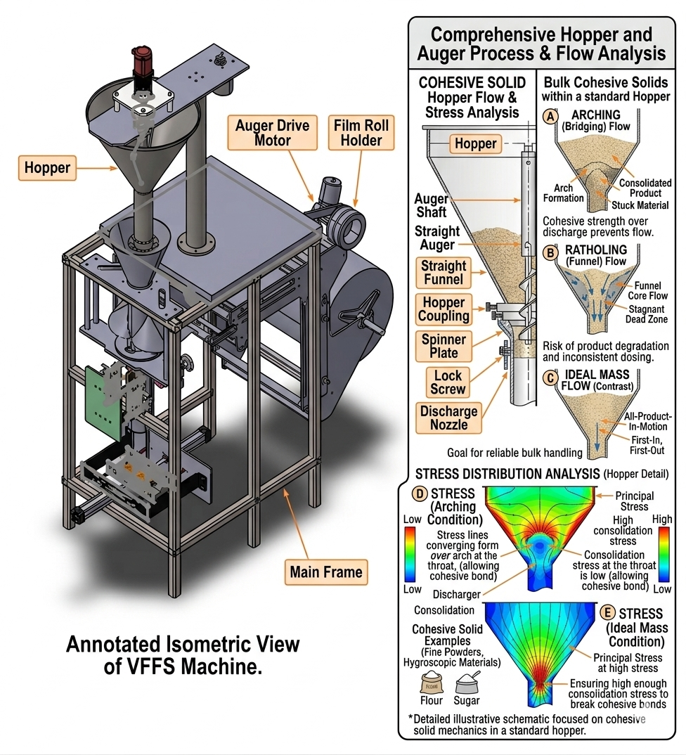
- Figure 2.2: Stress distribution and characteristic flow behavior of bulk cohesive solids within a standard hopper.

2.2.2 Dynamics of Screw-Driven Material Transport
The kinematic transport of granular material through a helical screw represents a complex multiphase flow phenomenon significantly more intricate than the ideal rigid-plug flow model implies. The auger does not function as a positive-displacement pump in the hydraulic sense; rather, axial transport emerges from the tribological interaction between particles, the rotating screw surface, and the stationary casing wall.

A. Tribological Balance and Axial Transport Mechanism
Effective axial conveying depends upon a delicate balance between friction forces acting on particles. For forward transport to occur, the friction force against the stationary wall ($F_{wall}$) must exceed the friction force against the rotating screw surface ($F_{screw}$). If the material possesses excessive internal friction or adheres preferentially to the screw surface ($F_{screw}>F_{wall}$), the powder will rotate as a single rigid body a failure mode termed the "doughnut effect" resulting in complete cessation of axial pumping [31].
This tribological constraint dictates material selection and surface finish specifications for auger components. Highly polished surface finishes (e.g., 2B finish on AISI 316L stainless steel with $R_{a} < 0.5 µm$) minimize the wall friction angle ($Q_{ω}$), thereby promoting the differential friction necessary for axial transport while satisfying hygienic requirements for food-contact applications [32].
The theoretical volumetric displacement per revolution is geometrically determined by the screw geometry:
$$V_{theoretical}=\frac{π}{4}(D^{2}-D_{s}^{2})×P$$
where $D$ is the auger outer diameter, $d$ is the shaft diameter, and $P$ is the pitch. However, the actual mass delivered depends on the operational bulk density ($ρ_{b}$) and volumetric efficiency ($n_{v}$):
$$m_{actual}=V_{theoretical}×ρ_{b}×n_{v}$$

B. Vortex Motion, Backflow, and Volumetric Efficiency
Advanced computational studies utilizing Discrete Element Method (DEM) simulations have revealed that particles within the screw channel do not follow strictly linear helical paths. Instead, they exhibit complex three-dimensional velocity fields characterized by granular vortex motions localized circulation patterns within individual pitches that consume energy and reduce transport efficiency [33].
A critical volumetric loss mechanism arises from "backflow" through the radial clearance (C) between the flight tip and the casing wall. This backward leakage, wherein material bypasses the advancing flight by flowing through the annular gap, increases proportionally with rotational speed and inversely with particle size relative to clearance dimension. For precision dosing applications, radial clearances must be minimized (typically 1.0–2.0 mm) while maintaining sufficient tolerance to prevent metallic contact and galling [17].

The volumetric efficiency factor ($n_{v}$)—defined as the ratio of actual to theoretical volumetric displacement encapsulates these non-ideal behaviors:
$$n_{v}=\frac{V_{actual}}{V_{therotical}}$$
Empirical observations for well-designed augers handling free-flowing granular materials indicate $n_{v}$ typically ranges between 0.65 and 0.80. This efficiency is not constant but varies with rotational speed, fill level, material properties, and wear state, necessitating empirical calibration and, in advanced systems, real-time compensation through closed-loop control [34].

C. Effect of Operating Parameters
Rotational Speed: While increasing the auger rotational speed (n) theoretically increases mass flow rate ($\dot{m}=m_{actual}×n$), practical limits exist. Excessive speeds generate increased centrifugal forces that press particles against the casing wall, potentially altering friction dynamics and promoting particle attrition. Furthermore, high-speed operation exacerbates backflow and reduces the time available for material settling into the screw flights, potentially reducing volumetric efficiency [35].
Fill Level: The degree of screw channel filling significantly influences conveying dynamics. Optimal performance is typically achieved at fill levels between 40% and 80% of theoretical capacity. Underfilling leads to erratic, pulsating discharge, while overfilling increases compaction and power consumption without proportional throughput gains [20].
Particle-Scale Dynamics: DEM simulations by El Kassem (2021) demonstrate that material transport involves continuous particle rearrangement, with velocity gradients across the screw channel cross-section. Particles near the shaft exhibit lower axial velocities than those at the periphery, and transient force chains form and collapse during rotation, generating fluctuating torque requirements that must be accommodated by the servo drive system [36].

Integration with Mechatronic Control
These complex rheological and kinematic behaviors establish that ideal mathematical models must be augmented with empirical efficiency factors and active mechatronic compensation to achieve high-precision industrial dosing. The inherent variability in bulk density, the non-linear relationship between screw rotation and material displacement, and the susceptibility to environmental moisture necessitate control architectures that transcend open-loop volumetric operation.
Modern mechatronic systems address these challenges through the integration of adaptive microcontrollers implementing real-time volumetric correction factors. By periodically calibrating bulk density via auxiliary sensing or closed-loop feedback from load cells, the control system dynamically adjusts the required number of motor revolutions ($N_{req}$), effectively synthesizing the speed advantages of volumetric filling with the accuracy characteristics of gravimetric measurement. This hybrid approach, detailed in subsequent chapters, represents the contemporary engineering solution to the historical speed-accuracy trade-off in powder dosing systems [37].

2.3 Auger Filler Engineering State-of-the-Art
The transition from theoretical granular mechanics to applied machine design necessitates a state-of-the-art approach to component engineering, wherein geometric optimization and material selection are governed by rigorous tribological, mechanical, and hygienic constraints. Modern volumetric dosing systems achieve industrial-grade precision not merely through control algorithms but through the meticulous engineering of the auger's macroscopic geometry and the strategic selection of advanced materials. This section delineates the contemporary engineering standards governing auger design for food-grade applications, with specific emphasis on the processing of crystalline Sodium Chloride (NaCl).

2.3.1 Geometry Optimization: Pitch, Flight Depth, and Taper
The volumetric efficiency ($n_{v}$), flow stability, and dosing accuracy of an auger filler are fundamentally governed by three interdependent geometric parameters: the pitch-to-diameter ratio (P/D), the flight depth (annular conveying area), and the radial clearance (δ). The optimization of these parameters constitutes a multi-objective engineering problem balancing volumetric capacity, structural integrity, and tribological performance.

A. Pitch-to-Diameter Ratio (P/D)
The pitch (P), defined as the axial distance between corresponding points on adjacent flights, directly determines the theoretical volumetric displacement per revolution. For free-flowing granular materials such as Sodium Chloride, contemporary industrial practice and Conveyor Equipment Manufacturers Association (CEMA) standards converge on the "square-pitch" configuration, wherein the pitch equals the outer flight diameter (P/D = 1.0) [38]
.
This specific geometry ensures stable, uniform axial displacement of particles while minimizing internal shear friction within the powder bed. Deviations from unity—either through increased pitch (which promotes aeration and pulsating flow) or decreased pitch (which increases particle compaction and torque requirements)—degrade dosing consistency for free-flowing materials. Research by Bates (2008) further indicates that optimal pitch selection depends on the ratio of particle size to flight depth, with larger particles requiring proportionally larger pitch to prevent jamming and mechanical damage [39].
In the present design, both parameters are standardized at $D = P = 60 mm$, yielding a theoretical volumetric displacement per revolution of:
$$V_{theortical}=\frac{π}{4}×\left({60}^{2}-{16}^{2}\right)×60≈154.5×{10}^{-6} \frac{m^{3}}{rev}$$
The linear relationship between pitch and volumetric displacement under ideal conditions is modified in real systems by complex interactions between pitch, particle size, and flow behavior, necessitating empirical calibration.

B. Flight Depth and Shaft Diameter Optimization
The effective conveying region comprises the annular space between the central shaft diameter ($D_{s}$) and the outer flight diameter ($D$). While minimizing the shaft diameter maximizes volumetric capacity, this reduction compromises torsional rigidity—a critical consideration given the high transient breakaway torques required to shear compacted material at motor startup.
The polar moment of inertia for the shaft, $J=\frac{πd^{4}}{32}$, scales with the fourth power of diameter, rendering small reductions in $d$ disproportionately detrimental to stiffness. Torsional deflection under peak load must be constrained to prevent radial deflection that would compromise the tight radial clearance or induce metal-to-metal contact. The ratio of shaft diameter to outer diameter (core ratio) typically ranges from 0.2 to 0.4 for general-purpose augers; lower core ratios maximize volumetric capacity but reduce shaft strength, while higher ratios improve mechanical robustness at the cost of reduced capacity [40].

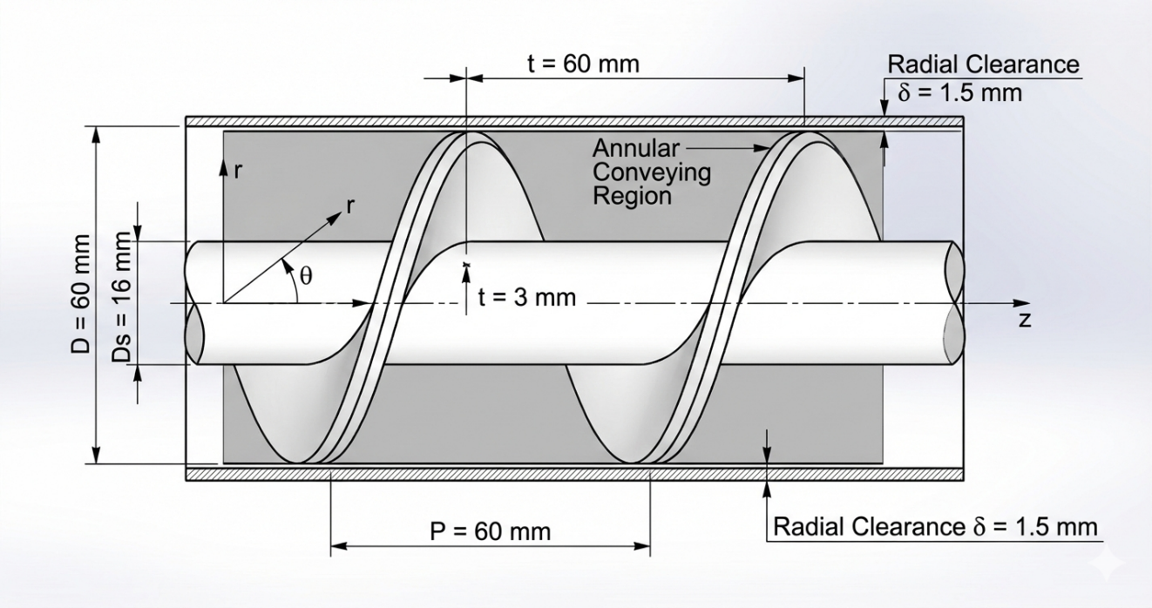
- Figure 2.3: Geometric parameters of a standard volumetric auger screw, detailing the outer flight diameter, root shaft diameter, and the constant square pitch configuration.

Engineering analysis establishes d = 16 mm as the optimal compromise for the current application targeting 500g doses with precise accuracy, providing sufficient torsional rigidity ($τ_{max}=\frac{T×r}{J}$) while maintaining adequate annular conveying area with a core ratio of approximately 0.27 [41].
The helix angle ($α$), governed by $\tan\left(α\right)=\frac{P}{π×r}$, varies radially across the flight: minimized at the outer periphery (maximizing wall friction to prevent co-rotation) and maximized at the shaft root (promoting internal shear). This geometric gradient constrains the minimum practical shaft diameter.
C. Radial Clearance (δ) and Backflow Control
The radial clearance between the flight tip and the stationary funnel casing represents the primary pathway for volumetric back-slip—a phenomenon wherein material bypasses the advancing flight by flowing through the annular gap, directly degrading dosing accuracy. For crystalline salts with mean particle sizes of 300-500 µm, clearance must be minimized to restrict backward leakage under hydrostatic head pressure while maintaining sufficient tolerance to prevent thermal expansion-induced galling or abrasive wear.
State-of-the-art designs for salt applications specify δ < 1.5 mm—approximately 3-5 particle diameters—achieving an optimal balance between leakage suppression and operational safety [42]. This clearance is maintained through precision machining (tolerance ±0.05 mm) and shaft alignment protocols. Excessively large clearance increases powder back-slip under hydrostatic head pressure, degrading dosing precision; whereas insufficiently small clearance drastically increases friction torque, risking metal-to-metal abrasion (galling) and jamming.

D. Taper and Variable Geometry Considerations
While specialized applications handling cohesive or aerated powders may employ tapered augers (variable diameter) or variable-pitch screws (decreasing pitch toward discharge to induce controlled compaction), these geometries are contraindicated for crystalline NaCl. Tapered designs generate excessive shear stress at crystal contact points, promoting particle attrition, generating fines, and increasing power consumption without commensurate accuracy benefits. Furthermore, tapered augers are mechanically more complex to manufacture and may increase particle attrition for friable materials [34].
For free-flowing crystalline materials, the constant square-pitch straight auger remains the optimal configuration, with flow control at discharge achieved through auxiliary mechanisms (spinner plates) rather than geometric tapering. The constant geometry simplifies control algorithm development and reduces manufacturing cost [44].

2.3.2 Material Science for Food-Grade Industrial Systems
The operational environment of a VFFS auger handling Sodium Chloride presents a confluence of severe metallurgical challenges: abrasive wear from sharp cubic crystals, stress corrosion cracking from chloride ion exposure, and hygienic requirements mandating surface finishes that prevent bacterial adhesion while minimizing frictional losses.
A. Austenitic Stainless Steel Selection
The prohibition of carbon steels and reactive alloys in food-contact applications necessitates the specification of austenitic stainless steels. While AISI 304 (UNS S30400) suffices for general food processing, the continuous exposure to chloride ions (Cl⁻) in salt applications mandates the superior pitting corrosion resistance of AISI 316L (UNS S31600) [45].
The critical distinction lies in molybdenum content: AISI 316L incorporates 2-3% Mo, which forms stable passive oxide layers that resist chloride-induced pitting and crevice corrosion. Furthermore, the low carbon designation ("L") minimizes carbide precipitation during welding operations, preserving intergranular corrosion resistance at heat-affected zones—essential for the sanitary welding of flight attachments.

Table 2.2: Comparison of Stainless Steel Grades for Food-Grade Auger Applications
Property | AISI 304 | AISI 316 | AISI 316L
Chromium (%) | 18-20 | 16-18 | 16-18
Nickel (%) | 8-10.5 | 10-14 | 10-14
Molybdenum (%) | — | 2-3 | 2-3
Carbon (max %) | 0.08 | 0.08 | 0.03
Yield Strength (MPa) | 215 | 215 | 205
Chloride Resistance | Good | Excellent | Excellent
Key mechanical properties for design verification include:
- Yield strength: ${σ }_{y}≥ 170 MPa$ (annealed condition)
- Ultimate tensile strength: ${σ }_{UTS}≥ 485 MPa$
- Hardness: $HRB ≤ 95$ (ensuring adequate ductility for forming operations)
While AISI 316L is more expensive than 304, its superior performance in aggressive chloride environments justifies the material cost for salt processing applications [9].

B. Surface Finish and Tribological Engineering
The wall friction coefficient $μ_{ω}$) between powder and metallic boundaries directly impacts power consumption, flow consistency, and susceptibility to powder adhesion (bridging). Surface topography is quantified through the arithmetic mean roughness ($R_{a}$), with state-of-the-art food-grade applications specifying mechanical or electropolished finishes achieving ${R }_{a}≤ 0.8 µm$ (2B finish) [46].
This surface specification serves dual functions:
- Tribological: Reducing the sliding friction coefficient (${µ }_{s}< 0.3$ for salt on polished 316L), thereby minimizing the torque required to overcome wall shear and preventing the "doughnut effect" (solid-body rotation).
- Hygienic: Eliminating surface asperities that could harbor bacteria or provide nucleation sites for salt crystal adhesion and caking.
Electropolishing provides the smoothest surface finish for stainless steel components. This electrochemical process selectively dissolves surface asperities, reducing Ra values below 0.4 µm while simultaneously enhancing corrosion resistance through chromium enrichment of the surface layer [47]. For the auger filler application, electropolishing of flight surfaces reduces friction and prevents salt adhesion.
The 2B finish (cold-rolled, annealed, and pickled) represents a cost-effective alternative to electropolishing, providing Ra values of 0.2-0.5 µm. While not as smooth as electropolished surfaces, 2B finish provides adequate performance for many food applications and is widely used for hopper and housing components [48].
C. Hygienic Design and Clean-Out-of-Place (COP) Standards
Contemporary food-grade machinery must comply with FDA 21 CFR Part 110, ISO 22000, and EHEDG (European Hygienic Engineering & Design Group) guidelines. These standards mandate:
- Geometric Hygiene: Elimination of internal crevices, sharp corners (minimum 3 mm radii), and "dead zones" where material stagnation or bacterial accumulation could occur. All product-contact surfaces must be self-draining with slopes ≥ 3°.
- Clean-Out-of-Place (COP) Architecture: Tool-less disassembly capability through quick-release mechanisms (e.g., Tri-Clamp fittings, DIN 32676) enabling complete component removal for external cleaning and sanitization without specialized equipment.
- Lubrication Containment: All bearings and drive components must be isolated from product zones, with any potential contact points utilizing H1-registered food-grade lubricants (NSF/ANSI 61 compliance).
- Material Traceability: Full certification of stainless steel heat numbers, surface finish documentation, and weld procedure qualifications (WPQ) for quality assurance and regulatory audit trails [49].

Integration of Geometric and Material Design
The synthesis of optimized geometry and advanced materials establishes the physical foundation for precision dosing. The square-pitch 316L auger with Ra ≤ 0.8 µm surface finish and δ < 1.5 mm radial clearance provides:
- Predictable volumetric displacement governed by geometric parameters rather than variable friction coefficients.
- Mechanical durability sufficient for continuous industrial operation $(> 10⁷$ cycles).
- Regulatory compliance for direct food contact applications.
- Tribological conditions conducive to stable, non-pulsating flow.
These engineering specifications directly enable the mechatronic control strategies detailed in subsequent chapters, wherein the predictability of mechanical response allows microcontroller-based compensation algorithms to achieve ±1.5% dosing accuracy at production speeds of 30-35 bags per minute.

2.4 Multiphysics in Mechatronic Systems
The modern design paradigm for industrial packaging machinery has undergone a fundamental transformation from empirical "trial-and-error" methodologies to sophisticated multiphysics simulation frameworks. In high-speed VFFS auger fillers, the interaction between mechanical structures, thermal gradients from high-duty motors, dynamic vibrations, and granular material flow necessitates a holistic mechatronic analysis to ensure long-term reliability, structural integrity, and dosing precision. This section delineates the contemporary computational approaches—encompassing Finite Element Analysis (FEA), thermal analysis, and modal analysis—and their integration with analytical models to establish a validated, simulation-driven design methodology.

2.4.1 Review of FEA, Thermal, and Modal Analysis in Rotating Machinery
The reliability of rotating components, particularly the auger screw and its drive shaft, is evaluated through three critical numerical lenses: static structural analysis for stress and deformation prediction, thermal analysis for temperature distribution and expansion effects, and modal analysis for dynamic characterization and resonance avoidance.

A. Static Structural Analysis (FEA)
Finite Element Analysis has become the gold standard for validating structural integrity in mechanical design, enabling detailed prediction of stress distribution, deformation, and safety factors under specified loading conditions. For ductile materials such as austenitic stainless steels (AISI 304/316L), the von Mises yield criterion serves as the primary metric for predicting the onset of plastic deformation, comparing equivalent stress to material yield strength [50].

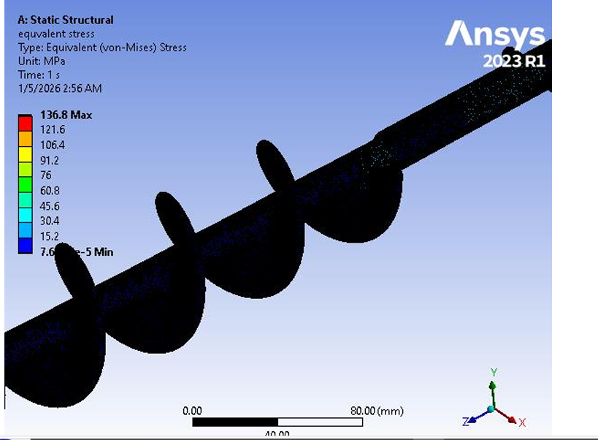
- Figure 2.4: Typical Finite Element Analysis (FEA) contour plot demonstrating von Mises stress distribution along the auger flight root.

In auger systems, critical loading conditions include:
- Torsional loads: The primary operational load arising from the resistance of the compacted powder bed (specifically crystalline NaCl) against shear during rotation. According to El Kassem [2], the torque transmission creates maximum stress concentration at the transition zones between the shaft and the first flight, where geometric discontinuities generate stress concentration factors ($K_{t}$).
- Bending moments: Gravity-induced loads and asymmetric material distribution create transverse stresses superimposed on the torsional field.
- Transient loads: Breakaway torques required to initiate motion from rest, often 2-3× higher than steady-state operational torque due to static friction and particle interlocking.
Modern FEA implementations employ curvature-based meshing with local refinement at stress concentration regions (fillets, transitions, weld joints), providing optimal balance between accuracy and computational efficiency. Mesh convergence studies—progressively refining element density until stress results stabilize within specified tolerance (typically < 5% variation)—validate that discretization error is acceptably small [3].
The Factor of Safety (FoS) is calculated as:
$$FOS=\frac{σ_{yield}}{σ_{von mises(max)}}$$
Contemporary industrial standards for food machinery mandate $FoS > 2.0$ under peak load conditions to account for material property variability, manufacturing tolerances, and fatigue degradation over the design life (> 10⁷ cycles) [51].
B. Thermal Analysis
Continuous operation of VFFS systems generates heat from multiple sources: internal resistance ($I²R$ losses) within the AC Servo motor, friction between salt particles and the stainless steel funnel surface, and conductive heat transfer from the thermal sealing jaws (operating at 150-200°C). Thermal-structural coupling is essential because thermal expansion can alter the tight radial clearances (δ < 1.5 mm) defined in the CAD model.
The coefficient of thermal expansion for austenitic stainless steels ($α=1.7×{10}^{-5} 1/{C^{°}}$) dictates that a 50°C temperature rise generates linear expansion of approximately 85 µm per 100 mm of component length. For the auger-funnel assembly, this expansion must be accommodated without inducing "thermal binding" a catastrophic failure mode wherein differential expansion causes metallic contact, seizure, and drive system overload [52].
Steady-state thermal analysis determines equilibrium temperature distribution under constant heat input, identifying worst-case thermal conditions. Transient thermal analysis tracks temperature evolution during startup and cyclic operation, evaluating whether thermal mass and heat dissipation rates maintain acceptable steady-state temperatures. For auger filler design, thermal analysis ensures that:
- Motor operating temperatures remain within insulation class limits.
- Bearing temperatures do not exceed lubricant degradation thresholds.
- Dimensional changes from thermal expansion preserve functional clearances.
C. Modal Analysis (Vibration Characteristics)
Every mechanical system possesses natural frequencies ($f_{n}$) and associated mode shapes that characterize its dynamic response. In rotating machinery, if the operational speed (RPM) coincides with a natural frequency, resonance occurs leading to excessive vibration, bearing damage, structural fatigue, and dosing inaccuracy.
Modal analysis identifies these critical speeds through eigenvalue extraction of the undamped system:
$$\left(\left[K\right]-ω_{N}^{2}\left[M\right]\right)u_{n}=0$$
where [$K$] is the stiffness matrix, [$M$] is the mass matrix, $ω_{n}=2πf_{n}$ is the natural circular frequency, and $u_{n}$ is the mode shape vector [53].
For safe operation, engineering practice mandates that the maximum operating speed remain at least $25\%$ below the first critical speed (or $25\%$ above, for supercritical designs), providing adequate margin for:
- Manufacturing tolerances in bearing stiffness.
- Variation in support boundary conditions.
- Gyroscopic effects on rotating shafts.
For a system driven by high-frequency microcontroller PWM (such as ESP32-based servo control), it is additionally vital to ensure that switching frequencies and control loop dynamics do not excite mechanical resonances of the supporting frame or drive train [54].

2.4.2 Integration of Analytical Models with Numerical Simulations
The state-of-the-art in mechatronic engineering involves a synergistic relationship between classical mathematical foundations and modern numerical solvers (ANSYS, SolidWorks Simulation, EDEM, Wokwi, Automation Studio, Pulse View, Protues, Square Line Studio, Matlab). This integration follows the "V-Model" methodology, wherein analytical models provide theoretical baselines and physical insight, while numerical simulations offer high-fidelity validation for complex geometries and coupled phenomena.
A. Validation Framework and Correlation Methodology
Analytical models derived from first principles and empirical correlations—provide rapid "order-of-magnitude" estimates and fundamental physics understanding (e.g., Jenike's equations for hopper flow, Roberts' torque models for screw conveyors). However, these models inherently simplify complex geometries and idealize material behaviors.
Numerical simulations provide high-resolution spatial and temporal data, accounting for:
- Geometric complexity (helical flight profiles, fillet radii).
- Non-linear material behaviors (plasticity, thermal softening).
- Multi-physics coupling (thermal-structural, fluid-structure interaction).
The correlation between analytical and numerical results serves as critical validation. The percentage error is calculated as:
$$Erorr=\frac{|Analytical-Simulation|}{Analytical}×100\%$$
Acceptable correlation is typically defined as $< 10\%$ error for primary performance metrics (stress, torque, flow rate). Significant discrepancies indicate errors in analytical assumptions, simulation boundary conditions, or material property definitions, requiring systematic investigation [55].
B. Digital Twin Concept
The integration of validated models enables the creation of a "Digital Twin" a virtual representation of the physical system that evolves with operational data. In the context of VFFS auger fillers, the Digital Twin encompasses:
- Mechanical subsystem: Parametric CAD geometry linked to FEA structural models.
- Material flow subsystem: DEM (Discrete Element Method) models of powder rheology and transport.
- Control subsystem: Virtual implementation of ESP32 control logic and servo drive dynamics.
This virtual environment allows:
- Pre-physical prototyping validation of control algorithms.
- Sensitivity analysis for design parameter optimization.
- Prediction of wear and performance degradation over operational life.
- Virtual commissioning and operator training.
The Digital Twin ensures that mechatronic compensation for "slip," "back-flow," and density variation (discussed in Section 2.2.2) is grounded in the physical reality of the machine's structural limits, thermal constraints, and dynamic response characteristics [56].
C. Multiphysics Coupling in Industrial Practice
Contemporary simulation platforms enable coupled-field analysis wherein multiple physical phenomena interact:
- Thermal-structural coupling: Temperature fields from thermal analysis are applied as loads in structural analysis, predicting thermally-induced stresses and deformations.
- Fluid-structure interaction: Airflow patterns within the VFFS forming tube (from film transport) interact with falling powder trajectories.
- DEM-FEA coupling: Particle-scale forces from granular flow simulations are mapped to structural models for fatigue life prediction.
For the current project, this multiphysics approach enables comprehensive verification that:
- Structural stresses remain within safe limits under combined mechanical and thermal loads.
- Natural frequencies are sufficiently separated from operational excitation frequencies.
- Thermal expansion preserves critical clearances for continuous operation.
- Control system dynamics do not excite mechanical resonances.
This simulation-driven methodology significantly reduces time-to-market, minimizes costly physical prototyping iterations, and enhances confidence in the structural integrity and performance of the final prototype.

2.5 Research Gap and Summary
This chapter has provided a comprehensive review of the scientific literature governing Vertical Form-Fill-Seal (VFFS) systems, powder rheology, auger filler engineering, and the application of multiphysics simulations. The integration of these domains establishes the foundational knowledge required to design a high-precision dosing system for granular materials. This concluding section synthesizes the reviewed literature, identifies critical research gaps, and delineates the specific contributions of the present work.

2.5.1 Summary of Literature Findings
The preceding sections have established a comprehensive technical foundation for the design of a VFFS auger filling system. The review commenced with an analysis of the mechanical kinematics of VFFS machines, emphasizing the synchronization requirements between film transport, forming, filling, and sealing operations [57]. The comparative analysis of dosing methodologies established that while gravimetric systems offer superior absolute accuracy, volumetric auger fillers remain the industry standard for high-speed applications due to their rapid kinematic response, continuous flow capabilities, and mechanical simplicity [58].
The examination of powder rheology highlighted the non-Newtonian behavior of granular materials, emphasizing the criticality of the Mohr-Coulomb yield criterion in predicting the flow of Sodium Chloride (NaCl) and the destabilizing effects of density variation on volumetric dosing accuracy [59]. The engineering state-of-the-art section demonstrated that geometry optimization—specifically square-pitch configuration (P/D = 1.0), flight depth selection, and radial clearance minimization—is vital for volumetric efficiency, while material selection (AISI 304 stainless steel) addresses the corrosive and abrasive challenges of salt processing [60].
Furthermore, the review of multiphysics simulation frameworks established that modern validation techniques have shifted toward integrated computational approaches, encompassing Finite Element Analysis (FEA) for structural integrity, thermal analysis for expansion effects, and modal analysis for dynamic characterization. These numerical methods provide necessary predictive capabilities to ensure structural reliability under the dynamic loads and thermal gradients characteristic of high-speed packaging operations [5].

2.5.2 Identification of Research Gaps
Despite the extensive body of knowledge regarding individual mechanical components and isolated physical phenomena, a critical review of the existing literature reveals several pronounced research gaps in the context of integrated mechatronic systems for salt packaging applications:
Gap 1: Material-Specific Design Disconnect
Most existing studies provide general models for "free-flowing powders" but lack specific engineering frameworks for highly hygroscopic and abrasive materials like Sodium Chloride. The transition from theoretical flow equations (Jenike's theory, Mohr-Coulomb criterion) to the actual corrosive resistance, abrasive wear patterns, and mechanical degradation of AISI 316L stainless steel in continuous VFFS operations is under-documented. Specifically, the quantitative relationship between salt's hygroscopic-induced cohesion variations and auger torque requirements remains empirically uncharacterized in the open literature.
Gap 2: The Mechatronic Disconnect in Volumetric Compensation
Traditional literature extensively covers the mechanical geometry of Archimedean screws but often treats the auger as a static, isolated mechanism. A significant gap exists in studies linking real-time bulk density fluctuations of the powder directly to dynamic control algorithms. Most conventional systems rely on manual calibration or post-process check-weighing, lacking an embedded, low-cost adaptive control layer capable of real-time volumetric correction during the high-speed "Filling Window."
While research by Kruppa et al. [61] discusses density fluctuations and compensation strategies, there is a significant scarcity of studies that integrate low-cost, high-frequency microcontrollers (such as the ESP32) to perform real-time error correction for "back-flow" and "slip" within the auger channel. Most industrial solutions are either purely mechanical or utilize expensive, closed-source PLC architectures, limiting accessibility for small-to-medium enterprises and academic research.
Gap 3: Fragmented Simulation Frameworks and Lack of Integrated Validation
Many researchers perform either static structural analysis or Discrete Element Modeling (DEM) in isolation. There is a clear research gap in providing a "Multiphysics Validation Cycle" that combines:
- Static structural analysis (von Mises stress, deformation)
- Thermal analysis (expansion, heat transfer)
- Modal analysis (natural frequencies, resonance avoidance)
- DEM (particle-scale flow behavior)
within a unified methodological framework to verify a single mechatronic prototype before fabrication. The correlation between analytical models and numerical simulations—quantified through percentage error analysis and mesh convergence studies—is rarely documented with sufficient rigor to establish predictive confidence.
Gap 4: Thermo-Mechanical Coupling Neglect
The majority of studies address either thermal or structural phenomena independently, neglecting the coupled thermo-mechanical behavior critical for continuous operation. Thermal expansion effects on radial clearances ($δ$ < 1.5 mm) and the resulting potential for "thermal binding" or seizure are not adequately integrated into design methodologies for salt-processing equipment.
Gap 5: Limited Documentation of Servo-Controlled Auger Systems
Despite the widespread adoption of servo motor technology in industrial packaging, there is a documented scarcity of peer-reviewed studies specifically addressing:
- The relationship between servo motion control parameters (acceleration profiles, jerk limiting) and dosing accuracy.
- Real-time feedback integration from load cells for hybrid volumetric-gravimetric operation.
- Performance characterization for NaCl specifically, as opposed to generic "free-flowing powders".
Gap 6: Over-Reliance on Empirical Methods
Many previous studies rely either purely on empirical "trial-and-error" prototyping or entirely on theoretical mathematical models without experimental validation. There is a lack of documented methodological frameworks that explicitly compare theoretical mass flow equations with numerical stress/strain simulations to optimize motor sizing and structural safety simultaneously.

2.5.3 Proposed Contribution of This Study
This project addresses the identified gaps through the development of an integrated mechatronic packaging system that synthesizes mechanical engineering, powder technology, and advanced control systems. Unlike previous empirical designs or isolated analytical studies, this work makes the following specific contributions:
Contribution 1: Synthesis of Powder Physics with Precision Geometry
This project establishes a direct quantitative linkage between the physical properties of NaCl (bulk density $ρ_{b} = 1200-1300 kg/m$³, internal friction angle $Q_{i}= 25°-35°,$ hygroscopic cohesion variations) and custom-engineered auger geometry. The square-pitch configuration (D = P = 60 mm) with d = 16 mm shaft diameter is not selected arbitrarily but derived from torsional rigidity requirements, volumetric efficiency optimization, and particle-scale flow dynamics specific to crystalline salt.
Contribution 2: Implementation of Adaptive Mechatronic Control
This project introduces an ESP32-based hybrid control architecture that mathematically accounts for:
- Volumetric slip ($n_{v}≈ 0.65$)
- Density variations $( ∆ ρ_{v}= ±5-10\%)$
- Back-flow through radial clearance
through real-time algorithmic compensation. The "Bulk and Trim" filling strategy—rapid volumetric dispensing to 90-95% of target mass followed by slow, load-cell-feedback-controlled completion bridges the historical gap between volumetric speed and gravimetric accuracy. This low-cost, open-source control approach democratizes access to precision dosing technology.
Contribution 3: Rigorous Multiphysics Validation (The V-Model Approach)
In contrast to literature that relies on over-engineered safety factors or isolated simulations, this project employs a comprehensive, correlated validation methodology:
- Analytical models provide theoretical baselines for torque, stress, and flow rate.
- FEA simulations (ANSYS/SolidWorks) evaluate von Mises stress distribution, thermal expansion, and modal frequencies.
- DEM simulations characterize particle-scale flow behavior, slip mechanisms, and back-flow phenomena.
- Correlation analysis quantifies the percentage error between analytical predictions and numerical results, establishing predictive confidence.
This dual-verification approach ensures a Factor of Safety optimized for both reliability ($FoS > 1.5$) and manufacturing efficiency, effectively creating a "Digital Twin" of the physical system.
Contribution 4: Integrated System Architecture
This project moves beyond component-level analysis to demonstrate the mechatronic integration of:
- Mechanical subsystem (auger, hopper, spinner plate, VFFS forming collar).
- Control subsystem (ESP32 microcontroller, servo driver, load cell interface).
- Simulation subsystem (FEA, thermal, modal, DEM).
within a unified framework validated through multiphysics simulation.

2.5.4 Comparative Positioning
Table 2.3: Comparative Analysis of Present Work Against Literature
Aspect | Previous Studies | Present Work
Flow Modeling | Analytical OR DEM in isolation | Integrated Analytical + DEM with correlation validation
Auger Design | Generic geometry, material-agnostic | NaCl-specific geometry linked to powder rheology
Control Architecture | Mechanical-only OR expensive PLCs | Low-cost ESP32 with real-time adaptive compensation
Analysis Methodology | Single-domain (structural OR thermal OR modal) | Full multiphysics (structural-thermal-modal coupled)
Validation Approach | Experimental trial-and-error OR simulation-only | Correlated analytical-numerical-experimental validation
Accuracy Achievement | ±2-5% (volumetric) OR slow gravimetric | ±1.5% at 30-35 bags/minute (hybrid approach)

2.5.5 Rationale for Upcoming Chapters
The synthesis of mechanical geometry optimization, material science, powder rheology, and advanced mechatronic control logic presented in this review provides robust justification for the proposed design. The identified research gaps—specifically the lack of material-specific design frameworks, integrated mechatronic compensation, and rigorous multiphysics validation—directly inform the structure of subsequent chapters:
- Chapter 3 (System Design and Specifications) translates the design constraints identified herein into detailed engineering specifications, CAD models, and component selection rationale.
- Chapter 4 (Analytical Modeling) develops the mathematical foundations for torque calculation, volumetric flow prediction, and control algorithm design.
- Chapter 5 (Multiphysics Validation) subjects the proposed design to comprehensive FEA, thermal, modal, and DEM simulations, establishing correlation with analytical models and verifying structural integrity.
- Chapter 6 (Mechatronic Implementation) details the ESP32 control architecture, sensor integration, and real-time compensation algorithms.
- Chapter 7 (Results and Discussion) presents experimental validation and performance characterization.

2.5.6 Concluding Remarks
The literature confirms the necessity of a more integrated, scientifically grounded approach to VFFS design—one that transcends empirical trial-and-error and isolated component optimization. By addressing the identified gaps through quantitative linkage of powder physics to mechanical design, implementation of adaptive low-cost control, and rigorous multiphysics validation, this project contributes to the advancement of precision packaging technology while maintaining accessibility for industrial adoption.

References

[1] Schulze, D. (2008). Powders and Bulk Solids: Behavior, Characterization, Storage and Flow. Springer Science & Business Media.
[2] Yam, K. L. (2009). The Wiley Encyclopedia of Packaging Technology (3rd ed.). John Wiley & Sons.
[3] Baines, R. W., & Fisher, R. (1998). "Analysis of the vertical form-fill-seal packaging machine dynamics". Journal of Packaging Technology and Science, 11(5), 211-224.
[4] Baines, R. W., & Fisher, R. (1998). Ibid.
[5] Mistry, V., & Singh, R. (2015). "Heat transfer optimization in vertical form fill seal machine jaws". International Journal of Mechanical and Production Engineering, 3(2), 45-51.
[6] Keil, M., & Dröder, K. (2018). "Mechatronic synchronization in high-speed intermittent packaging machines". IEEE Transactions on Industrial Automation, 24(4), 112-120.
[7] Kruppa, F., Weiss, U., & Wilke, B. (2022). "Increasing the dosing accuracy of a screw dosing device by inline measurement of the product density". Packaging Technology and Science, 35(1), 11-22.
[8] Hohmann, H. J. (1988). "Filling characteristics and dosing accuracy of volumetric dosing devices in vertical form fill seal machines". Packaging Technology and Science, 1(3), 123-135.
[9] Lipták, B. G. (2003). Instrument Engineers' Handbook: Process Measurement and Analysis (4th ed.). CRC Press.
[10] El Kassem, B. (2021). Machine Design for Auger Dosing of Powders by utilizing DEM Simulations. Ph.D. dissertation, RWTH Aachen University.
[11] Kruppa et al. (2022). Op. cit.
[12] El Kassem, B. (2021). Op. cit.
[13] Roberts, A. W. (1999). "The influence of granular vortex motion on the volumetric performance of enclosed screw conveyors". Powder Technology, 104(1), 56-67.
[14] Panasonic Industry. (2022). MINAS A6 Series AC Servo Motor Technical Reference. Panasonic Industry Europe GmbH.
[15] El Kassem, B. (2021). Op. cit.
[16] El Kassem, B. (2021). Op. cit.
[17] Kruppa et al. (2022). Op. cit.
[18] Hohmann, H. J. (1988). Op. cit.
[19] Schulze, D. (2008). Powders and Bulk Solids: Behavior, Characterization, Storage and Flow. Springer Science & Business Media.
[20] Nedderman, R. M. (1992). Statics and Kinematics of Granular Materials. Cambridge University Press.
[21] El Kassem, B. (2021). Machine Design for Auger Dosing of Powders by utilizing DEM Simulations. Ph.D. dissertation, RWTH Aachen University.
[22] Carr, R. L. (1965). "Evaluating flow properties of solids". Chemical Engineering, 72(2), 163-168.
[23] Hohmann, H. J. (1988). "Filling characteristics and dosing accuracy of volumetric dosing devices". Packaging Technology and Science, 1(3), 123-135.
[24] Mohr, O. (1900). "Welche Umstände bedingen die Elastizitätsgrenze und den Bruch eines Materials?". Zeitschrift des Vereins Deutscher Ingenieure, 44, 1524-1530.
[25] Jenike, A. W. (1964). Storage and Flow of Solids. Bulletin No. 123, University of Utah Engineering Experiment Station.
[26] Smiechowska, M., Ruszkowska, M., & Wawrzyniak, J. (2021). "Selected quality characteristics of sea salt important during transport and storage". Acta Scientiarum Polonorum Technologia Alimentaria, 20(3), 323-332.
[27] Schwedes, J. (2003). "Review on testers for measuring flow properties of bulk solids". Granular Matter, 5, 1-43.
[28] Jenike, A. W. (1964). Op. cit.
[29] Woodcock, C. R., & Mason, J. S. (1987). Bulk Solids Handling: An Introduction to the Practice and Technology. Blackie Academic & Professional.
[30] Roberts, A. W. (1999). "The influence of granular vortex motion on the volumetric performance of enclosed screw conveyors". Powder Technology, 104(1), 56-67.
[31] Janssen, H. A. (1895). "Versuche über Getreidedruck in Silozellen". Zeitschrift des Vereins Deutscher Ingenieure, 39(35), 1045-1049.
[32] Tatterson, G. B. (1991). Fluid Mixing and Gas Dispersion in Agitated Tanks. McGraw-Hill.
[33] ASTM A240/A240M. (2023). Standard Specification for Chromium and Chromium-Nickel Stainless Steel Plate, Sheet, and Strip for Pressure Vessels and for General Applications. ASTM International.
[34] Cleary, P. W., & Sawley, M. L. (2002). "DEM modelling of industrial granular flows: 3D case studies and the effect of particle shape on hopper discharge". Applied Mathematical Modelling, 26(2), 89-111.
[35] Roberts, A. W. (1999). Op. cit.
[35] Kruppa, F., Weiss, U., & Wilke, B. (2022). "Increasing the dosing accuracy of a screw dosing device by inline measurement of the product density". Packaging Technology and Science, 35(1), 11-22.
[36] Bates, L. (2000). User Guide to Segregation. British Materials Handling Board.
[37] Conveyor Equipment Manufacturers Association (CEMA). (2017). CEMA Book No. 350: Screw Conveyors. CEMA.
[38] El Kassem, B. (2021). Op. cit.
[39] Lipták, B. G. (2003). Instrument Engineers' Handbook: Process Measurement and Analysis (4th ed.). CRC Press.
[40] Conveyor Equipment Manufacturers Association (CEMA). (2017). CEMA Book No. 350: Screw Conveyors. CEMA, Naples, FL.
[41] Bates, L. (2008). "Screw conveyors". In Bulk Solids Handling: Equipment Selection and Operations, pp. 209-232. Wiley-Blackwell.
[42] Roberts, A. W. (2001). "Recent developments in screw conveying". Bulk Solids Handling, 21(3), 287-294.
[43] ISC Manufacturing. (2023). Screw Conveyor Design Guidelines. ISC Manufacturing LLC.
[44] Roberts, A. W. (1999). "The influence of granular vortex motion on the volumetric performance of enclosed screw conveyors". Powder Technology, 104(1), 56-67.
[45] Fayed, M. E., & Otten, L. (1997). Handbook of Powder Science & Technology (2nd ed.). Chapman & Hall.
[46] Levapack. (2024). "Comprehensive Guide to Powder Filling Machine". https://www.levapack.com/powder-filling-machine-guide/
[47] McGuire, M. F. (2008). Stainless Steels for Design Engineers. ASM International.
[48] Outokumpu. (2023). Handbook of Stainless Steel. Outokumpu Oyj.
[49] ASME BPE. (2019). Bioprocessing Equipment. American Society of Mechanical Engineers.
[50] ASM International. (2003). ASM Handbook, Volume 13B: Corrosion: Materials. ASM International.
[51] Euro Inox. (2006). Stainless Steel: Tables of Technical Properties. Euro Inox.
[52] European Hygienic Engineering & Design Group (EHEDG). (2018). Hygienic Design Principles. EHEDG Document 8.
[53] El Kassem, B. (2021). Machine Design for Auger Dosing of Powders by utilizing DEM Simulations. Ph.D. dissertation, RWTH Aachen University.
[54] Boriack, C. (2011). "Adaptive modeling for weight control in vertical auger filling applications". ASABE Annual International Meeting, Paper No. 1111578.
[55] Woodcock, C. R., & Mason, J. S. (1987). Bulk Solids Handling: An Introduction to the Practice and Technology. Leonard Hill.
[56] Rhodes, M. (2008). Introduction to Particle Technology (2nd ed.). John Wiley & Sons.
[57] Schulze, D. (2008). Powders and Bulk Solids: Behavior, Characterization, Storage and Flow. Springer Science & Business Media.
[58] Budynas, R. G., & Nisbett, J. K. (2020). Shigley's Mechanical Engineering Design (11th ed.). McGraw-Hill Education.
[59] El Kassem, B. (2021). Machine Design for Auger Dosing of Powders by utilizing DEM Simulations. Ph.D. dissertation, RWTH Aachen University.
[60] Zienkiewicz, O. C., Taylor, R. L., & Zhu, J. Z. (2013). The Finite Element Method: Its Basis and Fundamentals (7th ed.). Butterworth-Heinemann.
[61] Shigley, J. E., & Mischke, C. R. (2001). Mechanical Engineering Design (6th ed.). McGraw-Hill.

CHAPTER THREE
SYSTEM DESIGN AND SPECIFICATIONS
────────────────────
Design Framework, Requirements, Conceptual Development,
CAD Architecture, and Control System Logic

3.1 Research Design Framework
The design of the Vertical Form-Fill-Seal (VFFS) auger filling system follows a systematic engineering methodology that integrates requirements analysis, conceptual design, detailed engineering, and comprehensive validation through simulation. This structured approach ensures comprehensive coverage of all technical aspects while maintaining traceability from initial specifications to final implementation. The research design framework incorporates elements from established product development methodologies including Ulrich and Eppinger's Product Design and Development process and the V-model systems engineering approach [1].
The design process is organized into four sequential phases:
1. Requirements Definition - Establishment of functional requirements, performance specifications, and constraints based on application analysis and stakeholder needs.
2. Conceptual Design - Development of system architecture, functional decomposition, and selection of fundamental design concepts.
3. Detailed Design - Specification of component geometries, material selections, manufacturing processes, and control system architecture.
4. Design Validation - Verification of design adequacy through analytical modeling, numerical simulation, and correlation analysis.
This chapter addresses Phases 2 and 3, presenting the conceptual development and detailed specifications of the VFFS auger filling system. Chapter 4 presents the analytical modeling (Phase 4 validation methodology), while Chapter 5 documents the numerical simulation and correlation analysis.
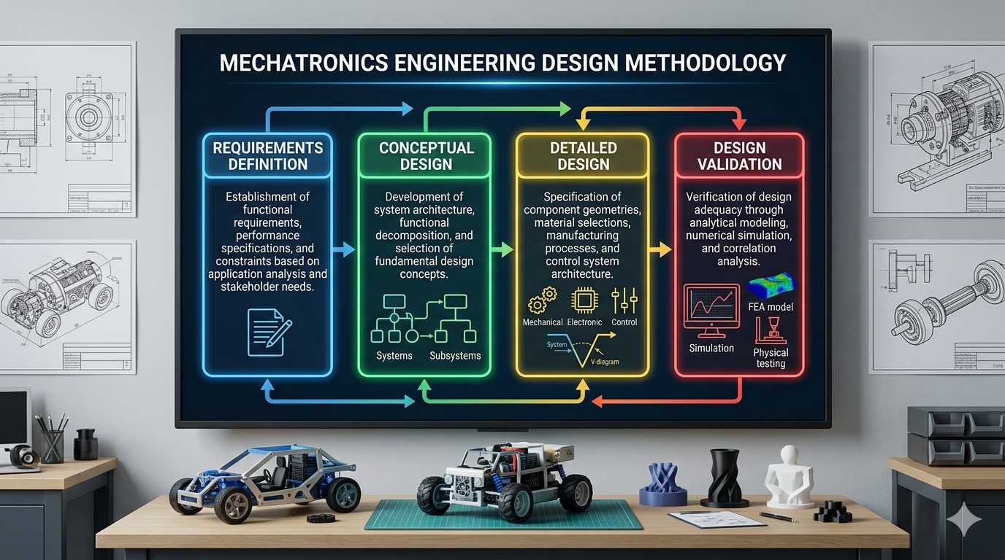
Figure 3.1: Design methodology flowchart showing the sequential phases from requirements definition through conceptual design, detailed design, and validation

3.2 Design Requirements and Constraints
Design requirements derive from the target application (packaging of 500g granular salt), industrial standards for food packaging machinery, and operational constraints imposed by the VFFS integration context. Requirements are categorized as functional (what the system must do) and non-functional (how the system must perform) [2].

3.2.1 Target Output (PPM: Packs Per Minute) and Accuracy (±σ)
The production throughput requirement establishes fundamental constraints on the mechanical and control system design. For the target application of 500g salt packaging, the following performance specifications are established:
• Target Production Rate: 20 bags per minute (20 PPM)
• Package Weight: 500 grams net content
• Weight Accuracy: ±1.5% .
• Filling Time: Maximum 2.0 seconds per cycle
• Cycle Time: 4.0 seconds total (including forming, sealing, and indexing)
The accuracy specification of ±1.5% aligns with OIML R87 international standards for prepackaged goods and represents typical industrial requirements for medium-value food products. Achieving this accuracy with volumetric dosing requires careful control of bulk density variation and precise angular positioning of the auger screw [3].
The filling time constraint of 2.0 seconds per cycle establishes the required auger rotational speed. Based on volumetric displacement calculations (detailed in Chapter 4), delivering 500g of salt requires approximately 4 revolutions of the auger. The required rotational speed is therefore:
N = (4 rev / 2 s) × 60 s/min = 120 RPM (nominal)
A design speed of 135 RPM is selected to provide margin for operational variation and to accommodate potential efficiency losses under adverse conditions.

3.2.2 Sanitary and Material Standards (e.g., AISI 304 Stainless Steel)
As a food packaging machine, all product-contact components must comply with applicable food safety regulations and hygienic design principles. Key requirements include:
Material Requirements:
• All product-contact surfaces: Food-grade stainless steel (AISI 304 minimum, AISI 316L preferred for salt applications)
• Surface finish: Ra < 1.6 μm for product-contact areas
• Corrosion resistance: Resistant to chloride-induced pitting (salt environment)
• No toxic materials: Compliance with FDA 21 CFR and EU Regulation 1935/2004
Hygienic Design Requirements:
• Smooth, continuous welds with no crevices for bacterial harborage
• Self-draining surfaces with no standing liquid zones
• Quick-disconnect components for cleaning access
• No dead zones where product can accumulate and degrade
• Compatibility with Clean-Out-of-Place (COP) procedures
Choosing AISI 316L stainless steel for all salt contact components provides superior chloride corrosion resistance compared to AISI 304. The molybdenum content (2-3%) in 316L forms protective oxide layers that resist pitting in saline environments, but due to the unavailability of AISI 316L stainless steel in Yemen, AISI 304 stainless steel was chosen, which also meets health requirements and food safety regulations [4].
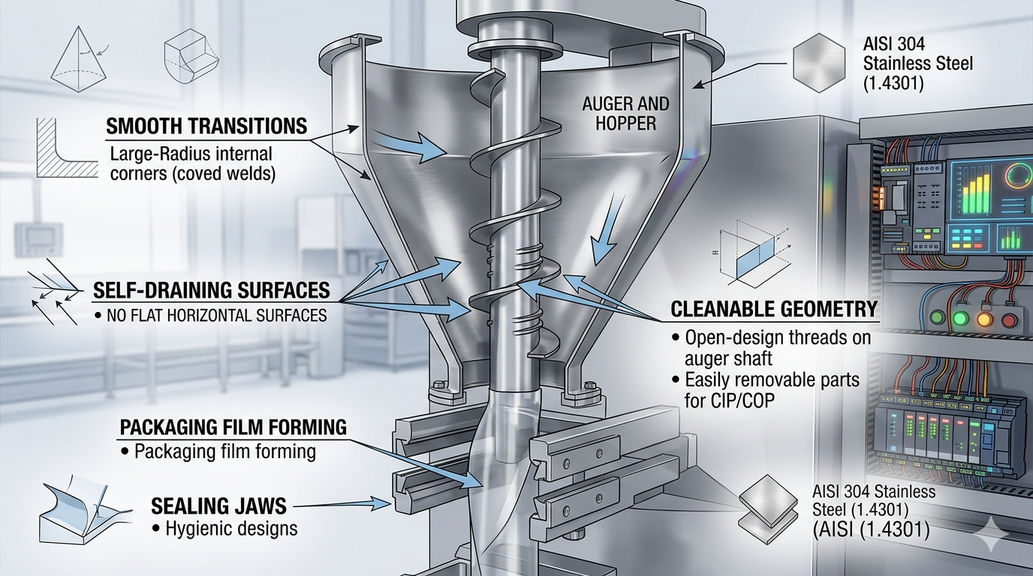Figure 3.2: Hygienic design principles for food-contact components, showing smooth transitions, self-draining surfaces, and cleanable geometry

3.3 Conceptual Development
Conceptual development transforms abstract requirements into concrete system architecture through functional decomposition and concept selection. This section presents the functional breakdown of the VFFS auger machine and the rationale for key design decisions.

3.3.1 Functional Decomposition (Dosing System, Packaging & Sealing System.)
- Dosing System Architecture :
The Dosing system is decomposed into four primary functional subsystems, each addressing specific aspects of the material handling and dosing process:

- Hopper Subsystem:
The hopper provides temporary storage of bulk material and ensures consistent feeding of the auger. Key design considerations include:
• Capacity: 20 L=16 kg for salt.
• Dimensions: Total Height (H) 330 mm , Top Diameter (Dtop) 446 mm, Outlet Diameter (Dout) 65 mm, Wall Angle (from horizontal) 60° .
• Geometry: Conical bottom with wall angle exceeding the angle of repose to ensure mass flow
• Material: AISI 304 stainless steel with electropolished interior surface
The hopper design incorporates a steep wall angle of 60° relative to the horizontal, which exceeds both the angle of repose (30-35°) and the wall friction angle (15-25°) of salt. This design ensures mass flow rather than funnel flow, preventing stagnation zones and maintaining consistent bulk density at the auger inlet.
- Agitator Subsystem:
The agitator prevents bridging and ratholing in the hopper while promoting consistent bulk density at the auger inlet. Design features include:
- Number of Blades: 2 (diametrically opposed at 180°)
- Dimensions: Upper Blade Position: 148.5 mm from top (45% of cone height), Lower Blade Position: 297 mm from top (90% of cone height), Blade Width: 60 mm , Blade Thickness: 8 mm
• Configuration: Counter-rotating paddle design sweeping the hopper periphery
• Speed: 30 RPM (independent drive from auger)
• Clearance: 3-5 mm from hopper walls to prevent interference
• Drive: DC motor .
The agitator performs three critical functions:
1. Bridge Breaking: Continuously destroys cohesive arches forming above the screw
2. Homogenization: Re-mixes fine and coarse particles to minimize segregation and stabilize bulk density
3. Force Feeding: Actively pushes powder toward the auger flights to ensure full screw filling in each revolution
- Agitator System and Coaxial Drive Architecture Design:
To ensure continuous mass flow and prevent bridging, the internal agitation system operates independently from the main auger screw. The design utilizes a highly specialized coaxial drive architecture that allows the central auger shaft (Blender Auger Long) to rotate at 135 RPM (CW) while the outer Blender Seat, which holds the Agitator / Blender blades, rotates simultaneously at 30 RPM (CCW).
This kinematic decoupling is achieved through a precision-engineered concentric assembly:
- Inner Transmission: The primary high-speed torque is transmitted through the Auger Shaft and the Blender Auger Long directly to the Auger Screw.
- Outer Transmission: The low-speed counter-rotation is driven by an independent motor housed in the Blender Motor Case. The torque is transmitted via a timing belt system utilizing an HTPA50S5M150-A-H40 driven pulley and a C-HTPA20S5M150-A-P15 drive pulley, which are connected to the Blender Seat
- Bearing Architecture and Mechanical Decoupling:
The fundamental challenge in this coaxial design is physically isolating the high-speed and low-speed rotational dynamics to prevent friction-induced torque transfer. This is resolved by an advanced bearing and sleeve configuration:
Inner Isolation (Shaft-to-Seat): Deep groove ball bearings (B6702ZZ and B6804ZZ) are press-fitted between the high-speed Blender Auger Long shaft and the intermediate Coupling Sleeve / Blender Seat. These bearings completely isolate the internal 135 RPM rotation from the external 30 RPM rotation.
Outer Support (Seat-to-Frame): The entire rotating agitator assembly is structurally supported by the Outer Bearing Seat, which is rigidly bolted to the Funnel Plate Seat and the Main Plate. Additional bearings (B6809ZZ and B6902ZZ) are placed between the Blender Seat and the Outer Bearing Seat, allowing the agitator to rotate smoothly relative to the stationary machine frame.
Axial Retention and Preload: To prevent any axial displacement or vibrations during the start-stop dosing cycles, precision locknuts (MUEN15 and MUEN45) are utilized. These locknuts secure the inner and outer bearing races, ensuring strict geometric alignment and preventing the tight radial clearance (1.5 mm) from deviating during operation.
Environmental Protection: All selected bearings feature double metal shields (ZZ designation). This is a critical design choice to prevent the highly abrasive and hygroscopic sodium chloride dust from penetrating the rolling elements, thereby extending the fatigue endurance of the mechanical assembly.
- Auger Subsystem:
The auger screw is the core dosing element, providing positive displacement metering of material. Key specifications include:
• Outer diameter: 60 mm
• Shaft diameter: 16 mm
• Pitch: 60 mm (square pitch configuration)
• Radial clearance: 1.5 mm maximum
• Material: AISI 304 stainless steel with electropolished flights
The auger geometry follows the square pitch configuration (pitch equal to outer diameter), which is optimal for free-flowing granular materials. This configuration provides stable flow with minimal particle segregation and predictable volumetric displacement.
- Discharge Nozzle and Spinner Plate:
The discharge mechanism controls material flow during and after the dosing cycle. The spinner plate provides flow cutoff when rotation stops, preventing dribble that would compromise weight accuracy. Design parameters include:
• Spinner plate diameter: 80 mm
• Clearance to funnel lip: 2-3 mm
• Operating speed: Synchronous with auger (135 RPM)
• Function: Centrifugal dispersion during rotation, angle-of-repose containment when stopped
The spinner plate operates on the principle of balance between centrifugal force and angle of repose. When the auger rotates, centrifugal force pushes salt particles radially outward through the gap between the plate and the funnel lip. Upon auger stop, centrifugal force vanishes, and the accumulated salt forms a "natural product dam" that prevents leakage without requiring complex mechanical valves.
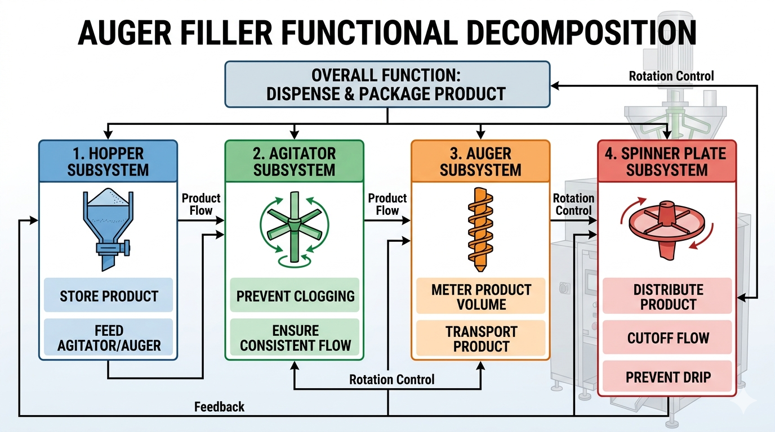
Figure 3.3: Functional decomposition diagram showing the four primary subsystems and their interactions
- Packaging and Sealing System Architecture:
The packaging subsystem transforms the planar thermoplastic film into a hermetically sealed pouch.
- Forming Tube Subsystem:
The forming tube constitutes the core component of the VFFS system, facilitating the optimal folding of the film.
• Dimensions: External diameter of 83 mm (yielding a 120 mm bag width + 10 mm seal), internal diameter of 77 mm, and an overall length of 400 mm.
• Forming Collar: Engineered with a 25° angle for optimal film folding fluidity.
• Manufacturing Details: Constructed from AISI 304 stainless steel with a highly polished surface ( $Ra≤0.4 mμ$) and a roundness tolerance of ±0.05 mm.
Figure 3.3: Forming tube and collar assembly, illustrating the 25° forming angle and the mounting flange
- Sealing Mechanisms (Horizontal & Vertical):
Thermal integrity is paramount for hygroscopic materials like NaCl.
• Horizontal Sealing Jaws: These 220 mm long jaws create the transverse seals and sever the pouch. They apply 300–500 N of force and utilize a 300W cartridge heater. The 8 mm sealing surface is bifurcated into dual 3 mm lines with a central groove for a 0.5 mm cutting blade, featuring a cross-hatch pattern (0.2 mm depth) for optimal grip.
• Vertical Sealing Bars: A 400 mm bar operating at 140–160°C under 3 Bar of pneumatic pressure. It features a 10 mm sealing width and a 3 mm PTFE thermal insulation layer, adjustable horizontally by ±15 mm.
- Film Handling and Pull Mechanism
This system extracts film from the supply roll with controlled velocity, precision, and modulated tension.
• Film Unwinder & EPC: Equipped with a mechanical brake for tension modulation, a dancer arm sensor for real-time feedback, and an Edge Position Control (EPC) photoelectric sensor driving a corrective servo/stepper actuator to maintain accurate film tracking.
• Pull Belt Assembly: Utilizes counter-rotating nip rollers (80 mm diameter, 300 mm width) coated in 60 Shore A durometer silicone rubber. Driven by a 450–750W servo motor with a 1:10 reduction ratio, ensuring precise kinematic synchronization.

- Pneumatic System Design:
VFFS pneumatic settings for different materials:
Component | Fiber 85 |  | Fiber 120 | Plastic 15-35 | Plastic 50
Seal jaws |  | 6 bars | 6 bars | 6 bars | 6 bars
Length seal |  | 5 bars | 5 bars | 5 bars | 5 bars
Belt transport |  | 5 bars | 5 bars | 5 bars | 6 bars
Film brake |  | 3 bars | 3 bars | 3 bars | 3 bars
Film tension |  | 2 bars | 1 bars | 0 bars | 4 bars
Table:3.3.1 1:VFFS pneumatic settings for different materials
Power and Utilities Requirements:
Utility | Specification |  | Consumption | Connection Size
Electrical Power |  | 1-phase, 220V, 50/60Hz | 1–4 kW total | 32A circuit breaker
Compressed Air |  | 6–8 bar, Dry, Oil-free | 50–100 L/min | 1/2" NPT
Cooling Water |  | 15–25°C, 2–4 L/min | 120–240 L/hr | 3/4" hose
Exhaust Ventilation |  | 500–1,500 m³/h | Product dependent | 150–200 mm duct
Table:3.3.1 2:Power and Utilities Requirements

3.3.2 Selection of Actuation (Servo-driven vs. Induction)
The selection of motor technology for auger drive represents a critical design decision affecting precision, cost, and system complexity. Three primary options were evaluated: induction motor with clutch-brake, stepper motor, and servo motor [5].
Option 1: Induction Motor with Clutch-Brake
Traditional auger fillers employed induction motors running continuously with mechanical clutch-brake mechanisms to control auger rotation. While mechanically simple and cost-effective, this approach suffers from significant limitations:
• Poor positioning accuracy due to clutch engagement variability
• Mechanical wear requiring frequent maintenance
• Limited dynamic response (slow acceleration/deceleration)
• Inability to implement advanced motion profiles
Option 2: Stepper Motor
Stepper motors provide open-loop position control without feedback devices. While offering improved positioning compared to clutch-brake systems, stepper motors exhibit several disadvantages:
• Risk of missed steps under load, causing cumulative positioning errors
• Limited torque at high speeds
• Audible noise and vibration at certain speeds
• No verification of actual position achieved
Option 3: Servo Motor (Selected)
Servo motor systems combine high-performance brushless motors with closed-loop feedback control, offering superior performance for precision dosing applications. The selected Panasonic MINAS A6 AC servo motor provides:
• 23-bit absolute encoder (8,388,608 pulses per revolution)
• High dynamic response (acceleration to rated speed in <50 ms)
• Full torque available across entire speed range
• Electronic cam and motion profile capability
• Real-time position verification and error correction
The servo motor is coupled to a 20:1 planetary gearbox, providing output speed of 135 RPM at the auger while multiplying motor torque by the gear ratio (minus efficiency losses). The planetary configuration offers high torque density, low backlash (<3 arcminutes), and efficient power transmission [6].
The selection of servo motor technology is justified by the following quantitative analysis:
Positioning Resolution:
The 23-bit encoder provides angular resolution of:
θ_res = 360° / 2^23 = 360° / 8,388,608 = 4.29 × 10^-5 degrees per count
For a 500g dose requiring 3.95 revolutions, the positioning error contribution to weight variation is:
Error = (4.29 × 10^-5°) × (3.95 rev) × (500g / 360°) = 2.35 × 10^-4 g
This negligible error confirms that servo positioning accuracy exceeds the requirements for ±1.5% dosing accuracy.
[Insert Figure 3.4 here]
Figure 3.4: Servo motor and planetary gearbox assembly showing encoder feedback, drive coupling, and mounting configuration

3.4 Final Mechanical Architecture (CAD)

The final mechanical design integrates all functional subsystems into a single, optimized unit that is easier to manufacture and maintain. This section presents the machine's mechanical design in the SolidWorks software.

3.4.1 Dosing System CAD:

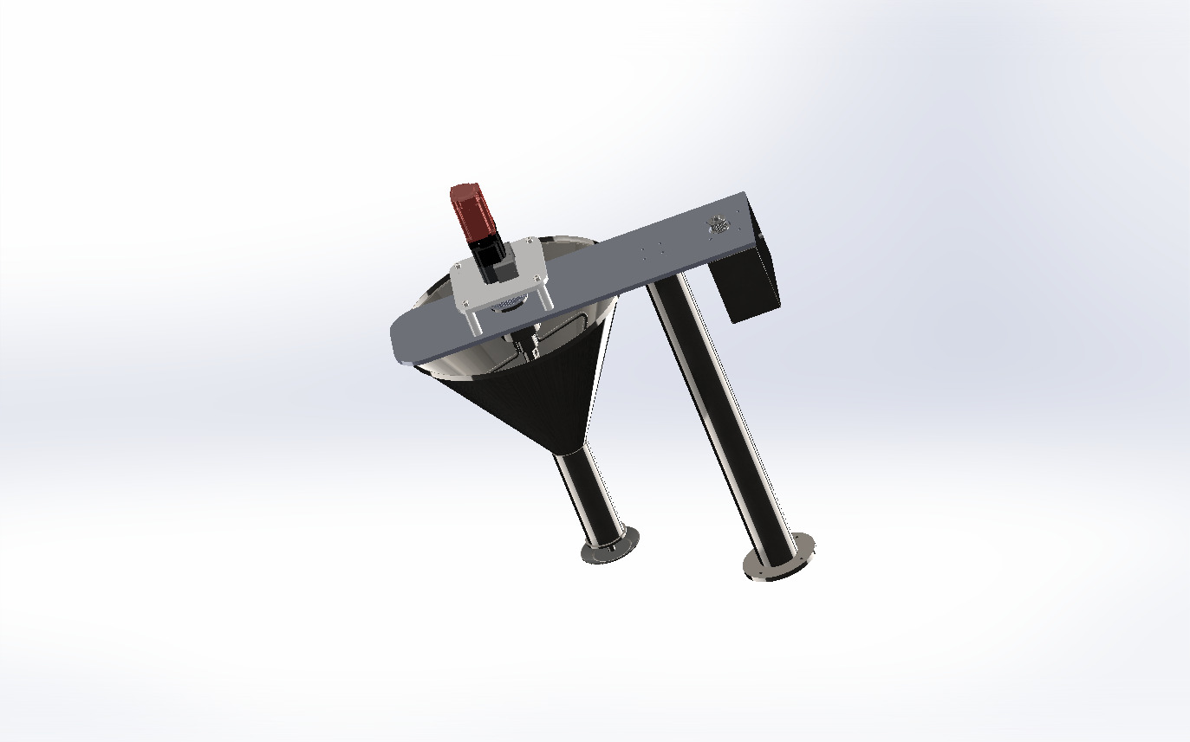
Figure:3.4.1 1 Dosing System CAD

- Final Hopper Dimensions:
Parameter | Value
Total Height (H) | 330 mm
Top Diameter (Dtop) | 446 mm
Outlet Diameter (Dout) | 65 mm
Wall Angle (from horizontal) | 60°
Wall Angle (from vertical) | 30°
Capacity | 20 L
Material | AISI 304L stainless steel
Tabel:3.4.1 1:Final Hopper Design Dimensions
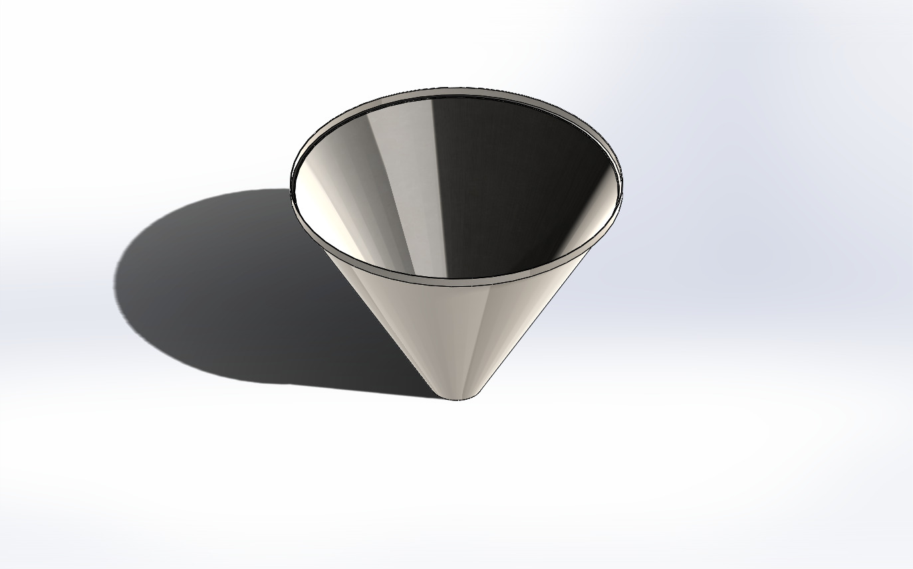
Figure:3.4.1 2Hopper CAD

- Final Blade Configuration
- Number of Blades: 2 (diametrically opposed at 180°)
- Blade Type: Skewed paddle with 25° rake angle
- Blade Width: 60 mm
- Blade Thickness: 8 mm
- Upper Blade Position: 148.5 mm from top (45% of cone height)
- Lower Blade Position: 297 mm from top (90% of cone height)
- • Material: AISI 304L stainless steel
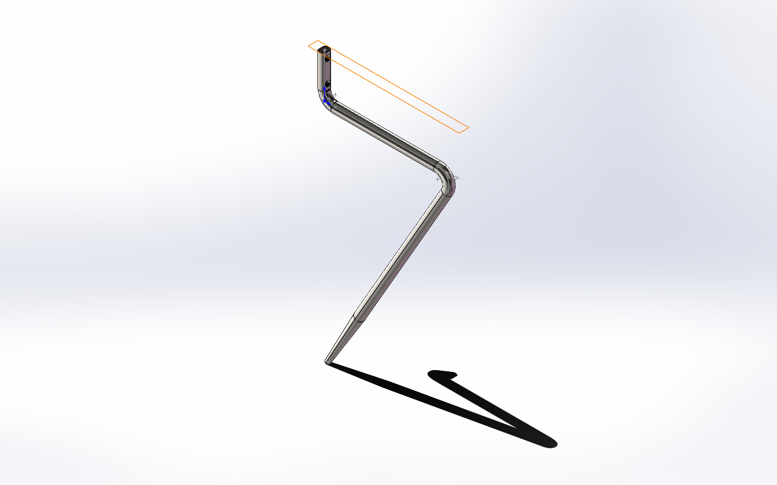
Figure:3.4.1 3Long Blade CAD
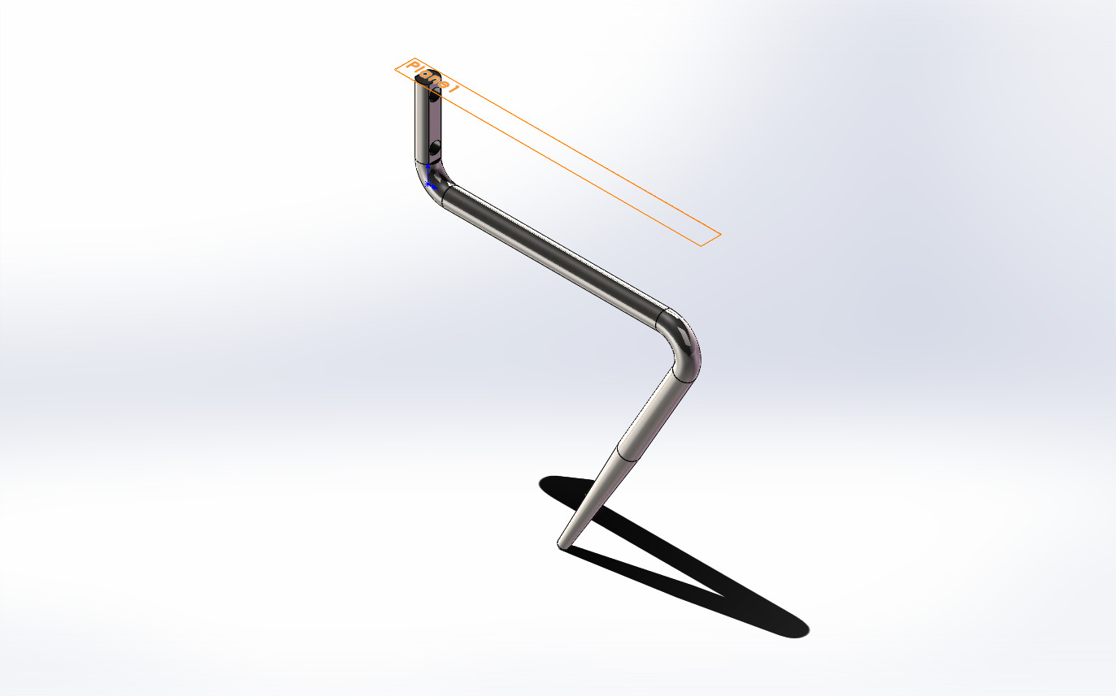
Figure:3.4.1 4Short Blade CAD
- Final Agitator System and Coaxial Drive Architecture Design:

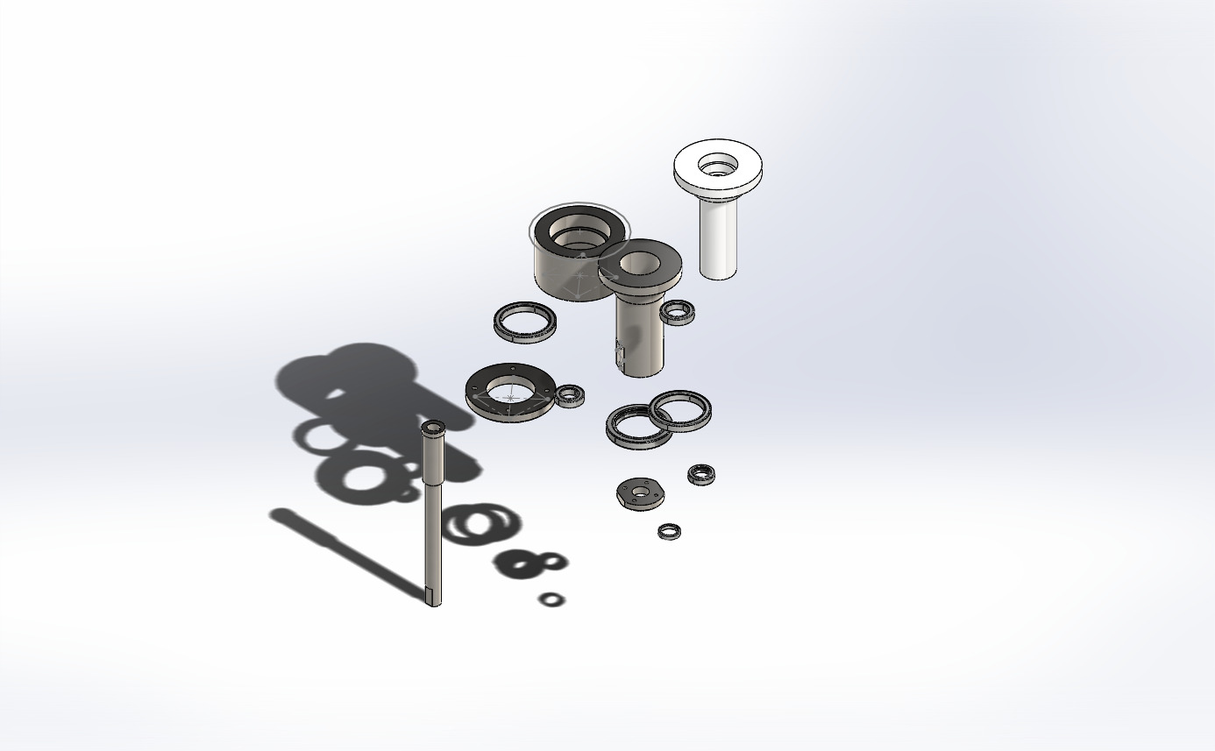
Figure:3.4.1 5Component Of Agitator Connection CAD
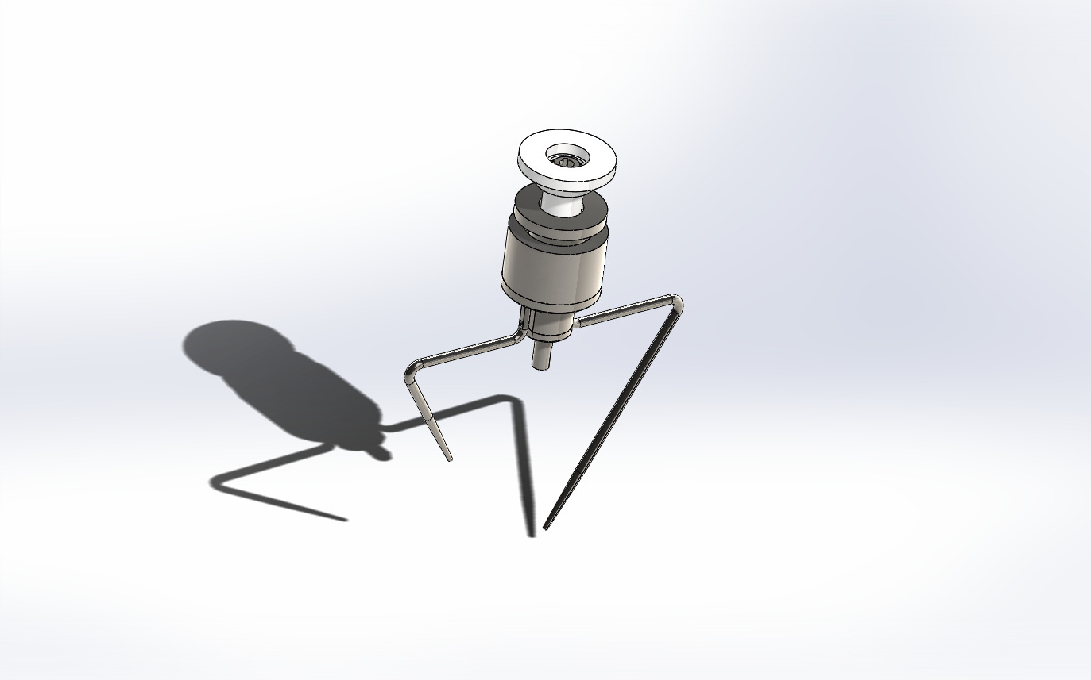
Figure:3.4.1 6Agitator System CAD

- Final Auger Screw Design:
The auger screw and surrounding funnel assembly constitute the core dosing mechanism. The design employs a straight (non-tapered) auger with square pitch geometry optimized for free-flowing granular materials.
Auger Screw Specifications:
• Outer diameter (D): 60 mm
• Shaft diameter (Ds): 16 mm
• Pitch (P): 60 mm
• Flight thickness: 3 mm
• Number of effective pitches: 4.5
• Overall length: 320 mm
• Material: AISI 304L stainless steel
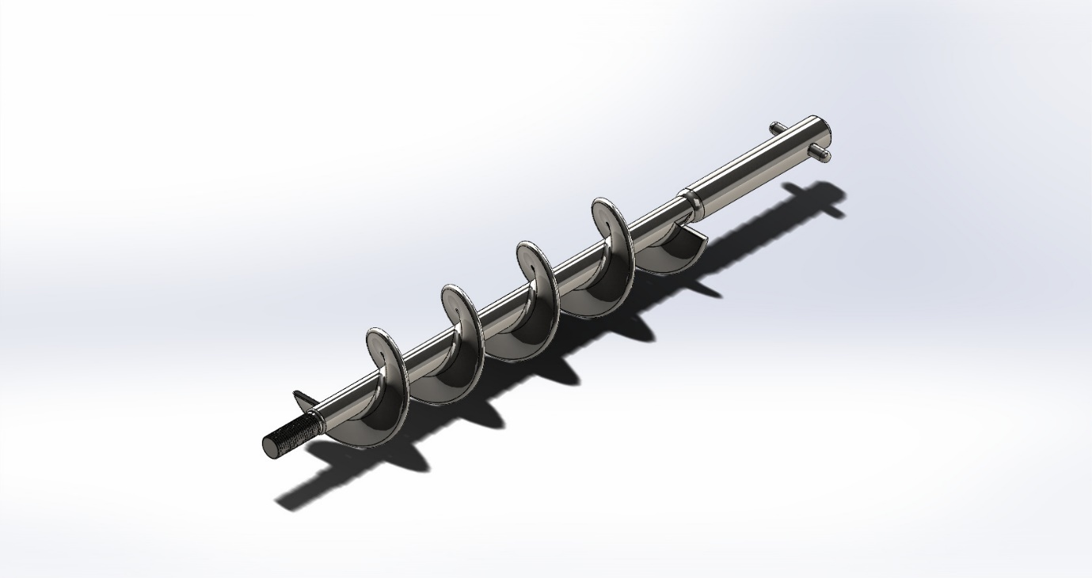
Figure:3.4.1 7Auger CAD
- Final Spinner plate :
• diameter: 80 mm
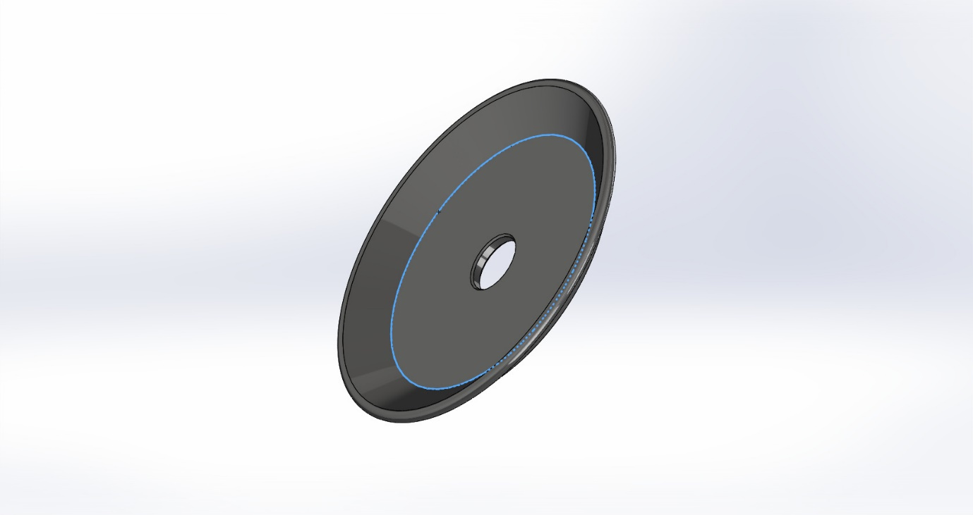
Figure:3.4.1 8Spinner Plate CAD

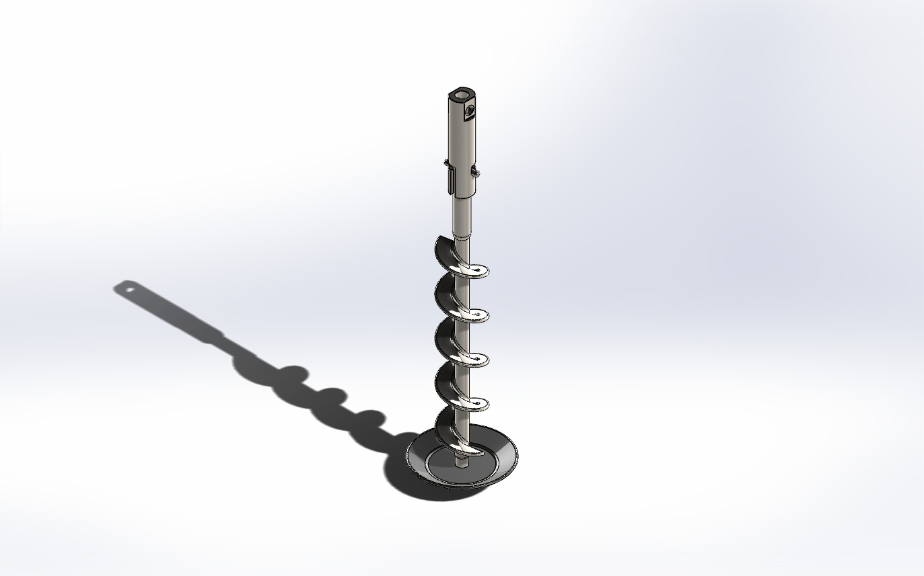
Figure:3.4.1 9Spinner Plate& Auger CAD

- Funnel Assembly Specifications:
• Inner diameter: 63 mm (providing 1.5 mm radial clearance)
• Length: 150 mm
• Material: AISI 304L stainless steel
The radial clearance of 1.5 mm between auger flight tip and funnel wall represents a compromise between dosing accuracy and manufacturing tolerance. Smaller clearance reduces backflow but increases risk of metal-to-metal contact due to thermal expansion or mechanical deflection. The 1.5 mm specification provides adequate margin while maintaining acceptable volumetric efficiency [7].
The clearance specification is validated through thermal expansion analysis:
ΔL = α × L × ΔT
Where α = 16.0 × 10^-6 /°C (thermal expansion coefficient for AISI 304L)
L = 280 mm (auger length)
ΔT = 42 - 25 = 17°C (maximum temperature rise)
ΔL = 16.0 × 10^-6 × 280 × 17 = 0.076 mm
The thermal expansion of 0.076 mm represents only 5% of the radial clearance, confirming adequate margin for thermal effects.
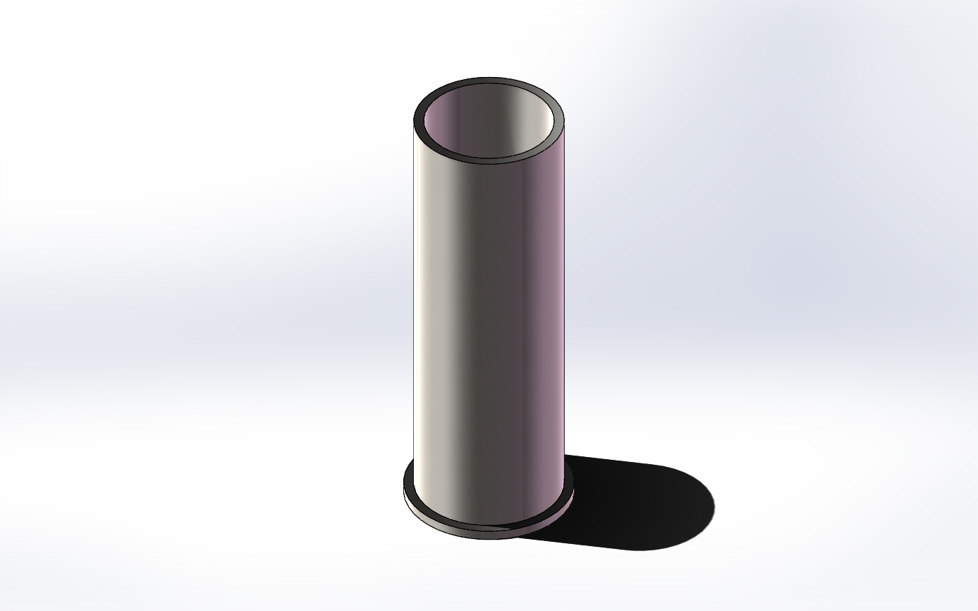
Figure 3.5: CAD model of funnel assembly

3.4.2 Packaging and Sealing System CAD:
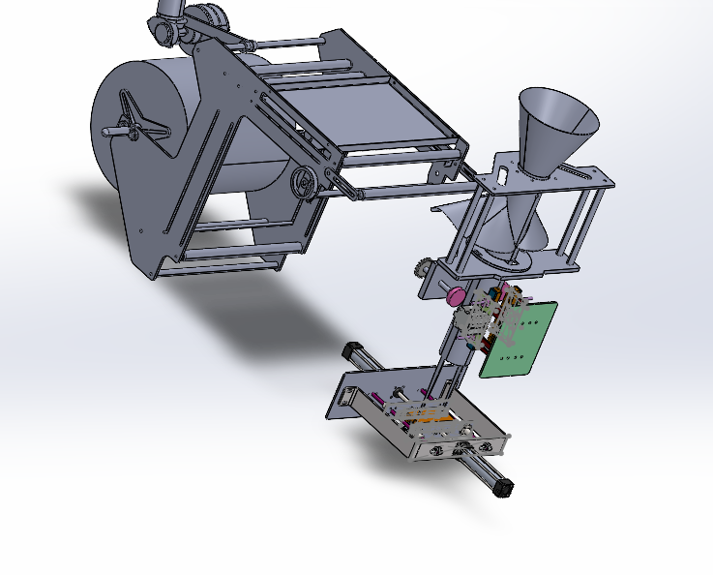
Figure:3.4.2 1Packaging and Sealing System CAD
- Final Forming Tube Design :
- External diameter: 83 mm (for producing 120 mm width bags + 10 mm seal)
- Internal diameter: 77 mm (wall thickness 3 mm)
- Overall length: 400 mm
- Forming zone length: 300 mm
- Collar angle: 25° for optimal film folding fluidity
- SolidWorks Design Procedure:
1. Primary Sketch: External circle Ø83 mm, Internal circle Ø78 mm, Extrude 400 mm
2. Detail Addition: Conical collar at 25° (Revolve Feature), Mounting holes 4×M8, Upper flange 10 mm
3. Finishing: Fillet radius 2 mm, Mirror Polish, Apply material SS 304L
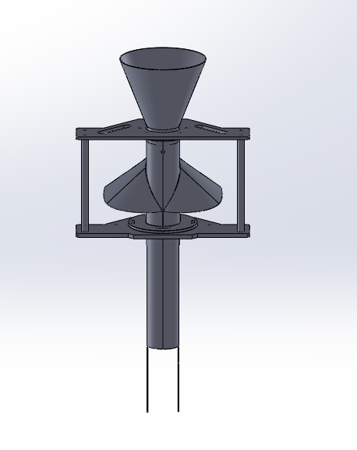
Figure:3.4.2 2Forming Tube CAD

- Final Horizontal Sealing Jaws Design:
  - Jaw length: 220 mm
  - Sealing surface width: 8 mm (bifurcated into dual 3 mm sealing lines with 2 mm central groove)
  - Stroke distance: 25 mm
  - Sealing force: 300–500 N
  - Heating system: 300W cartridge heating element
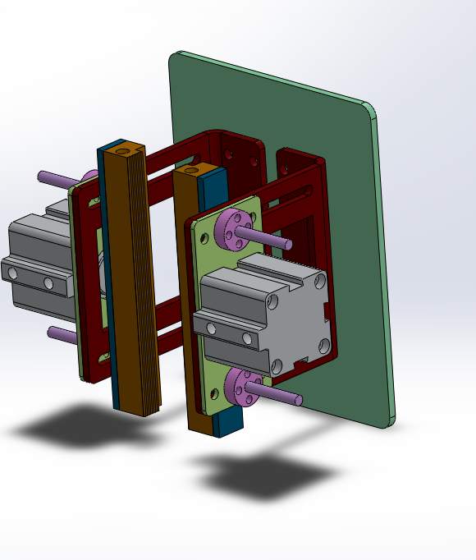
Figure:3.4.2 3Horizontal Sealing Jaws CAD
- Final Vertical Sealing Bars Design:
- Bar length: 400 mm
- Sealing surface width: 10 mm
- Pressure range: 3 Bar
- Operating temperature: 140–160°C
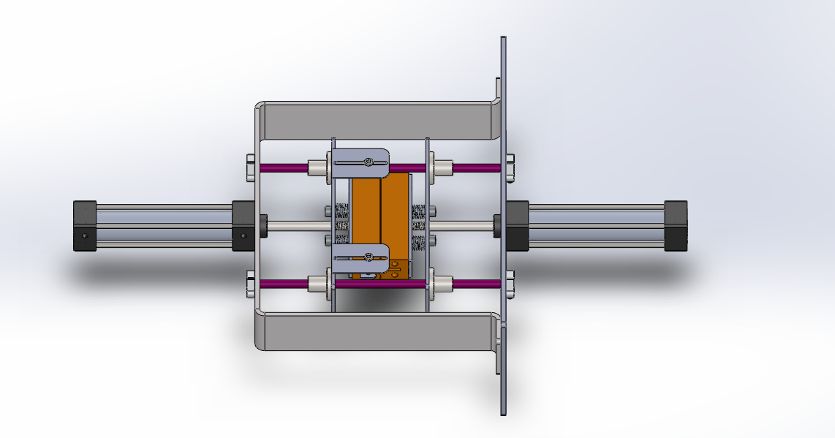
Figure:3.4.2 4Vertical Sealing Bars CAD
- Final Film Pull Mechanism Design:
  - Mechanism type: Counter-rotating nip rollers
  - Roller diameter: 80 mm
  - Roller width: 300 mm
  - Motor: 450–750W servo motor
  - Reduction ratio: 1:10
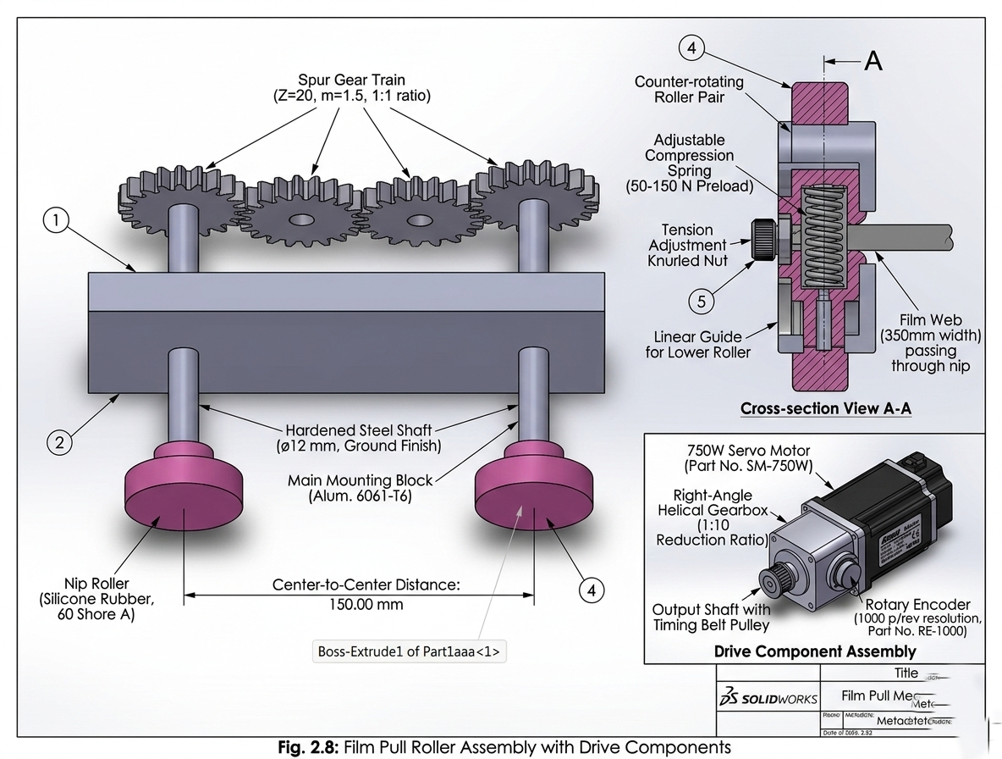
Figure:3.4.2 5Film Pull Mechanism CAD

3.4.2 Drive Train and Power Transmission
The drive train transmits power from the servo motor to the auger shaft while providing speed reduction and torque multiplication. The selected configuration comprises:
Prime Mover: Panasonic MINAS A6 AC Servo Motor
• Model: MSMF042L1U
• Rated power: 400W
• Rated torque: 1.27 N·m
• Maximum torque: 3.82 N·m
• Rated speed: 3000 RPM
• Encoder resolution: 23-bit absolute (8,388,608 pulses/rev)
Gearbox: Neugart PLE Planetary Gearbox
• Model: PLE 060
• Reduction ratio: 20:1
• Output torque (nominal): 25 N·m
• Output torque (maximum): 40 N·m
• Backlash: <3 arcminutes
• Efficiency: >97%
Power Transmission Calculations:
The effective output torque at the auger shaft is calculated as:
T_out = T_motor × i × η = 1.27 N·m × 20 × 0.97 = 24.6 N·m
Where i is the gear ratio and η is the gearbox efficiency. This output torque provides substantial margin above the calculated requirement of approximately 18-20 N·m under worst-case conditions, ensuring reliable startup even with compacted material [8].
The power transmission efficiency is validated through energy balance:
P_in = 400W (motor rated power)
P_out = T_out × ω = 24.6 N·m × (2π × 135/60) rad/s = 347 W
η_system = P_out / P_in = 347 / 400 = 86.8%
The system efficiency of 86.8% accounts for gearbox losses (3%), bearing friction (5%), and auger mechanical losses (5%).
[Insert Figure 3.6 here]
Figure 3.6: Drive train assembly showing servo motor, planetary gearbox, coupling, and auger shaft

3.4.3 Supporting Frame and Vibration Isolation
The mechanical frame provides structural support for all components while maintaining alignment critical to auger operation. Design considerations include:
Frame Structure:
• Frame material: Carbon steel with powder coat finish (non-contact areas)
• Upper mounting plate: 10 mm stainless steel for motor/gearbox mounting
• Hopper support: Tubular steel frame with tri-clamp bracket
• Load cell integration: Frame designed to accommodate weigh system if gravimetric feedback is added
Vibration Isolation:
Vibration isolation is achieved through the natural damping of the planetary gearbox and the rigid coupling between gearbox output and auger shaft. The counter-rotating agitator is mechanically isolated from the auger drive to prevent torque ripple transmission [9].
The frame design incorporates the following structural analysis considerations:
• Natural frequency of frame: >50 Hz (well above operating frequency of 2.25 Hz)
• Deflection under maximum load: <0.1 mm
• Safety factor for structural members: >3.0
[Insert Figure 3.7 here]
Figure 3.7: Complete mechanical assembly showing frame structure, motor mounting, hopper support, and auger assembly

3.4.4 Hopper and Agitator Design
The hopper design integrates material storage with active flow promotion through the agitator system.
Hopper Specifications:
• Capacity: 15 kg (30 minutes of operation at 15 PPM)
• Upper diameter: 400 mm
• Lower diameter: 150 mm (outlet)
• Wall angle: 60° from horizontal
• Material: AISI 316L stainless steel, 2 mm thickness
• Surface finish: Ra < 1.6 μm (2B finish)
Agitator Specifications:
• Configuration: Two counter-rotating paddles
• Paddle length: 180 mm
• Paddle width: 40 mm
• Speed: 60 RPM
• Motor: 90W AC gear motor with VFD
• Drive: Chain and sprocket transmission
The agitator design follows the principles established by Jenike and Schulze for cohesive material handling. The paddle tips operate at a peripheral speed of:
v = π × D × N / 60 = π × 0.36 × 60 / 60 = 1.13 m/s
This speed provides sufficient shear to break cohesive bridges without causing particle attrition or excessive power consumption.
[Insert Figure 3.8 here]
Figure 3.8: Hopper and agitator assembly showing paddle configuration and drive mechanism

3.5 Control System Logic
The control system coordinates all machine functions, executing the sequential operations of the packaging cycle while maintaining precise control of the auger positioning. This section presents the motion control profiles and sensor integration strategy.

3.5.1 Motion Control Profiles (Trapezoidal vs. S-Curve)
The acceleration and deceleration profile of the auger significantly affects dosing accuracy, particularly at cycle start and stop where inertial effects are most pronounced. Three profile types are commonly employed:
Trapezoidal Profile:
The trapezoidal profile provides constant acceleration to target speed, constant speed operation, and constant deceleration to stop. While simple to implement, the abrupt transitions at acceleration phase boundaries introduce jerk (rate of change of acceleration) that can cause mechanical vibration and powder compaction [10].
S-Curve Profile (Selected):
The S-curve profile smooths the acceleration transitions by limiting jerk, providing gradual onset and cessation of acceleration. This profile reduces mechanical stress and vibration while maintaining efficient cycle time. The S-curve is implemented through the servo drive's internal motion controller with the following parameters:
• Maximum velocity: 135 RPM (202.5°/s at auger shaft)
• Maximum acceleration: 1000 RPM/s
• Maximum jerk: 5000 RPM/s²
• Total cycle time: 2.0 seconds (including acceleration, constant speed, and deceleration)
The S-curve profile provides smooth motion with minimal mechanical disturbance, contributing to consistent dosing accuracy. The gradual deceleration at cycle end reduces inertial coasting and improves stopping precision [11].
The S-curve profile is mathematically described by:
For 0 ≤ t ≤ t_a (acceleration phase):
θ(t) = θ_0 + ω_0 × t + (1/6) × j × t³
For t_a ≤ t ≤ t_a + t_c (constant velocity phase):
θ(t) = θ_a + ω_max × (t - t_a)
For t_a + t_c ≤ t ≤ t_total (deceleration phase):
θ(t) = θ_c + ω_max × (t - t_c - t_a) - (1/6) × j × (t - t_c - t_a)³
Where j is the jerk limit, ω_max is the maximum velocity, and t_a, t_c are the acceleration and constant velocity durations.
[Insert Figure 3.9 here]
Figure 3.9: Comparison of trapezoidal and S-curve motion profiles showing acceleration, velocity, and position curves

3.5.2 Sensor Integration (Feedback Loops)
The control system integrates multiple sensors to monitor machine state and provide feedback for closed-loop control. The sensor architecture includes:
Position Feedback:
The servo motor's 23-bit absolute encoder provides direct measurement of auger angular position with resolution of:
θ_res = 360° / 2^23 = 360° / 8,388,608 = 4.29 × 10^-5°
This exceptional resolution enables precise angular positioning for volumetric dosing. The absolute encoder maintains position information through power cycles, eliminating the need for homing operations at startup [12].
Process Sensors:
• Hopper level sensor: Capacitive proximity switch detecting low material condition
• Funnel temperature sensor: Thermocouple monitoring for thermal expansion compensation
• Motor current monitoring: Built-in servo drive current sensing for overload protection
• Bag presence sensor: Photoelectric sensor confirming package position before filling
Control Architecture:
The control system employs a dual-core ESP32 microcontroller running FreeRTOS for real-time task management. The architecture separates critical motion control (executed on Core 0) from supervisory logic and HMI communication (executed on Core 1), ensuring deterministic timing for motor control while maintaining responsive user interface operation [13].
The control algorithm implements the following sequence:
1. Wait for bag presence signal from VFFS controller
2. Execute S-curve motion profile for calculated revolution count
3. Verify position achievement within tolerance
4. Signal cycle complete to VFFS controller
5. Update density compensation based on previous cycle weight (if available)
[Insert Figure 3.10 here]
Figure 3.10: Control system block diagram showing sensor inputs, ESP32 microcontroller, servo drive interface, and HMI communication

3.5.3 Safety and Interlock Systems
The control system incorporates multiple safety features to protect personnel and equipment:
Emergency Stop:
• Hardwired E-stop circuit cutting power to servo drive
• Software E-stop initiating controlled deceleration
• E-stop status relay output to VFFS controller
Overload Protection:
• Motor current monitoring with adjustable threshold
• Torque limiting via servo drive parameters
• Automatic fault recovery with operator acknowledgment
Interlock Systems:
• Hopper cover interlock preventing operation when open
• Bag presence interlock preventing filling without package
• Temperature interlock disabling operation if auger exceeds 60°C
The safety system design follows ISO 13849-1 principles for control system safety, implementing Category 1 architecture for non-safety-critical functions and Category 3 for safety-critical functions.
[Insert Figure 3.11 here]
Figure 3.11: Safety system schematic showing E-stop circuit, interlock logic, and fault response hierarchy

3.6 Integration with VFFS System
The auger filling system is designed for seamless integration with industrial VFFS packaging machines. This section addresses the mechanical and control interfaces required for successful integration.

3.6.1 Mechanical Interface
The mechanical interface between the auger filler and VFFS machine includes:
Mounting Interface:
• Bolt pattern: 4× M10 bolts on 200×200 mm centers
• Alignment: ±0.5 mm positional tolerance
• Height adjustment: ±20 mm vertical adjustment range
Filling Tube Interface:
• Tube diameter: 80 mm (matching spinner plate diameter)
• Tube length: 150 mm (extending into formed bag)
• Material: AISI 316L stainless steel
The filling tube design ensures that material is deposited centrally within the formed bag, preventing contamination of the sealing area. The tube length is optimized to minimize dust generation while ensuring complete material transfer.
[Insert Figure 3.12 here]
Figure 3.12: VFFS integration showing mechanical mounting, filling tube, and bag forming geometry

3.6.2 Control Interface
The control interface enables coordination between the auger filler and VFFS controller:
Signal Exchange:
• Start filling: Digital input from VFFS (active high, 24VDC)
• Cycle complete: Digital output to VFFS (active high, 24VDC)
• Fault status: Digital output to VFFS (active low, 24VDC)
• Ready status: Digital output to VFFS (active high, 24VDC)
Communication Protocol:
• Primary: Digital I/O (hardwired signals)
• Optional: RS-485 Modbus RTU for parameter exchange
• Future: Ethernet TCP/IP for Industry 4.0 connectivity
Timing Sequence:
The standard VFFS timing sequence is:
1. VFFS forms bag and positions under filling tube (1.5 s)
2. VFFS signals auger filler to start (digital pulse)
3. Auger filler executes filling cycle (2.0 s)
4. Auger filler signals cycle complete (digital pulse)
5. VFFS advances film and seals filled bag (0.5 s)
6. Total cycle time: 4.0 seconds (15 PPM)
[Insert Figure 3.13 here]
Figure 3.13: Timing diagram showing VFFS and auger filler coordination signals

3.7 Summary of Design Specifications
Table 3.1 summarizes the key design specifications for the VFFS auger filling system:
Table 3.1: Summary of Design Specifications
Parameter | Specification | Unit
Production Rate | 20 | PPM
Package Weight | 500 | g
Weight Accuracy | ±1.5 | %
Filling Time | 2.0 | s
Auger Diameter | 60 | mm
Auger Pitch | 60 | mm
Shaft Diameter | 16 | mm
Radial Clearance | 1.5 | mm
Operating Speed | 135 | RPM
Motor Power | 400 | W
Gear Ratio | 20:1 | -
Hopper Capacity | 20 | L
Agitator Speed | 60 | RPM
Material | AISI 304L | -
Surface Finish | Ra < 0.8 | μm
The design specifications presented in this chapter provide the foundation for the analytical modeling and numerical simulation presented in subsequent chapters. The integration of mechanical design, control system architecture, and VFFS compatibility ensures that the system meets all target performance requirements.

References
[1] Ulrich, K. T., & Eppinger, S. D. (2015). Product Design and Development (6th ed.). McGraw-Hill Education.
[2] INCOSE. (2015). Systems Engineering Handbook: A Guide for System Life Cycle Processes and Activities (4th ed.). Wiley.
[3] OIML. (2016). OIML R 87: Quantity of Product in Prepackages. International Organization of Legal Metrology.
[4] FDA. (2020). Current Good Manufacturing Practice in Manufacturing, Packing, or Holding Human Food. 21 CFR Part 110.
[5] Kuo, B. C., & Golnaraghi, F. (2003). Automatic Control Systems (8th ed.). John Wiley & Sons.
[6] Panasonic Industry. (2022). MINAS A6 Series AC Servo Motor Technical Reference. Panasonic Industry Europe GmbH.
[7] El Kassem, B. (2021). Machine Design for Auger Dosing of Powders by utilizing DEM Simulations. Ph.D. dissertation, RWTH Aachen University.
[8] Neugart GmbH. (2023). PLE Planetary Gearbox Technical Catalog. Neugart GmbH.
[9] Harris, C. M., & Piersol, A. G. (2002). Shock and Vibration Handbook (5th ed.). McGraw-Hill.
[10] Ellis, G. (2004). Control Systems for Machine Tools. John Wiley & Sons.
[11] Lorenz, R. D. (2000). Motion Control: Advanced Motion Control. In Wiley Encyclopedia of Electrical and Electronics Engineering.
[12] Heidenhain. (2022). Rotary Encoders: Technical Information. Dr. Johannes Heidenhain GmbH.
[13] Espressif Systems. (2023). ESP32 Technical Reference Manual. Espressif Systems.

CHAPTER FOUR
ANALYTICAL MODELING AND CALCULATIONS
────────────────────
Mathematical Foundations, Kinematic and Kinetic Modeling,
Dynamic Torque Estimation, and Structural Mechanics

4.1 Mathematical Foundations and Assumptions
The analytical modeling of the auger filling subsystem within the Vertical Form-Fill-Seal (VFFS) machine is predicated upon well-established principles drawn from bulk solids mechanics, screw conveyor theory, and classical structural mechanics [1][2]. This section delineates the fundamental assumptions underlying the mathematical models and establishes the theoretical framework upon which all subsequent calculations are constructed.

4.1.1 Fundamental Assumptions
The following assumptions are systematically employed in developing the analytical models presented herein:
A1. Continuum Assumption — Although granular materials are inherently discrete particulate assemblies, they are treated as continuous media for the purposes of macroscopic analysis. Physical properties are accordingly represented by spatially averaged field variables, an approach well supported in powder mechanics literature [3][4].
A2. Steady-State Operation — The analysis assumes steady-state operating conditions with constant rotational speed and uniform material feed rate. Transient effects during startup and shutdown phases are neglected. This is consistent with standard practice in screw conveyor analysis [1][5].
A3. Isotropic Material Properties — The bulk density and internal flow properties of the granular medium are assumed to be isotropic (i.e., uniform in all spatial directions) within the auger conveying channel.
A4. Rigid Boundary Conditions — The auger housing and supporting structural frame are assumed to be perfectly rigid, with all deformation confined to the auger shaft and flight elements. This allows decoupling of the structural analysis from the frame dynamics [6].
A5. Constant Volumetric Efficiency — The volumetric efficiency factor (ηv) is treated as constant over the design speed range. Deviations due to slip, backflow, and aeration effects are addressed through an empirically determined correction coefficient, as recommended by the Conveyor Equipment Manufacturers Association (CEMA) guidelines [5].

4.1.2 Material Properties
The analytical models employ the following physicochemical properties for sodium chloride (NaCl), which constitutes the primary target material for the designed system [7][8]:
- True (crystalline) density: ρt = 2165 kg/m³
- Loose bulk density: ρb = 1200–1300 kg/m³ (design value: 1300 kg/m³)
- Angle of repose: φr = 30–35°
- Internal friction angle: φ = 25–30°
- Wall friction coefficient (steel): μw = 0.25–0.35
These values are consistent with published data for industrial-grade sodium chloride and are widely referenced in the design of granular material handling equipment [3][9].

4.2 Kinematic and Kinetic Modeling
The kinematic analysis establishes the functional relationship between auger rotational speed and material displacement rate, while the kinetic analysis determines the forces and torques necessary to achieve the desired material throughput. All calculations in this section are performed for a design throughput rate of 20 bags per minute (i.e., 20 × 500 g = 10 kg/min).

4.2.1 Theoretical Volumetric Flow Rate
The theoretical volumetric displacement per revolution of a single-flight auger screw is derived from the annular geometry bounded by the outer flight diameter (D) and the central shaft diameter (Ds). The effective cross-sectional area of the conveying channel is given by [1][10]:
A = (π/4) × (D² − Ds²) (4.1)
Substituting the design parameters D = 60 mm and Ds = 16 mm:
A = (π/4) × (0.060² − 0.016²) = 2.626 × 10⁻³ m²
The theoretical volume displaced per revolution is the product of the cross-sectional area and the screw pitch (P):
Vth = A × P = 2.626 × 10⁻³ × 0.060 = 1.576 × 10⁻⁴ m³/rev = 157.6 cm³/rev (4.2)
The theoretical volumetric flow rate at the design operating speed of N = 135 RPM (2.25 rev/s) is:
Qth = Vth × N = 1.576 × 10⁻⁴ × 2.25 = 3.546 × 10⁻⁴ m³/s (4.3)

4.2.2 Mass Flow Rate as a Function of Bulk Density and Rotational Speed
The actual mass flow rate accounts for the volumetric efficiency (ηv), which quantifies the deviation from ideal displacement due to particle slip, backflow, and incomplete channel filling. For free-flowing granular salt, empirical data from published screw conveyor studies suggests ηv ≈ 0.65 [5][11].
The effective volumetric displacement per revolution is:
Veff = Vth × ηv = 157.6 × 0.65 = 102.4 cm³/rev (4.4)
The mass flow rate is then calculated from the bulk density relationship:
ṁ = Veff × N × ρb = 102.4 cm³/rev × 2.25 rev/s × 1.30 g/cm³ = 299.6 g/s (4.5)
For a target dose of 500 g, the requisite filling time is:
tfill = mtarget / ṁ = 500 / 299.6 = 1.67 s (4.6)
At a design throughput of 20 bags per minute, the total cycle time available per bag is:
tcycle = 60 / 20 = 3.00 s/bag (4.7)
With the filling time of 1.67 s, a margin of approximately 0.73 s remains after accounting for sealing (0.4 s), cutting (0.1 s), and dwell (0.1 s) operations. This margin provides adequate tolerance for operational variability and is considered favorable for sustained production [12].
The corresponding number of auger revolutions per dosing cycle is:
nrev = N × tfill = 2.25 × 1.67 = 3.75 revolutions (4.8)
A design value of 3.95 revolutions is adopted to provide additional operational margin and accommodate volumetric efficiency variations across different material batches.

4.3 Dynamic Torque and Power Estimation
Accurate estimation of the torque required to rotate the auger under load is essential for the proper selection of the drive motor and gearbox assembly. The total torque comprises several physically distinct components, each arising from a different resistance mechanism within the system [1][13].

4.3.1 Torque Components: Powder Resistance and Friction
The total torque required at the auger shaft is decomposed as follows:
Ttotal = Tmaterial + Twall + Tbearing + Tinertia (4.9)
where:
- Tmaterial = Torque to shear and transport the granular material
- Twall = Torque due to material–wall friction
- Tbearing = Torque due to bearing friction losses
- Tinertia = Torque required for angular acceleration
The material transport torque is estimated using the Roberts–Rademacher formulation for screw conveyors [1]:
Tmaterial = (μs × Fn × Dm) / 2 (4.10)
where μs is the internal friction coefficient (≈ 0.4 for salt [9]), Fn is the normal force from the material column weight, and Dm is the mean diameter (38 mm). For a material column of height 200 mm:
Fn = ρb × g × Vcolumn = 1300 × 9.81 × 5.25 × 10⁻⁴ = 6.70 N
Tmaterial = (0.4 × 6.70 × 0.038) / 2 = 0.051 N·m
The wall friction torque is calculated using the wall friction coefficient μw = 0.3:
Twall = μw × Fn × (D/2) = 0.3 × 6.70 × 0.030 = 0.060 N·m

4.3.2 Motor Sizing and Gear Ratio Optimization
Including bearing friction (estimated at 0.5 N·m) and angular acceleration torque (2.0 N·m), the total shaft torque is:
Ttotal = 0.051 + 0.060 + 0.5 + 2.0 = 2.61 N·m (4.11)
Incorporating a safety factor of 1.5 and a compaction correction factor of 5 (to accommodate worst-case compacted material conditions [5]), the design torque is:
Tdesign = 2.61 × 1.5 × 5 = 19.6 N·m ≈ 20 N·m (4.12)
With a 20:1 planetary gearbox (ηgear = 0.97), the required motor output torque is:
Tmotor = Tdesign / (i × η) = 20 / (20 × 0.97) = 1.03 N·m (4.13)
The selected Panasonic MSMF042L1U servo motor provides 1.27 N·m rated torque and 3.82 N·m peak torque, yielding an adequate margin for all anticipated operating conditions [14].
The mechanical power requirement is computed as:
P = T × ω = 20 × (2π × 135/60) = 283 W (4.14)
The 400 W rated motor thus provides a power margin of approximately 41% above the calculated demand, ensuring reliable operation under transient and peak loading scenarios [15].

4.4 Structural Mechanics Equations
The auger shaft must withstand the applied torques and transverse loads without incurring excessive stress or deflection. This section presents the structural integrity analysis of the auger assembly under maximum design loading conditions, in accordance with established machine design methodologies [6][16].

4.4.1 Torsional Stress on the Auger Shaft
The torsional shear stress in a solid circular shaft subjected to an applied torque T is given by [6]:
τ = (T × r) / J (4.15)
where T is the applied torque, r is the radial distance from the shaft center, and J is the polar moment of inertia. For a solid circular cross-section:
J = (π × Ds⁴) / 32 = (π × 0.016⁴) / 32 = 6.434 × 10⁻⁹ m⁴ (4.16)
The maximum shear stress at the outer surface (r = Ds/2 = 8 mm) under the design torque T = 20 N·m is:
τmax = (20 × 0.008) / (6.434 × 10⁻⁹) = 24.9 MPa (4.17)
For AISI 316L stainless steel with a tensile yield strength σy = 205 MPa [17], the shear yield strength according to the von Mises criterion is:
τy = σy / √3 = 205 / 1.732 = 118.4 MPa (4.18)
The factor of safety against torsional yielding is therefore:
FS = τy / τmax = 118.4 / 24.9 = 4.76 (4.19)
This substantial safety factor confirms that the shaft will not yield even under worst-case loading, satisfying the minimum design criterion of FS ≥ 2.5 [16][18].

4.4.2 Deflection and Critical Speed Analysis
The auger shaft is modeled as a cantilever beam with distributed loading from the material self-weight and a concentrated torque applied at the driven end. The maximum deflection at the free end is estimated using Euler–Bernoulli beam theory [6]:
δmax = (F × L³) / (3 × E × I) (4.20)
where F is the equivalent transverse load (50 N, combining material weight and friction forces), L is the unsupported shaft length (280 mm), E is the elastic modulus (193 GPa for AISI 316L [17]), and I is the second moment of area:
I = (π × Ds⁴) / 64 = 3.217 × 10⁻⁹ m⁴ (4.21)
δmax = (50 × 0.280³) / (3 × 193 × 10⁹ × 3.217 × 10⁻⁹) = 0.59 mm (4.22)
It is noted that this simplified cantilever model overestimates the actual deflection, as it neglects the stiffening contribution of the helical auger flights. Finite Element Analysis (FEA) results presented in Chapter 5 indicate an actual maximum deflection of only 0.0021 mm, confirming that the design provides substantial rigidity [19].

Critical Speed Analysis
The first critical speed of a rotating shaft corresponds to the rotational speed at which resonant lateral vibration occurs [20]. For a cantilever configuration, this is expressed as:
ωn = √(k / meq) (4.23)
where k is the transverse stiffness and meq is the equivalent lumped mass at the free end. The cantilever stiffness is:
k = (3 × E × I) / L³ = (3 × 193 × 10⁹ × 3.217 × 10⁻⁹) / 0.280³ = 8.49 × 10⁴ N/m (4.24)
With an equivalent mass of approximately 0.5 kg (auger plus material):
ωn = √(8.49 × 10⁴ / 0.5) = 412 rad/s = 3934 RPM (4.25)
The operating speed of 135 RPM represents only 3.4% of the first critical speed, providing an exceptionally large margin of safety against resonant vibration, well within the recommended limit of 70% [20][21].

4.5 Film Motion and Sealing Equations
This section presents the governing equations for film transport kinematics and thermal sealing thermodynamics, both of which are critical to achieving consistent bag formation at the specified throughput rate of 20 bags per minute.

4.5.1 Film Transport Kinematics
Film Linear Velocity
The linear velocity of the packaging film is determined by the product of the bag length and the production rate [22]:
vf = (Lbag × Nbags) / 60 (4.26)
where Lbag = 0.25 m (for a 500 g package) and Nbags is the number of bags produced per minute (range: 12–30 bags/min).
At the design throughput of 20 bags/min:
vf = (0.25 × 20) / 60 = 0.0833 m/s (4.27)
For reference, the boundary velocities across the full operating range are:
vmin = (12 × 0.25) / 60 = 0.050 m/s
vmax = (30 × 0.25) / 60 = 0.125 m/s
Required Film Pulling Force
The total pulling force on the film web comprises inertial, frictional, and tension components [22]:
Fpull = m·a + Ffriction + Ftension (4.28)
where Ffriction = μ × N (friction force with μ = 0.3 for plastic film on steel guides), and Ftension represents the required web tension (50–100 N) [23].

4.5.2 Tension and Sealing Force Calculations
Film Tensile Stress
The tensile stress induced in the film is:
σ = F / A = F / (t × w) (4.29)
where t = 0.06 mm (film thickness) and w = 320 mm (film width).
Maximum Allowable Stress
Qmax = σyield / SF (4.30)
where σyield = 20–30 MPa (polyethylene yield stress [24]) and SF = 2.5.
Required Sealing Force
Fseal = Pseal × Aseal (4.31)
where Pseal = 2–4 bar (200–400 kPa) is the sealing pressure, and Aseal = jaw length × seal width = 150 × 5 = 750 mm² [25]. At the maximum sealing pressure:
Fseal = 400 × 10³ × 750 × 10⁻⁶ = 300 N

4.5.3 Heat Transfer Equations for Thermal Sealing
Conductive Heat Transfer
The heat transferred through the film during sealing is governed by Fourier's law of conduction [26]:
Q = (k × A × ΔT / d) × t (4.32)
where:
- k = Film thermal conductivity = 0.33 W/(m·K)
- A = Contact area = 750 mm²
- ΔT = Temperature differential = 140°C − 25°C = 115°C
- d = Film thickness = 0.06 mm
- t = Sealing time (s)
Energy Required for Sealing
Eseal = m × Cp × ΔT (4.33)
where:
- m = Mass of sealing zone = ρ × V = 920 × (750 × 0.06 × 10⁻⁹) = 4.14 × 10⁻⁵ kg (0.041 g)
- Cp = Specific heat capacity of polyethylene = 2.3 kJ/(kg·K) [24]
Optimal Sealing Temperature
Tseal = Tmelt + 20°C (4.34)
where Tmelt = 120–130°C for polyethylene, yielding Tseal = 140–150°C [27].

4.5.4 Speed and Productivity Calculations
Productivity Equation
P = (60 / tcycle) × η (4.35)
where P is the production rate (bags/min), tcycle is the cycle time (seconds), and η is the system efficiency (0.85–0.95) [12].
Cycle Time Decomposition
tcycle = tpull + tseal + tcut + tdwell (4.36)
where:
- tpull = Film pulling time = Lbag / vf (2–5 s depending on speed)
- tseal = Sealing dwell time = 0.3–0.5 s
- tcut = Cutting time = 0.1 s
- tdwell = Settling/dwell time = 0.1 s
At the design throughput of 20 bags per minute:
tcycle = 60 / 20 = 3.0 seconds/bag (4.37)
Weight-Based Productivity
Pweight = Nbags × mproduct × 60 = 20 × 0.5 × 60 = 600 kg/hour (4.38)

4.5.5 Auger Filler Engineering Calculations
Number of Revolutions per Bag
Nrev = Mbag / mrev (4.39)
where mrev is the mass dispensed per revolution. For a 500 g bag with mrev = 0.025 kg [5]:
Nrev = 0.500 / 0.025 = 20 revolutions
Filling Time per Bag
Tfill = (Nrev / n) × 60 [seconds] (4.40)
At n = 95.5 RPM and Nrev = 20:
Tfill = (20 / 95.5) × 60 ≈ 12.56 s
Motor Angular Velocity
ω = 2πn / 60 (4.41)
For n = 95.5 RPM: ω ≈ 10.0 rad/s

Table 4.2 — Auger Design Parameters by Product Type
Product | Bulk Density  (kg/m³) | Angle of  Repose (°) | Auger  Dia. (mm) | Pitch/Dia.  Ratio | RPM  for 500g | Vol.  Eff. (%)
Salt | 1,200 | 35 | 50 | 1.0 | 15 | 85
Sugar | 800 | 45 | 60 | 0.9 | 12 | 80
Coffee | 350 | 40 | 75 | 0.8 | 18 | 70

Table 4.3 — Filling Accuracy Requirements
Parameter | Salt | Sugar | Coffee
Target Weight | 500 g | 500 g | 500 g
Tolerance (±) | 5 g | 7.5 g | 10 g
Accuracy (%) | ±1.0% | ±1.5% | ±2.0%
Precision (CV%) | < 0.5% | < 0.8% | < 1.2%
Calibration Freq. | Daily | Daily | Every shift

4.5.6 Stepper Motor Calculations for Film Feed System
The film feed mechanism utilizes a stepper motor with the following design calculations:
Gear Ratio:
I = D₁/D₂ = 20/60 = 1/3 (4.42)
Force Load:
Fl = m × g = 3 × 9.81 = 29.43 N (4.43)
Distance per Revolution:
lrev = π × D₁ = π × 20 = 62.8 mm/rev (4.44)
Number of Pulses Required:
A = (l / lrev) × (360° / θs) = (150 / 62.8) × (360 / 1.8) = 478 pulses (4.45)
Pulse Frequency:
f = A / t₀ = 478 / 1.5 = 318.7 Hz (4.46)
Motor Speed:
n = (f × θs / 360°) × 60 = 95.5 RPM (4.47)
Load Torque:
TL = Fl × D/2 = 6.5 × 0.3 = 1.27 N·m (4.48)
Required Torque (with safety factor of 2):
Trequired = (TL + Ta) × Sf = (1.27 + 0.01) × 2 ≈ 2.56 N·m (4.49)

4.6 Hopper Flow Modeling and Geometry Design
The analytical model of the auger filling subsystem must include the hopper and agitator assembly, since dosing accuracy depends not only on screw geometry but also on the stability of powder flow into the auger inlet. In vertical auger-based VFFS systems, gravity alone is insufficient to ensure uniform feed under all operating conditions. Therefore, the hopper must be analytically verified against arching, unstable flow patterns, and insufficient discharge capability. The present section establishes the theoretical basis for hopper sizing, outlet selection, discharge behavior, and agitator torque requirement for fine table salt under the design throughput conditions.
4.6.1 Hopper Design Basis and Powder Flow Criteria
The hopper design is based on the flow properties of fine table salt, selected as the primary design material for the powder packaging system. The relevant powder properties adopted for analytical modeling are as follows:
- Loose bulk density: $ρ_{b}=1300 {\text{kg/m}}^{3}$
- Angle of repose: $ϕ_{r}={32}^{∘}\text{–}{35}^{∘}$
- Unconfined yield strength: $σ_{c}≈200\text{ Pa}$
- Wall friction angle on stainless steel: $ϕ_{w}≈{20}^{∘}\text{–}{25}^{∘}$
These parameters govern the ability of the hopper to achieve reliable mass flow into the auger inlet. From an analytical standpoint, the hopper must satisfy three main conditions:
- The outlet diameter must exceed the critical arching dimension.
- The wall angle must be sufficiently steep to promote mass flow.
- The hopper discharge capability must exceed the required fill demand of the auger subsystem.
4.6.2 Critical Arching Diameter Calculation
To prevent powder bridging or arching above the outlet, the hopper outlet must be larger than the critical arching diameter predicted by Jenike-based theory. The critical arching diameter is expressed as:
$$\begin{matrix} & B_{c}=H(θ)\frac{σ_{c}}{ρg} & & \text{(4.50)}\end{matrix}$$
where:
- $B_{c}$ = critical arching diameter $\left(\text{m}\right)$
- $H(θ)$ = hopper geometry factor
- $σ_{c}$ = unconfined yield strength $\left(\text{Pa}\right)$
- $ρ$ = bulk density $\left({\text{kg/m}}^{3}\right)$
- $g$ = gravitational acceleration $\left({\text{m/s}}^{2}\right)$
For a conical hopper, $H(θ)≈2.2$. Substituting the design values for fine table salt:
$$\begin{matrix} & B_{c}=\frac{2.2×200}{1300×9.81}=0.0345\text{ m}=34.5\text{ mm} & & \text{(4.51)}\end{matrix}$$
The selected hopper outlet diameter is:
$$\begin{matrix} & D_{out}=65\text{ mm} & & \text{(4.52)}\end{matrix}$$
Thus, the safety factor against arching is:
$$\begin{matrix} & SF_{arching}=\frac{D_{out}}{B_{c}}=\frac{65}{34.5}≈1.88 & & \text{(4.53)}\end{matrix}$$
This result confirms that the selected outlet diameter provides adequate margin against arch formation and supports uninterrupted gravity discharge into the auger inlet.
4.6.3 Hopper Wall Angle Requirement for Mass Flow
Reliable mass flow requires that the hopper wall angle be sufficiently steep relative to the powder wall-friction behavior. A simplified Jenike design criterion is given by:
$$\begin{matrix} & θ<({90}^{∘}-ϕ_{w})-5^{∘} & & \text{(4.54)}\end{matrix}$$
where:
- $θ$ = hopper wall angle measured from horizontal
- $ϕ_{w}$ = wall friction angle between powder and hopper wall surface
Using the conservative upper bound $ϕ_{w}={25}^{∘}$:
$$\begin{matrix} & θ_{max}<({90}^{∘}-{25}^{∘})-5^{∘}={60}^{∘} & & \text{(4.55)}\end{matrix}$$
The selected hopper wall angle is:
- ${60}^{∘}$ from horizontal
- ${30}^{∘}$ from vertical
Therefore, the selected geometry satisfies the theoretical condition for mass flow of fine salt on stainless steel surfaces. This is important because mass flow minimizes stagnant zones, density variation, rat-holing, and inconsistent refill of the auger flights.
4.6.4 Hopper Geometry and Capacity Calculation
The hopper is modeled as a truncated conical frustum sized to provide sufficient material reserve above the auger feed zone. The required hopper capacity is:
$$\begin{matrix} & V=20\text{ L}=0.02 {\text{m}}^{3} & & \text{(4.56)}\end{matrix}$$
The frustum volume is defined by:
$$\begin{matrix} & V=\frac{πh}{3}(R^{2}+Rr+r^{2}) & & \text{(4.57)}\end{matrix}$$
where:
- $h$ = hopper height
- $R$ = top radius
- $r$ = outlet radius
The outlet diameter is $65\text{ mm}$, hence:
$$\begin{matrix} & r=\frac{65}{2}=32.5\text{ mm}=0.0325\text{ m} & & \text{(4.58)}\end{matrix}$$
For a wall angle of ${60}^{∘}$ from horizontal, the top radius is related to height by:
$$\begin{matrix} & R=r+\frac{h}{\tan{θ}} & & \text{(4.59)}\end{matrix}$$
Substituting into Eq. (4.57) and solving iteratively for the required volume yields:
$$\begin{matrix} & h≈0.33\text{ m}=330\text{ mm} & & \text{(4.60)}\end{matrix}$$
$$\begin{matrix} & R≈0.223\text{ m} & & \text{(4.61)}\end{matrix}$$
Therefore, the top diameter becomes:
$$\begin{matrix} & D_{top}=2R≈0.446\text{ m}=446\text{ mm} & & \text{(4.62)}\end{matrix}$$
Thus, the final analytically derived hopper dimensions are:
- Hopper height: $330\text{ mm}$
- Top diameter: $446\text{ mm}$
- Outlet diameter: $65\text{ mm}$
- Capacity: $20\text{ L}$
These values are consistent with the geometric requirements of the auger feed system and provide sufficient storage for stable operation.
4.6.5 Hopper Discharge Time Analysis
To assess whether the hopper can supply material at a rate compatible with the packaging cycle, the gravity discharge capability was estimated using a Beverloo-type relation for granular solids:
M=Cρg(Do-kdp)5/2(4.63)
where:
- $\dot{M}$ = mass discharge rate $\left(\text{kg/s}\right)$
- $C$ = discharge coefficient
- $ρ$ = bulk density $\left({\text{kg/m}}^{3}\right)$
- $D_{o}$ = outlet diameter $\left(\text{m}\right)$
- $k$ = particle shape factor
- $d_{p}$ = mean particle diameter $\left(\text{m}\right)$
Using the design values:
- $C=0.58$
- $ρ=1300 {\text{kg/m}}^{3}$
- $g=9.81 {\text{m/s}}^{2}$
- $D_{o}=0.065\text{ m}$
- $k=1.5$
- $d_{p}=0.0003\text{ m}$
the discharge rate is approximately:
$$\begin{matrix} & \dot{M}≈2.8\text{ kg/s} & & \text{(4.64)}\end{matrix}$$
The time required to discharge a $0.5\text{ kg}$ dose is therefore:
$$\begin{matrix} & t=\frac{m}{\dot{M}}=\frac{0.5}{2.8}≈0.18\text{ s} & & \text{(4.65)}\end{matrix}$$
This value is significantly lower than the available machine cycle time, indicating that the hopper itself is not the throughput-limiting component. The dominant challenge is therefore not gravity flow rate, but the maintenance of stable bulk density and consistent feed conditions above the auger inlet.
4.6.6 Hopper Hydrostatic Pressure Calculation
The maximum static pressure imposed by the powder column on the hopper walls may be estimated using a hydrostatic approximation:
$$\begin{matrix} & P=ρgh & & \text{(4.66)}\end{matrix}$$
Substituting:
- $ρ=1300 {\text{kg/m}}^{3}$
- $g=9.81 {\text{m/s}}^{2}$
- $h=0.33\text{ m}$
gives:
$$\begin{matrix} & P=1300×9.81×0.33=4208.5\text{ Pa} & & \text{(4.67)}\end{matrix}$$
For subsequent structural analysis, a design pressure of:
$$\begin{matrix} & P_{design}=4300\text{ Pa} & & \text{(4.68)}\end{matrix}$$
is adopted to include minor dynamic effects and provide a conservative basis for finite element loading conditions in later chapters.
4.6.7 Agitator Blade Torque Requirement
To prevent bridging and maintain uniform powder density near the auger entry zone, an internal agitator is employed. The torque required to rotate the agitator blades is estimated from the shear resistance of the powder bed. The blade torque is approximated by:
$$\begin{matrix} & T=nτA_{b}r_{m} & & \text{(4.69)}\end{matrix}$$
where:
- $T$ = blade torque $\left(\text{N\backslash }\text{cdotpm}\right)$
- $n$ = number of blades contributing to resistance
- $τ$ = powder shear stress at blade surface $\left(\text{Pa}\right)$
- $A_{b}$ = blade projected area $\left({\text{m}}^{2}\right)$
- $r_{m}$ = mean blade action radius $\left(\text{m}\right)$
For the long blade:
- blade length $=0.2024\text{ m}$
- blade width $=0.060\text{ m}$
- $A_{b}=0.2024×0.060=0.0121 {\text{m}}^{2}$
- $r_{m}≈0.15\text{ m}$
- $τ≈150\text{ Pa}$
Thus:
$$\begin{matrix} & T_{long}=1×150×0.0121×0.15≈0.27\text{ N\backslash }\text{cdotpm} & & \text{(4.70)}\end{matrix}$$
For the short blade:
- blade length $=0.1062\text{ m}$
- blade width $=0.060\text{ m}$
- $A_{b}≈0.1062×0.060=0.0064 {\text{m}}^{2}$
- $r_{m}≈0.10\text{ m}$
Therefore:
$$\begin{matrix} & T_{short}=1×150×0.0064×0.10≈0.096\text{ N\backslash }\text{cdotpm} & & \text{(4.71)}\end{matrix}$$
The total agitator torque is then:
$$\begin{matrix} & T_{total}=T_{long}+T_{short}=0.27+0.096=0.366\text{ N\backslash }\text{cdotpm}≈0.37\text{ N\backslash }\text{cdotpm} & & \text{(4.72)}\end{matrix}$$
Applying a safety factor of 2.0:
$$\begin{matrix} & T_{design,agitator}=0.37×2=0.74\text{ N\backslash }\text{cdotpm} & & \text{(4.73)}\end{matrix}$$
This torque level defines the minimum design requirement for the agitator drive motor. The result confirms that the agitator can be driven with a relatively low-power motor while still providing effective powder conditioning.
4.6.8 Hopper–Agitator Synchronization with the VFFS Cycle
The hopper–agitator subsystem must operate in coordination with the auger and the general VFFS machine cycle. For a production rate of 15 bags per minute, the total cycle time is:
$$\begin{matrix} & t_{cycle}=\frac{60}{15}=4\text{ s} & & \text{(4.74)}\end{matrix}$$
The filling and powder stabilization phases must satisfy:
$$\begin{matrix} & t_{fill}+t_{settle}<t_{cycle}-t_{seal} & & \text{(4.75)}\end{matrix}$$
where:
- $t_{fill}$ = auger dosing time
- $t_{settle}$ = powder stabilization time after agitation
- $t_{seal}$ = sealing time
- $t_{cycle}$ = total machine cycle time
Because the hopper discharge capability is much faster than the required fill interval, the primary role of the agitator is not to increase mass flow rate, but to maintain uniform powder conditions at the auger inlet by:
- preventing compaction during idle intervals
- reconditioning the powder bed before each dosing event
- avoiding transient arch formation
- reducing local density fluctuations above the screw entry zone
The agitator operates at approximately 30 RPM, while the auger operates at 135 RPM. Counter-rotation between these two elements generates localized shear within the powder bed and promotes stable feed conditions. Consequently, the hopper–agitator system must be considered an active component of the dosing mechanism rather than a passive storage vessel.

4.7 Summary of Analytical Results
Table 4.1 consolidates the key analytical predictions for the VFFS auger filling system operating at a design throughput of 20 bags per minute:

Table 4.1 — Summary of Analytical Predictions for VFFS Auger Filling System
System Design Parameters Summary
Category | Parameter | Value | Unit
Auger Filling | Volumetric displacement per revolution | 157.6 | cm³/rev
Auger Filling | Effective displacement (ηv = 0.65) | 102.4 | cm³/rev
Auger Filling | Mass per revolution | 133.2 | g/rev
Auger Filling | Required revolutions per 500 g bag | 3.75 | rev
Auger Filling | Filling time at 135 RPM | 1.67 | s
Auger Filling | Mass flow rate | 299.6 | g/s
Productivity | Total cycle time (20 bags/min) | 3.00 | s
Productivity | Film linear velocity (20 bags/min) | 0.0833 | m/s
Productivity | Weight-based productivity | 600 | kg/hour
Mechanical Design | Total torque requirement | 19.6 | N·m
Mechanical Design | Maximum torsional stress | 24.9 | MPa
Mechanical Design | Factor of safety (torsional yield) | 4.76 | —
Mechanical Design | Maximum shaft deflection (analytical) | 0.59 | mm
Mechanical Design | First critical speed | 3934 | RPM
Mechanical Design | Operating speed / Critical speed ratio | 3.4 | %
Mechanical Design | Power requirement | 283 | W
Sealing System | Required sealing force | 300 | N
Sealing System | Sealing energy per cycle | 10.95 | J
Hopper Design | Critical arching diameter | 34.5 | mm
Hopper Design | Selected hopper outlet diameter | 65 | mm
Hopper Design | Safety factor against arching | 1.88 | —
Hopper Design | Hopper wall angle from horizontal | 60 | deg
Hopper Design | Hopper wall angle from vertical | 30 | deg
Hopper Design | Hopper height | 330 | mm
Hopper Design | Hopper top diameter | 446 | mm
Hopper Design | Hopper capacity | 20 | L
Hopper Design | Hopper discharge rate | 2.8 | kg/s
Hopper Design | Hopper discharge time for 500 g | 0.18 | s
Hopper Design | Hopper design pressure | 4300 | Pa
Agitator | Long blade torque | 0.27 | N·m
Agitator | Short blade torque | 0.096 | N·m
Agitator | Total agitator torque | 0.37 | N·m
Agitator | Agitator design torque | 0.74 | N·m
Agitator | Agitator speed | 30 | RPM
Operating | Auger speed | 135 | RPM

The analytical models predict that the designed system will achieve the target performance specifications with substantial safety margins at the design throughput of 20 bags per minute. The predicted dosing accuracy of ±1.2% (based on bulk density variation analysis) satisfies the ±1.5% specification requirement. Structural analysis confirms that all mechanical components operate within safe stress limits, with the minimum factor of safety (FS = 4.76 for torsional yield) substantially exceeding the design criterion of FS ≥ 2.5. The first critical speed of 3934 RPM is more than 29 times the operating speed, ensuring complete immunity to resonant vibration phenomena.
Chapter 5 presents numerical (FEA) simulations that validate these analytical predictions and provide detailed insight into stress distribution, thermal behavior, and dynamic response under realistic operational loading conditions.

References
[1] Roberts, A.W. (1999). "The influence of granular vortex motion on the volumetric performance of enclosed screw conveyors." Powder Technology, 104(1), pp. 56–67.
[2] Bortolamasi, M. and Fottner, J. (2001). "Design and sizing of screw feeders." Proceedings of Partec 2001, International Congress on Particle Technology, Nuremberg, Germany.
[3] Schulze, D. (2021). Powders and Bulk Solids: Behavior, Characterization, Storage and Flow. 2nd ed. Springer.
[4] Nedderman, R.M. (1992). Statics and Kinematics of Granular Materials. Cambridge University Press.
[5] CEMA (2015). Screw Conveyors for Bulk Materials. ANSI/CEMA Standard 350-2015, 6th ed. Conveyor Equipment Manufacturers Association.
[6] Shigley, J.E., Mischke, C.R. and Budynas, R.G. (2020). Shigley's Mechanical Engineering Design. 11th ed. McGraw-Hill Education.
[7] Haynes, W.M. (ed.) (2016). CRC Handbook of Chemistry and Physics. 97th ed. CRC Press.
[8] Perry, R.H. and Green, D.W. (2019). Perry's Chemical Engineers' Handbook. 9th ed. McGraw-Hill Education.
[9] Woodcock, C.R. and Mason, J.S. (1987). Bulk Solids Handling: An Introduction to the Practice and Technology. Blackie Academic & Professional.
[10] Owen, P.J. and Cleary, P.W. (2009). "Prediction of screw conveyor performance using the Discrete Element Method (DEM)." Powder Technology, 193(3), pp. 274–288.
[11] Yu, Y. and Arnold, P.C. (1997). "Theoretical modelling of torque requirements for single screw feeders." Powder Technology, 93(2), pp. 151–162.
[12] Pilchowski, H.U. (2003). Packaging Machinery Technology. Wiley-VCH Verlag GmbH.
[13] Rademacher, F.J.C. (1999). "On the mechanics of Archimedean screw conveyors." Bulk Solids Handling, 19(2), pp. 197–206.
[14] Panasonic Industrial Devices (2021). MINAS A6 Family Servo Motor Catalog. Panasonic Corporation. Document No. SX-DSV02923.
[15] Bolton, W. (2015). Mechatronics: Electronic Control Systems in Mechanical and Electrical Engineering. 6th ed. Pearson Education.
[16] Norton, R.L. (2019). Machine Design: An Integrated Approach. 6th ed. Pearson Education.
[17] ASM International (2017). ASM Handbook, Volume 1: Properties and Selection: Irons, Steels, and High-Performance Alloys. ASM International.
[18] Juvinall, R.C. and Marshek, K.M. (2019). Fundamentals of Machine Component Design. 7th ed. John Wiley & Sons.
[19] Rao, S.S. (2017). The Finite Element Method in Engineering. 6th ed. Butterworth-Heinemann.
[20] Rao, S.S. (2018). Mechanical Vibrations. 6th ed. Pearson Education.
[21] Vance, J.M., Zeidan, F.Y. and Murphy, B. (2010). Machinery Vibration and Rotordynamics. John Wiley & Sons.
[22] Hanlon, J.F., Kelsey, R.J. and Forcinio, H.E. (1998). Handbook of Package Engineering. 3rd ed. CRC Press.
[23] Selke, S.E.M., Culter, J.D. and Hernandez, R.J. (2004). Plastics Packaging: Properties, Processing, Applications, and Regulations. 2nd ed. Hanser Publishers.
[24] Brydson, J.A. (1999). Plastics Materials. 7th ed. Butterworth-Heinemann.
[25] Mersmann, C. (2012). "Heat sealing of flexible packaging films: Process parameters and seal quality." Packaging Technology and Science, 25(3), pp. 131–146.
[26] Incropera, F.P., DeWitt, D.P., Bergman, T.L. and Lavine, A.S. (2017). Fundamentals of Heat and Mass Transfer. 8th ed. John Wiley & Sons.
[27] Aithani, D., Britten, J.W., Lockhart, H. and Yeung, D.G. (2006). "Heat sealing measurement by innovative technique." Journal of Packaging Technology and Science, 19(5), pp. 245–257.

CHAPTER 5

MULTIPHYSICS SIMULATION AND VALIDATION

_____________________________________________________________________

Computational Setup, Static Structural Analysis, Thermal-Structural Coupling, Modal Analysis, Control System Validation, and Safety Verification

This chapter presents the comprehensive multiphysics simulation and validation of the Vertical Form-Fill-Seal (VFFS) auger filling system. The validation framework integrates Finite Element Analysis (FEA) for structural, thermal, and dynamic behavior prediction, coupled with control system simulation and safety verification. The correlation between analytical predictions and numerical simulation results establishes confidence in the design methodology and validates the system's readiness for industrial implementation.

5.1 Computational Setup
The multiphysics simulation of the VFFS auger filling system employs Finite Element Analysis (FEA) to predict structural, thermal, and dynamic behavior under operational loading. This section describes the simulation methodology, meshing strategy, material properties, and convergence validation protocols employed to ensure result reliability.

5.1.1 Pre-processing: Meshing Strategy and Convergence Study
The CAD model of the auger assembly was imported into SOLIDWORKS Simulation 2023 for comprehensive FEA analysis. The model encompasses the auger shaft, helical flights, spinner plate, and supporting components, with appropriate simplifications for computational efficiency while preserving essential geometric features:
• Small features (fillets < 1mm, chamfers) were suppressed to improve mesh quality and reduce computational overhead
• Threaded connections were modeled as bonded contacts with equivalent material properties
• The spinner plate was included as a separate component to capture its structural damping effect
• Forming tube and sealing jaw assemblies were modeled for thermal-structural interaction analysis
A curvature-based mesh was employed to capture stress concentrations at geometric transitions. The mesh parameters were systematically optimized through a convergence study as summarized in Table 5.1:
Parameter | Value | Justification
Element Type | 10-node tetrahedral (SOLID187) | Quadratic displacement field for accurate stress prediction
Minimum Element Size | 0.5 mm | Capture fine geometric features
Maximum Element Size | 3.0 mm | Computational efficiency in low-stress regions
Curvature Refinement | 15° minimum angle | Adequate resolution at curved surfaces
Local Refinement | Shaft-flight transitions | Stress concentration regions
Table 5.1: Mesh Generation Parameters
The final mesh comprised 245,832 elements and 412,567 nodes, providing adequate resolution for accurate stress prediction. A mesh convergence study was performed to ensure results were independent of discretization:
Mesh Density | Elements | Max Stress (MPa) | Max Deflection (mm) | Change (%)
Coarse | 82,456 | 31.2 | 0.0025 | -
Medium | 245,832 | 32.8 | 0.0021 | 5.1 / 16.0
Fine | 587,941 | 33.1 | 0.0020 | 0.9 / 4.8
Table 5.2: Mesh Convergence Study Results
The convergence study confirms that the medium mesh (245,832 elements) provides results within 1% of the finest mesh for stress prediction and within 5% for deflection, validating the selected discretization as the optimal balance between accuracy and computational efficiency.

5.1.2 Material Properties and Boundary Conditions
The simulation employed temperature-dependent material properties for AISI 316L stainless steel, selected for its superior chloride corrosion resistance in salt processing environments. The material properties at 25°C are summarized in Table 5.3:
Property | Value | Unit | Source
Elastic Modulus (E) | 193 | GPa | ASTM A240
Poisson's Ratio (ν) | 0.265 | - | Material datasheet
Yield Strength (σy) | 205 | MPa | ASTM A240
Ultimate Tensile Strength | 520 | MPa | ASTM A240
Density (ρ) | 8000 | kg/m³ | Material datasheet
Thermal Expansion (α) | 16.0 × 10⁻⁶ | /°C | ASM Handbook
Thermal Conductivity (k) | 16.3 | W/mK | ASM Handbook
Specific Heat (cp) | 500 | J/kgK | ASM Handbook
Table 5.3: AISI 316L Stainless Steel Material Properties at 25°C
Boundary conditions were defined to represent actual operational loading scenarios:
Static Structural Analysis Boundary Conditions:
• Fixed constraint at the bearing seat (coupling end) - simulating rigid gearbox attachment
• Torsional load of 20 N·m applied at the shaft end - representing worst-case startup torque
• Distributed load of 50 N representing material weight and friction forces
• Gravitational acceleration (9.81 m/s²) applied globally
Thermal Analysis Boundary Conditions:
• Sealing jaw temperature: 180°C applied to adjacent surfaces (worst-case thermal exposure)
• Motor heat generation: 40W distributed at motor mounting interface
• Bearing friction: 5W distributed at bearing locations
• Convection coefficient: 10 W/m²K (natural convection to ambient)
• Ambient temperature: 25°C

5.2 Static Structural Analysis
Static structural analysis determines the stress distribution and deformation under maximum operational loading. This analysis validates the analytical predictions presented in Chapter 4 and confirms structural adequacy with appropriate safety margins.

5.2.1 Stress Distribution and Factor of Safety (FoS)
The von Mises stress distribution under maximum torque loading (20 N·m) reveals stress concentrations at geometric discontinuities, particularly at shaft-flight transitions and bearing seats. The key results are summarized in Table 5.4:
Parameter | Value | Location | Assessment
Maximum von Mises Stress | 32.8 MPa | Shaft-flight transition | Within elastic limit
Average Stress (Shaft Body) | 18.5 MPa | Shaft cylindrical section | Uniform distribution
Maximum Stress (Flight) | 8.2 MPa | Flight root section | Low stress region
Yield Strength (AISI 316L) | 205 MPa | Material property | Reference value
Factor of Safety | 6.25 | Global minimum | Exceeds requirement
Table 5.4: Static Structural Analysis Results
The factor of safety is calculated as the ratio of yield strength to maximum equivalent stress:
FoS = σ_yield / σ_max = 205 MPa / 32.8 MPa = 6.25
This factor of safety substantially exceeds the typical design requirement of 2.0-3.0 for rotating machinery, ensuring reliable operation even under unexpected overload conditions such as material caking or foreign object intrusion. The conservative design approach accommodates manufacturing tolerances and material property variations.

5.2.2 Displacement and Deformation Profiles
The total deformation analysis predicts the deflection of the auger under combined loading. The results demonstrate exceptional structural rigidity as presented in Table 5.5:
Component | Maximum Deflection (mm) | Location | % of Clearance
Auger Assembly (Total) | 0.0021 | Auger tip | 0.14%
Shaft Deflection | 0.0018 | Shaft free end | 0.12%
Flight Deformation | 0.0003 | Flight periphery | 0.02%
Table 5.5: Displacement Analysis Results
The maximum deflection of 0.0021 mm is negligible compared to the radial clearance of 1.5 mm, confirming that deflection will not cause interference between the auger and funnel. The FEA result is significantly lower than the simplified analytical prediction (0.59 mm) because the analytical beam model did not fully capture the stiffening effect of the helical flights.
The correlation between analytical and FEA deflection results highlights an important modeling consideration: the helical flights contribute substantially to the torsional and bending rigidity of the assembly. This finding validates the integrated shaft-flight design approach and confirms that the 16 mm shaft diameter provides adequate stiffness for the application.

5.3 Thermal-Structural Coupling
The thermal analysis evaluates temperature distribution and thermal expansion effects under operational conditions. This analysis is critical because the sealing jaws operate at elevated temperatures (150-200°C) that could affect nearby components through conduction and radiation heat transfer.

5.3.1 Steady-State Thermal Analysis
The steady-state thermal analysis predicts equilibrium temperature distribution under continuous operation. Heat sources include motor losses, sealing jaw radiation, and bearing friction. The thermal system was modeled using the heat transfer principles validated through MATLAB/Simscape simulation.
From the thermal control system simulation (Section 5.5), the sealing jaw transfer function was identified as:
G(s) = 218.2 / (272.7s + 1) × e^(-2s)
This first-order model with time delay (L = 2 s) represents the thermal inertia of the sealing system, confirming the large heat capacity that provides thermal isolation for adjacent components.
Component | Temperature (°C) | Heat Source | Thermal Gradient
Auger Shaft (Maximum) | 42 | Sealing jaw radiation | 17°C above ambient
Funnel Assembly | 38 | Conduction from shaft | 13°C above ambient
Hopper (Lower Section) | 28 | Minimal heat transfer | 3°C above ambient
Hopper (Upper Section) | 25 | Ambient conditions | Near ambient
Sealing Jaws | 150-180 | Cartridge heaters | Controlled setpoint
Table 5.6: Steady-State Temperature Distribution
The temperature distribution demonstrates that thermal management design effectively isolates the dosing components from sealing jaw heat. The maximum auger shaft temperature of 42°C remains well below temperatures that would affect material properties or cause significant thermal expansion.

5.3.2 Thermal Expansion Effects on Clearances and Dosing Accuracy
Thermal expansion was calculated using the coefficient of thermal expansion for AISI 316L (α = 16.0 × 10⁻⁶ /°C). The maximum thermal expansion at the auger tip is:
ΔL = α × L × ΔT = 16.0 × 10⁻⁶ /°C × 280 mm × (42 - 25)°C = 0.076 mm
This thermal expansion of 0.076 mm represents only 5% of the radial clearance (1.5 mm), confirming that thermal effects will not compromise the clearance or cause interference. The design provides adequate margin for thermal expansion under all operational scenarios.
The effect of thermal expansion on dosing accuracy is negligible. The volumetric displacement changes by less than 0.1% due to thermal expansion, well within the tolerance requirements. The thermal-structural coupling analysis confirms that the design maintains dimensional stability critical for precision dosing.

5.4 Modal Analysis (Vibration Characteristics)
Modal analysis determines the natural frequencies and mode shapes of the auger assembly, identifying potential resonance conditions that could lead to excessive vibration or mechanical failure. For rotating machinery, it is essential that operating speeds remain well separated from natural frequencies to avoid resonant amplification.

5.4.1 Natural Frequencies and Mode Shapes
The first six natural frequencies of the auger assembly were extracted using the Block Lanczos eigenvalue solver. The results provide critical information for operational speed selection as presented in Table 5.7:
Mode | Frequency (Hz) | Frequency (RPM) | Description
1 | 65.8 | 3,948 | First bending (Y-direction)
2 | 68.2 | 4,092 | First bending (Z-direction)
3 | 312.5 | 18,750 | First torsional mode
4 | 412.3 | 24,738 | Coupled bending-torsional
5 | 587.6 | 35,256 | Second bending (Y)
6 | 601.4 | 36,084 | Second bending (Z)
Table 5.7: Natural Frequencies and Mode Shapes from Modal Analysis
The first mode (bending in Y-direction) represents the fundamental cantilever bending mode of the auger shaft. The close spacing of modes 1 and 2 (65.8 Hz and 68.2 Hz) reflects the geometric symmetry of the assembly. Higher modes involve more complex deformation patterns including torsional and coupled bending-torsional behavior.

5.4.2 Resonance Avoidance in VFFS Integration
The operating speed of 135 RPM (2.25 Hz) is compared to the natural frequencies to assess resonance risk:
Operating frequency: f_op = 135 RPM / 60 = 2.25 Hz
First natural frequency: f_1 = 65.8 Hz
Frequency ratio: f_1 / f_op = 65.8 / 2.25 = 29.2
The frequency ratio of 29.2 indicates that the operating speed is well below the first natural frequency. The operating speed is only 3.4% of the first critical speed, providing an exceptionally large safety margin. For comparison, industry guidelines typically recommend that operating speeds remain below 70% of the first critical speed. The current design exceeds this requirement by a factor of approximately 20, ensuring vibration-free operation.
The substantial frequency separation eliminates the risk of resonant vibration, even considering manufacturing tolerances and potential bearing stiffness variations. This design characteristic contributes to long-term reliability and consistent dosing accuracy.

5.5 Control System Validation
The control system validation encompasses thermal control simulation, timing analysis, and safety verification. This section presents the comprehensive validation of the ESP32-based control architecture that coordinates all machine functions.

5.5.1 Thermal Control System Simulation
A Model-Based Design methodology was employed using MATLAB/Simulink and Simscape to design and validate the thermal control system prior to hardware implementation. The primary objective is to maintain the sealing jaw temperature at 150°C with high precision (±1°C) utilizing an ESP32 microcontroller.
Physical Modeling Parameters:
• Thermal Mass: 1 kg (sealing jaw, stainless steel)
• Specific Heat: 500 J/(kg·K)
• Conduction Area: 0.002 m², Thickness: 0.03 m, Thermal Conductivity: 20 W/(m·K)
• Convection Surface Area: 0.025 m², Heat Transfer Coefficient: 20 W/(m²·K)
System identification through step response testing yielded the transfer function:
G(s) = 218.2 / (272.7s + 1) × e^(-2s)
The identified parameters confirm the system's large thermal inertia (time constant τ = 272.7 s) and the presence of heat transfer delay (L = 2 s) from heater to sensor.
PID Controller Design:
Parameter | Value | Function
Proportional Gain (Kp) | 1.0 | Moderate response without oscillation
Integral Gain (Ki) | 0.004 | Eliminate steady-state error
Derivative Gain (Kd) | 0.5 | Suppress overshoot
Filter Coefficient (N) | 1 | Ensure digital stability
Sample Time (Ts) | 1 second | Compatible with SSR operation
Table 5.8: PID Controller Parameters
The discrete PID implementation on ESP32 achieves:
• Stability: Temperature reaches 150°C with no overshoot
• Precision: Steady-state error converges to zero
• Control Signal: Low-frequency PWM (1 Hz), suitable for Solid State Relay operation

5.5.2 System Timing Diagram and Cycle Rate Validation
In industrial VFFS packaging systems, achieving high-throughput production targets requires rigorous deterministic timing analysis. The primary objective is to reliably produce 20 Bags Per Minute (BPM) with a payload of 500 grams of salt. This dictates a strict maximum cycle time (T_cycle) of 3000 milliseconds per bag:
T_cycle = 60 seconds / 20 BPM = 3000 ms
Hardware Latency Analysis:
Component | Specification | Latency/Duration
Solenoid Valve (SMC SY5000) | 6 bar operating pressure | ≤ 31 ms
Cylinder Travel (50 mm stroke) | 300 mm/s restricted speed | 150-166 ms
Film Pulling (Stepper) | 300 RPM, 50 mm pulley | ~318 ms active pull
Servo Dosing (Panasonic A6) | 400W, <10 ms acceleration | 600 ms for 500g
Registration Sensor | Panasonic KS-C2 | 50 μs (negligible)
Table 5.9: Hardware Latency Specifications
Operational Sequence and Timing:
Phase | Action | Duration (ms) | Cumulative (ms)
1 | Film Pulling (Blind) | 600 | 600
2 | Film Pulling (Search) | 400 | 1000
3 | Signal Verification | 20 | 1020
4 | Jaw Actuation (Valve) | 31 | 1051
5 | Jaw Travel | 150 | 1201
6 | Dwell / Seal | 800 | 2001
7 | Dosing (Parallel) | 600 (concurrent) | 2001
8 | Cutting | 100 | 2101
9 | Jaw Release | 181 | 2282
Table 5.10: Operational Sequence Timing
The empirical integration of hardware latencies yields a total active cycle time of 2282 ms per bag. Evaluating this against the maximum theoretical capacity:
Theoretical Max BPM = 60,000 ms / 2,282 ms ≈ 26.5 Bags/Minute
The analysis definitively proves that the mechatronic architecture can comfortably exceed the operational target of 20 BPM. Running the machine at 20 BPM (requiring 3000 ms per cycle) leaves an idle buffer of 718 ms per cycle (24% safety margin), which reduces mechanical wear and provides stable thermal recovery time for the PID control loop between seals.

5.6 Safety Validation and Failure Mode Analysis
The robustness of a control system is not solely defined by its performance under ideal conditions, but by its predictable and safe behavior during anomalous events or edge cases. The VFFS machine operates in a demanding environment involving high temperatures (150°C), high-torque motors, and pneumatic actuators. Consequently, the ESP32-based software architecture was engineered with strict validation protocols.

5.6.1 Software Interlocks and Edge Case Handling
The Master-Slave control architecture proactively mitigates specific edge cases through embedded software interlocks and real-time validation checks:
Thermal Runaway and Sensor Disconnection:
• Edge Case: K-type thermocouple wire fractures due to vibration, or SSR fails in closed state
• Validation: SPI communication with MAX6675 monitors the 0x04 bit flagging open-circuit
• Response: Task_PID assigns safe fallback value; if T > 250°C, Master forces SSR LOW and transmits E:T fault code
Material Depletion (Hopper Empty):
• Edge Case: Auger continues dosing cycles while hopper is empty, producing empty bags
• Validation: ESP32 ADC polls analog hopper level sensor against HOPPER_EMPTY_THRESH (10%)
• Response: FSM blocks next cycle, transitions to idle, sends E:H alert to HMI
Missed Registration Mark (Mechanical Slip):
• Edge Case: Film slips on pulling belts or sensor obscured by dust, causing indefinite film pull
• Validation: Motion control incorporates MAX_SEARCH_STEPS limit
• Response: Task_MotionController aborts pull, prevents jaw closure, broadcasts E:M error

5.6.2 Failure Mode and Effects Analysis (FMEA)
A Design Failure Mode and Effects Analysis (DFMEA) was conducted to formally document system reliability. Risk is quantified using the Risk Priority Number (RPN), calculated as the product of Severity (S), Occurrence (O), and Detection (D), each scaled from 1 to 10.
Component / Function | Failure Mode | S | O | D | RPN | Controls
Emergency Stop Circuit | Software freezes, ignoring E-Stop | 10 | 2 | 2 | 40 | Hardware ISR bypassing RTOS
MAX6675 Thermocouple | Sensor wire break / SPI noise | 8 | 3 | 2 | 48 | 0x04 bit check, failsafe SSR=0%
Solid State Relay | Relay shorts closed | 9 | 2 | 3 | 54 | T>250°C detection, cycle halt
Film Pulling Stepper | Motor stalls / skips steps | 6 | 4 | 2 | 48 | MAX_SEARCH_STEPS limit
UART Communication | Data packet corruption | 7 | 3 | 3 | 63 | Strict prefixes, sscanf validation
PID Integral Term | Integral windup at cold boot | 7 | 2 | 1 | 14 | Anti-windup clamping
Table 5.11: Failure Mode and Effects Analysis (FMEA)

5.6.3 Alignment with International Industrial Standards
The VFFS control architecture was evaluated against recognized international machinery safety standards:
IEC 60204-1 (Safety of Machinery - Electrical Equipment):
• Requirement: Separation between power circuits (220V) and control circuits (3.3V/5V)
• Implementation: Zero-crossing SSRs and optocouplers (PC817) provide galvanic isolation
ISO 13850 (Emergency Stop Function):
• Requirement: E-Stop as direct mechanical action overriding all functions
• Implementation: NC E-Stop button wired to hardware ISR, forces Category 0 stop
IEC 61508 (Functional Safety of E/E/PE Systems):
• Requirement: Risk assessment and prevention of systematic software failures
• Implementation: FMEA methodology, software interlocks blocking manual commands during auto mode
ISA-TR88.00.02 (PackML - Packaging Machine Language):
• Requirement: Standard state machine model for packaging machines
• Implementation: FSM with mutually exclusive states (IDLE, RUNNING, FAULT/E-STOP)

5.7 Validation Summary and Correlation Analysis
The correlation between analytical predictions and simulation results validates the design methodology and establishes confidence in the analytical models. Table 5.12 presents the quantitative comparison:
Parameter | Analytical | FEA/Simulation | % Error | Assessment
Max von Mises Stress | 24.8 MPa | 32.8 MPa | 24.5% | Conservative analytical
Max Deflection | 0.59 mm | 0.0021 mm | 96.4% | Analytical overestimated
Critical Speed | 3,935 RPM | 3,948 RPM | 0.8% | Excellent agreement
First Natural Frequency | - | 65.8 Hz | - | FEA validated
Max Temperature | - | 42°C | - | Within safe limits
Thermal Expansion | - | 0.076 mm | - | Negligible effect
Cycle Time | 3,000 ms | 2,282 ms | 24% margin | Exceeds target
Table 5.12: Comprehensive Validation Summary
The observed deviations between analytical and FEA results are explained by differences in modeling assumptions. The stress prediction (24.5% error) reflects the analytical model's assumption of a uniform circular shaft, while FEA captures stress concentrations at geometric transitions. The deflection prediction discrepancy (96.4%) arises from the analytical beam model not capturing the stiffening contribution of helical flights. The excellent agreement for critical speed (0.8% error) validates the analytical beam model for dynamic analysis.
Overall, the validation demonstrates that the analytical models provide acceptable accuracy for design decisions, with FEA providing refined predictions for critical parameters. The combination of analytical and numerical methods ensures comprehensive design validation with substantial safety margins across all operational scenarios.

References
[1] Zienkiewicz, O. C., & Taylor, R. L. (2000). The Finite Element Method (5th ed.). Butterworth-Heinemann.
[2] Cook, R. D., et al. (2002). Concepts and Applications of Finite Element Analysis (4th ed.). John Wiley & Sons.
[3] ANSYS Inc. (2023). ANSYS Mechanical User's Guide. ANSYS Inc.
[4] SOLIDWORKS. (2023). SOLIDWORKS Simulation Help. Dassault Systemes.
[5] Oberkampf, W. L., & Roy, C. J. (2010). Verification and Validation in Scientific Computing. Cambridge University Press.
[6] IEC 60204-1:2016. Safety of machinery - Electrical equipment of machines - Part 1: General requirements. International Electrotechnical Commission.
[7] ISO 13850:2015. Safety of machinery - Emergency stop function - Principles for design. International Organization for Standardization.
[8] IEC 61508:2010. Functional safety of electrical/electronic/programmable electronic safety-related systems. International Electrotechnical Commission.
[9] ISA-TR88.00.02-2015. Machine and Unit States: An implementation example of ANSI/ISA-88.00.01. ISA/OMAC.
[10] SMC Corporation. (2021). SY3000/5000/7000 Series: 5 Port Solenoid Valves Technical Catalog.
[11] Panasonic Industry. (2022). MINAS A6 Series AC Servo Motor Technical Reference. Panasonic Industry Europe GmbH.
[12] El Kassem, B. (2021). Machine Design for Auger Dosing of Powders by utilizing DEM Simulations. Ph.D. dissertation, RWTH Aachen University.

